Analysis of pneumococcal small interspersed repeats

Introduction
Small interspersed repeats, spatially separated genomic regions of similar sequence typically less than 200 bp in length, are frequently found in bacterial chromosomes (Delihas, 2008). These can be classified as either ‘simple’, when consisting of a single repeated unit, or ‘composite’, when comprised of a combination of different subsequences arranged in particular patterns (Bachellier et al., 1999). For example, a number of enterobacterial species harbour many instances of the simple 127 bp Enterobacterial Repetitive Intergenic Consensus (ERIC) sequence (Hulton et al., 1991) and hundreds of composite Bacterial Interspersed Mosaic Elements (BIMEs), which include multiple copies of the Palindromic Unit in a regular configuration (Gilson et al., 1991). Similarly, N. meningitidis genomes host simple 183 bp AT-rich Repeats and two families of more common, composite elements: 70-200 bp Neisserial Intergenic Mosaic Elements (NIMEs) and Correia Elements (CE), comprised of internal sequences up to 156 bp long delimited by 26 bp inverted repeats (Parkhill et al., 2000).

Many such repeat families are likely to be non-autonomous mobile parasitic elements, termed Miniature Inverted-repeat Transposable Elements (MITEs) (Delihas, 2008). These are characterized as being AT-rich, possessing terminal inverted repeats (TIR), having highly base-paired secondary structures and generating target site duplications (TSDs) on insertion. In a number of cases, it has been proposed that repeats are mobilized by the transposases encoded by IS elements within the same host, based on similarities between the TIR of the MITE and the IS sequence. For instance, the Nezha MITE found in cyanobacteria is proposed to be mobilized by ISNpu3-like elements (Zhou et al., 2008).

The tightly folded secondary structure characteristic of putative MITEs means they can impact on gene expression when they insert into transcribed regions. Some BIMEs, when inserted into operons, have been found to decrease the expression of downstream CDSs through acting as transcriptional attenuators (Espeli et al., 2001). By contrast, regions upstream of ERIC elements integrated into operons may be destabilised by the presence of the repeat when in a specific orientation, as it appears to trigger transcript cleavage through introducing a putative RNase E target site (De Gregorio et al., 2005). Similarly, there is evidence that CE act as a target site for RNase III-mediated endoribonucleolytic cleavage when transcribed (Mazzone et al., 2001; De Gregorio et al., 2002). CE insertions have also been found to influence gene expression through generating functional promoters in N. meningitidis (Snyder et al., 2009). As well as affecting transcriptional regulation, repeat sequences can alter the sequences of genes without disrupting their function. For instance, in Rickettsia, repeat element insertions have been found in both coding and non-coding genes that appear still to be functional (Ogata et al., 2000; Ogata et al., 2002).

The first small interspersed repeat to be discovered in S. pneumoniae was the BOX element, a composite repeat consisting of boxA and boxC sequences usually separated by a variable number of boxB elements arranged in a tandem array (Martin et al., 1992). The variation in different strains’ complements of these repeats has allowed them to form the basis of a PCR-based epidemiological typing scheme (van Belkum et al., 1996). An early hypothesised function of BOX elements, based on their proximity to a number of genes involved in competence and pathogenesis, was that they might act as regulatory motifs (Martin et al., 1992), and subsequent experiments have shown that boxA and boxC elements are able to stimulate the expression of downstream genes, although boxB elements can have an opposing inhibitory effect, depending on their orientation (Knutsen et al., 2006). A BOX element has also been hypothesised to increase the frequency of pneumococcal phase variation through affecting the regulation of neighbouring genes (Saluja and Weiser, 1995). Similarity between the TIR of BOX elements and ISSpn2, a transposon found in S. pneumoniae, has been proposed as the basis for mobilization of these elements. Likewise a second repeat also present in high copy number in the pneumococcal genome, the simple 107 bp long Repeat Unit of Pneumococcus (RUP), has TIR similar to those of IS630-Spn1, another transposon commonly found in S. pneumoniae (Oggioni and Claverys, 1999). RUP were proposed to preferentially insert into or near IS elements, based on their distribution in a draft of the S. pneumoniae TIGR4 genome (Tettelin et al., 2001), leading to the suggestion that these elements may serve to limit the number of functional transposase genes in the chromosome (Delihas, 2008).

Analysis of small interspersed repeat sequences

Three families of repeats are present in the pneumococcal chromosome
The curated output of RepeatScout (see Materials and Methods) revealed the presence of three distinct repeat families in the genome of S. pneumoniae ATCC 700669. One of these corresponded exactly to the ~107 bp RUP element. Another represented the reverse complement of the 3’ end of BOX elements; consequently, to fully define such repeats, independent models for each of the BOX modules were then constructed. The third is a novel repeat element, which shall be referred to as the Streptococcus pneumoniae Rho-Independent Terminator-like Element (SPRITE), on the basis of its sequence and predicted secondary structure (Figure 7.1C, Figure 7.2C).

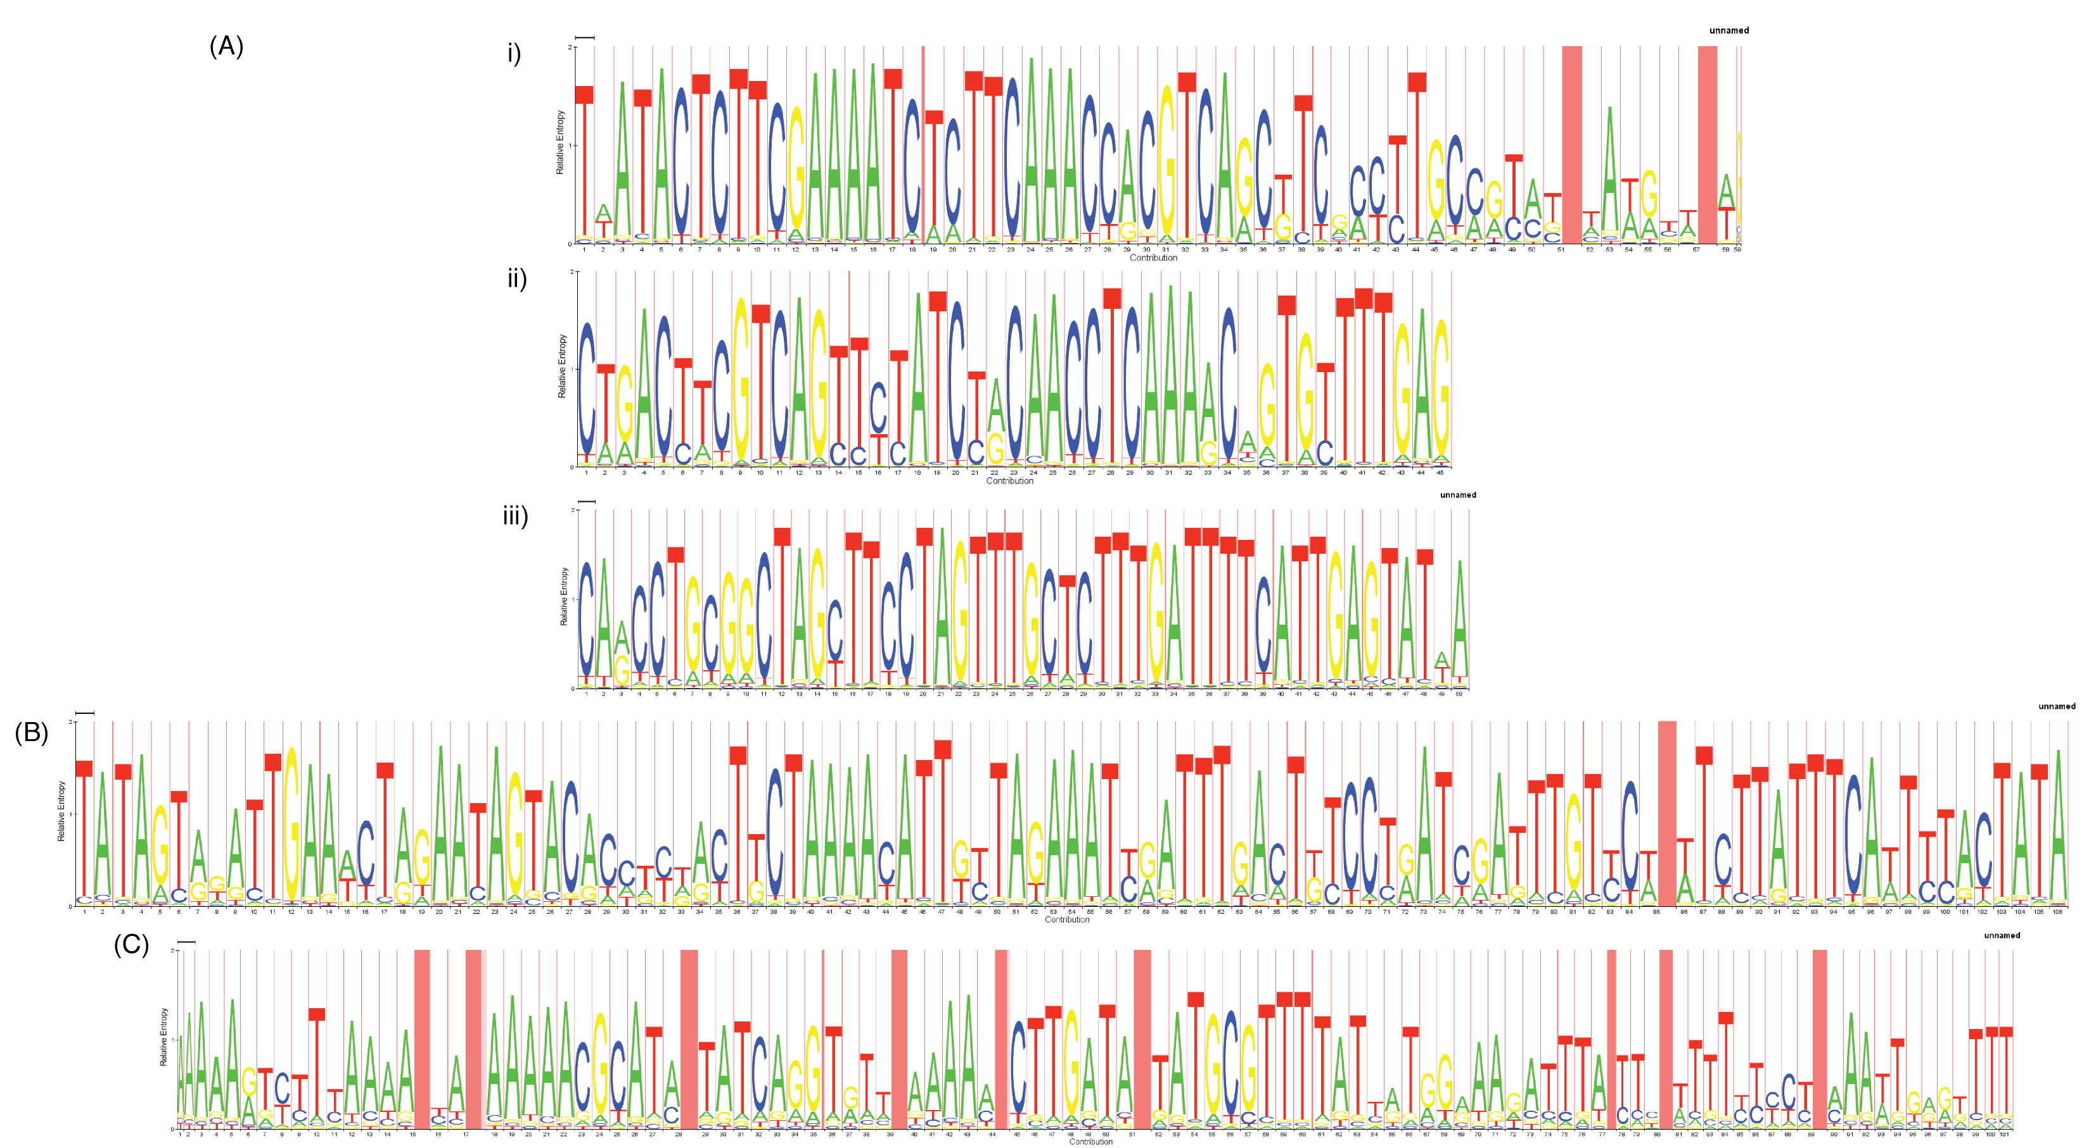
Figure 7.1 HMM logos representing pneumococcal interspersed repeat sequences. These images describe the HMMs used for sequence searches. Each column corresponds to a nucleotide in the repeat element. The total height of bases in each column represents how informative that position is in describing the element; the relative heights of the different bases indicate their respective emission probabilities in the model. Red shaded columns show positions where base insertions occur: the total width of these columns represents the expected number of inserted bases, whilst the dark shaded component indicates the probability that an insertion occurs. The repeats displayed are a) i) boxA, ii) boxB, iii) boxC, b) RUP and c) SPRITE.
Following refinement of the models (see Materials and Methods), the final HMMs used to identify the repeats are represented as logos in Figure 7.1. Overall, 125 BOX (composed of 422 modules), 110 RUP and 30 SPRITE elements were found in the ATCC 700669 genome; in addition, 17 lone box modules were found. All of the original examples used to define BOX and RUP elements were identified by this approach (Martin et al., 1992; Oggioni and Claverys, 1999). It seems likely that the lower frequency of the SPRITE repeat is the explanation as to why it was not characterised prior to the availability of complete genome sequences.

Each of the three families of repeats share at least some features of MITEs. All are typically less than 200 bp in length; unsurprisingly, the modular BOX elements are the most variable in size, ranging from 67 bp to 637 bp. Both RUP and SPRITE are AT-rich relative to the S. pneumoniae genome (GC content of 39.5%), with mean GC levels of 27.5% and 28.1% respectively. BOX and RUP have been previously shown to have TIR and cause TSDs on insertion (Martin et al., 1992; Oggioni and Claverys, 1999; Knutsen et al., 2006). SPRITE repeats have comparatively shorter and simpler TIR (the tetranucleotide AAAA and the complement TTTT; Figure 7.1C). Any TSD produced by SPRITE insertions could not be established from the current dataset, because no instances of the repeat with an easily comparable empty site could be found in the available collection of sequences, and no clear evidence could be identified by examining the regions flanking insertions.

All three elements are predicted to form stem-loop structures if transcribed into an RNA form (Figure 7.2). The structure of BOX elements was generated from those elements with a canonical A₁B₁C₁ sequence; notably, the folding of the boxB element is predicted to involve few interactions with the boxA and C elements that form the rest of the structure. If this folded RNA is functional, this characteristic may be permissive in allowing boxB to be absent, or present in multiple copies, without causing much disruption to the overall form of the transcript.

The SPRITE structure is less tightly folded than that of BOX or RUP, and consists of an 18 bp duplex followed by a relatively uridine-rich (~48% uridine) tract, seeming likely to imbue it with the properties of a Rho-independent terminator. However, the repeat’s structure is distinctive in that both the stem duplex and T-rich tract are much longer than the ~10 bp size of both these features in typical streptococcal Rho-independent terminators (de Hoon et al., 2005). Hence it appears that SPRITE are distinct from normal Firmicute terminators, although they may be able to function in such a capacity.
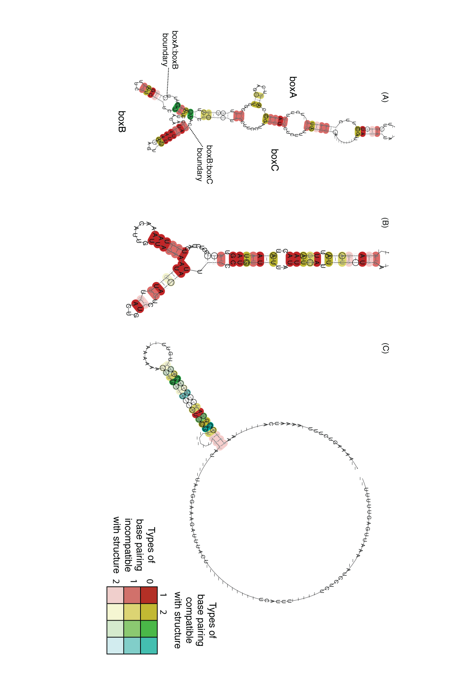
Figure 7.2 Predicted repeat sequence secondary structures. These images represent the predicted secondary structures of transcribed forms of the repeat sequence families: a) BOX, b) RUP and c) SPRITE. The structures were generated from an alignment of 30 sequences from the S. pneumoniae ATCC 700669 genome in each case; only BOX elements with a canonical A₁B₁C₁ structure were used to produce the structure in a). The boundaries between the different subsequences are marked on the image. Base pairings are coloured according to their conservation in the alignment: the bolder the colour, the more strongly conserved the pairing of the bases, with different colours indicating different numbers of compatible interactions at equivalent sites in the structure (see key).
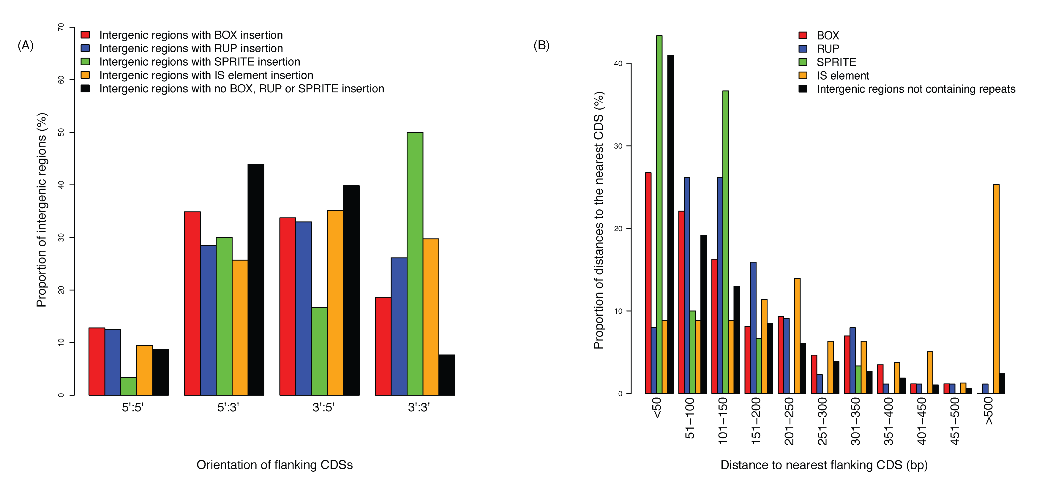
Figure 7.3 Distribution of repeat sequences within the S. pneumoniae ATCC 700669 genome. a) The orientation of the CDSs flanking different repeat elements. Data are shown for BOX, RUP, SPRITE and IS elements annotated in the chromosome; the black bars indicate the orientations of all neighbouring CDSs in the genome not separated by intervening small interspersed repeats. b) A comparison of the distance from repeat sequences, including IS elements, to the nearest CDS, and the distribution of lengths of intergenic sequences not containing repeats.

Genomic distribution of pneumococcal repeats
The distribution of these repeats relative to the protein coding genes of S. pneumoniae ATCC 700669 was examined. BOX, RUP and SPRITE were all found to mimic the coding bias of the sequence, with 60.8%, 60.9% and 63.3% of insertions on the leading strand of the genome, respectively. Although BOX elements have been found to affect gene regulation (Knutsen et al., 2006), they are only slightly overrepresented between divergently transcribed genes, and like RUP, SPRITE and IS elements, they are significantly overrepresented between convergently transcribed genes (Figure 7.3A; Table 7.1). This may be seen as evidence that these elements are mobile, parasitic entities: the regions downstream of CDS are less likely to be under strong selection pressures, and hence more likely to tolerate repeat element insertions, than upstream regulatory regions or intergenic sequences between cotranscribed genes. Most strongly enriched in these regions are SPRITE, which, given their resemblance to terminator sequences, seem the most probable to disrupt transcription if inserted upstream or between genes.

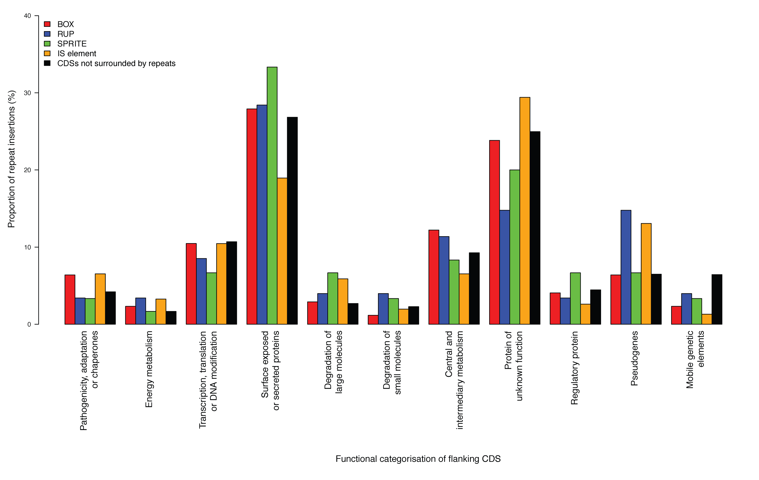
Figure 7.4 Distribution of repeat sequences relative to CDS function. Functional classification of CDSs adjacent to repeat sequences in the genome of S. pneumoniae ATCC 700669. For each type of repeat, both flanking CDSs were considered, and the proportions indicated by the graph. The black bars record the equivalent classification of CDSs with at least one associated intergenic region not containing a repeat sequence.

Across the pneumococcal chromosome, the size of intergenic distances follows a gradually decaying distribution (Figure 7.3B). A similar pattern is observed with the distances between BOX elements and the nearest gene, whereas the density of RUP elements is greatest 50-150 bp from the nearest gene. IS elements have an even more pronounced tendency to be distant from neighbouring CDSs; this may reflect the greater potential disruption to gene expression caused by these longer repeats should they insert within, or near, functional transcripts. SPRITE sequences tend to be close to adjacent CDSs, with only one SPRITE found less than 200 bp from the nearest gene. This enrichment of SPRITE close to the 3’ termini of CDS suggests they may have been co-opted by the pneumococcus into acting as functional transcriptional terminators.

Few clear relationships can be ascertained by looking at the association between repeats and the functional classes of their flanking CDSs (Figure 7.4). This again argues against a general role for these repeats as upstream regulatory elements coordinating transcriptional responses to stimuli, as has been previously suggested (Martin et al., 1992), because no informative overrepresentation of a repeat near CDSs with a particular function is observed. Furthermore, in agreement with the analysis of the S. pneumoniae TIGR4 genome (Tettelin et al., 2001), no support for the hypothesised association between IS elements and RUP insertions can be found (Oggioni and Claverys, 1999). There is also no evidence for the positioning of repeat arrays next to genes encoding surface-exposed proteins that may trigger a host response, proposed as a mechanism for promoting horizontal transfer of CDSs for antigenic proteins in N. meningitidis (Bentley et al., 2007). One apparent association, the preponderance of RUP elements and IS elements adjacent to pseudogenes, seems likely to reflect the tolerance of repeat insertions into regions of the genome that are no longer functional.

Nor is there evidence that the repeats play a role in the positioning of recombination events. Using the in vitro transformation data (Chapter 5), the density of BOX, RUP and SPRITE repeats in the aligned regions of the genome not found to participate in recombinations does not significantly differ from that within RSSs (Fisher’s exact tests, p = 0.55, 1.0 and 0.52 respectively) or FRs (Fisher’s exact tests, p = 0.068, 1.0 and 0.40 respectively). Hence there is no evidence of a link between any of the repeats and the positioning of horizontal sequence transfer events. This would appear to be in contrast to the 9 nt DNA uptake sequences (DUS) of H. parainfluenzae and H. influenzae (Danner et al., 1980; Fitzmaurice et al., 1984; Smith et al., 1999) or 10 nt Uptake Signal Sequence (USS) of N. meningitidis and N. gonorrhoeae (Goodman and Scocca, 1988; Smith et al., 1999), which must be present on the DNA molecule for it to be efficiently passed into the cells of the respective species through the competence system.

Mobility of pneumococcal repeats
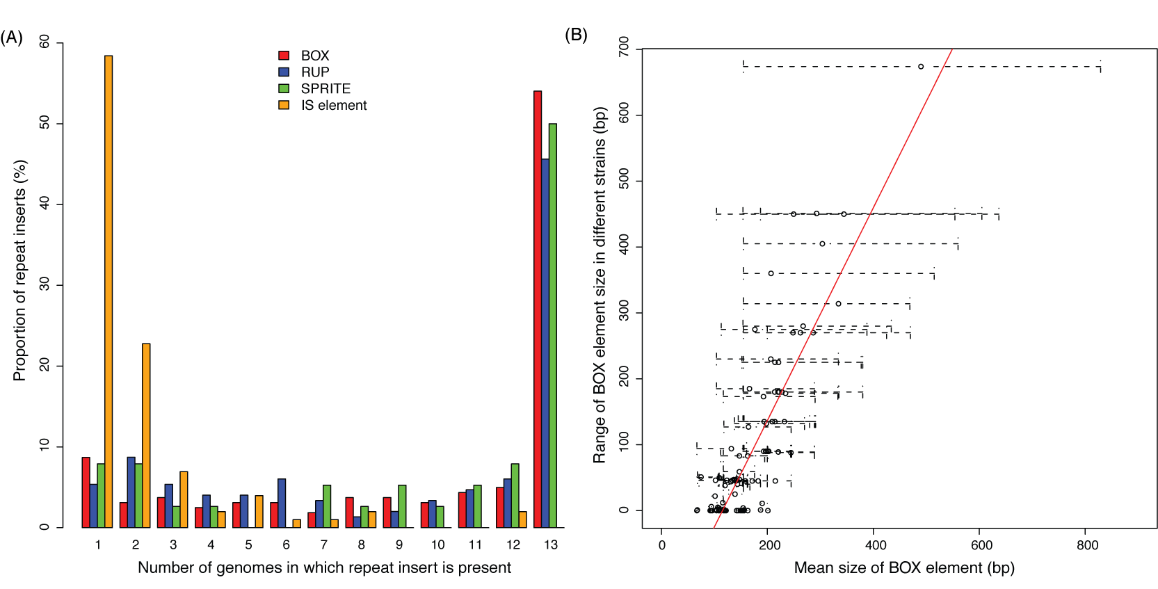
Figure 7.5 Distribution of repeat sequences between pneumococcal genomes. a) For each of the three families of small, interspersed repeat, and for IS elements, orthologous insertion events were defined between chromosomes (see Methods) and scored for presence or absence in the 13 complete pneumococcal clinical isolate chromosomes. The bar chart shows the proportion of insertions of each repeat element shared by a given number of pneumococcal sequences, ranging from insertions present in a single chromosome to those conserved among all strains. b) Variation in the length of BOX elements. For each BOX element identified in the chromosome sequences, the mean, minimum and maximum sizes of orthologous inserts in different strains was calculated. The graph shows the mean length plotted against the range in size, with the dotted bars showing the span of sizes detected.
The level of variation in repeat insertions between all publicly available complete S. pneumoniae genomes was also studied (Figure 7.5A). For all three small interspersed repeats, approximately half of the insertions are ‘core’, i.e. present at the same location in all sequenced strains. This contrasts with the distribution of autonomously mobile IS elements, of which the majority of insertions are present only in a single strain. This is likely to reflect IS elements having a comparatively higher transposition rate, while also being removed more quickly by selection. Assuming that the frequency of IS elements in the pneumococcal population is relatively stable over time, this implies that they are much more mobile than the small interspersed repeats. Despite the hypothesized transposition of RUP in trans by IS630-Spn1 elements, there is no clear evidence from this distribution between genomes that it is more mobile than BOX, which has a lower level of similarity to the TIR of ISSpn2 (Knutsen et al., 2006), or SPRITE, for which no significant similarity with pneumococcal IS TIR could be found.

One way in which BOX elements are observed to vary quite considerably is in their size (Figure 7.5B). Several mechanisms have been proposed to explain the fluctuation in the length of tandem repeat arrays, including slipped strand mispairing, unequal crossover during homologous recombination and circular excision followed by reinsertion (Achaz et al., 2002). Plotting the mean size of each BOX element insertion against the range of the lengths of the insertion in different genomes reveals a positive linear correlation (Pearson correlation, R² = 0.74, p < 2.2 × 10⁻¹⁶). This implies that the greater the average number of boxB repeats in a BOX element, the more likely that element is to vary by losing or acquiring these modules. Notably, all BOX elements with a large mean size exhibit considerable variation in length between strains, with none of them stably maintaining an extended form. This result indicates that at the disparate loci at which BOX elements are found, there is significant variation in the rate of mechanisms that change the number of boxB modules in these arrays, or greatly differing levels of selection pressure constraining the size of these composite repeats.

Repeat sequences in other streptococci
The application of the HMMs to the genomes of other nasopharyngeal commensals (H. influenzae, N. meningitidis and Staph. aureus) failed to identify any cases where the repeats had been horizontally transferred. A similar investigation of all publicly available complete streptococcal genomes, encompassing twelve species other than S. pneumoniae, also detected few instances of these repeat elements (Table 7.2). The sole representative genome of the most closely related species to S. pneumoniae, S. mitis B6 (Denapaite et al., 2010), contained 104 BOX elements (a mean density of 0.048 kb⁻¹), slightly lower than the mean of 122 in the pneumococcal chromosomes (a mean density of 0.057 kb⁻¹). By contrast, the density of SPRITE sequences in S. mitis is about half that of the pneumococcus, and there are only 9 detected instances of RUP in S. mitis B6. As S. mitis and S. pneumoniae are able to exchange DNA, it is not clear whether the repeats were present in their last common ancestor, or whether they have been acquired after speciation and subsequently spread horizontally. By contrast, all three repeat types are almost entirely absent from the genome of S. sanguinis, the only other mitis group streptococci to have been sequenced. Hence the most parsimonious conclusion is that these elements have spread in the pneumococcal chromosome subsequent to the divergence of the more distantly related members of the mitis group.

The only other streptococcal species to have a comparatively high number of detected repeats was S. suis, all genomes of which had 11 boxC elements. These were found to coincide with previously discovered repeats, annotated as 'RepSU1', on the complementary strand of the genome in strains SC84, P1/7 and BM407 (Holden et al., 2009). Further analysis revealed the presence of two novel families of BOX-type elements in these genomes, composed of a total of seven different subsequences in particular permutations. One is bounded by boxA and C modules, both of which are around 50 nt long, as are the pneumococcal equivalents. The RepSU1 elements accounted for only the smallest BOX-type repeats of this type, equivalent to A₁C₁ BOX sequences. The other family has a boxE sequence at the 5’ end and a boxF module at the 3’ end; these motifs are comparatively large, having mean sizes of 115 nt and 133 nt respectively. Both types are found surrounding the same type of intervening boxB modules; however, the boxAC-flanked elements are also sometimes found having boxD modules, always in addition to boxB modules. Hence the diversity of S. suis BOX elements appears to be greater than that of the S. pneumoniae equivalents.

Disruption and modification of genes through repeat element insertion
BOX, RUP and SPRITE elements are frequently found together in clusters, and appear to have inserted into one another on a number of occasions. These spatial groupings may reflect a common preference for insertion sites, or a general tolerance of insertions in certain regions of the chromosome. However, repeats are also found interspersed within pseudogenes and regulatory sequences. It is known that BOX insertions can affect the expression of nearby genes (Saluja and Weiser, 1995; Knutsen et al., 2006); another example where they might impact on the transcription of an operon is upstream of the trp gene cluster. In many Gram positive species, this operon is regulated by two copies of the T box riboswitch, which binds uncharged tRNA. Whilst streptococci have previously been thought to only have a single copy (Gutierrez-Preciado et al., 2007), in fact the pneumococcus has two, separated by a A₁B₂C₁ BOX element. This results in the formation of a compound 5’ untranslated region nearly a kilobase long, composed of three elements that, given their individually stable structures, seem likely to fold largely independently.

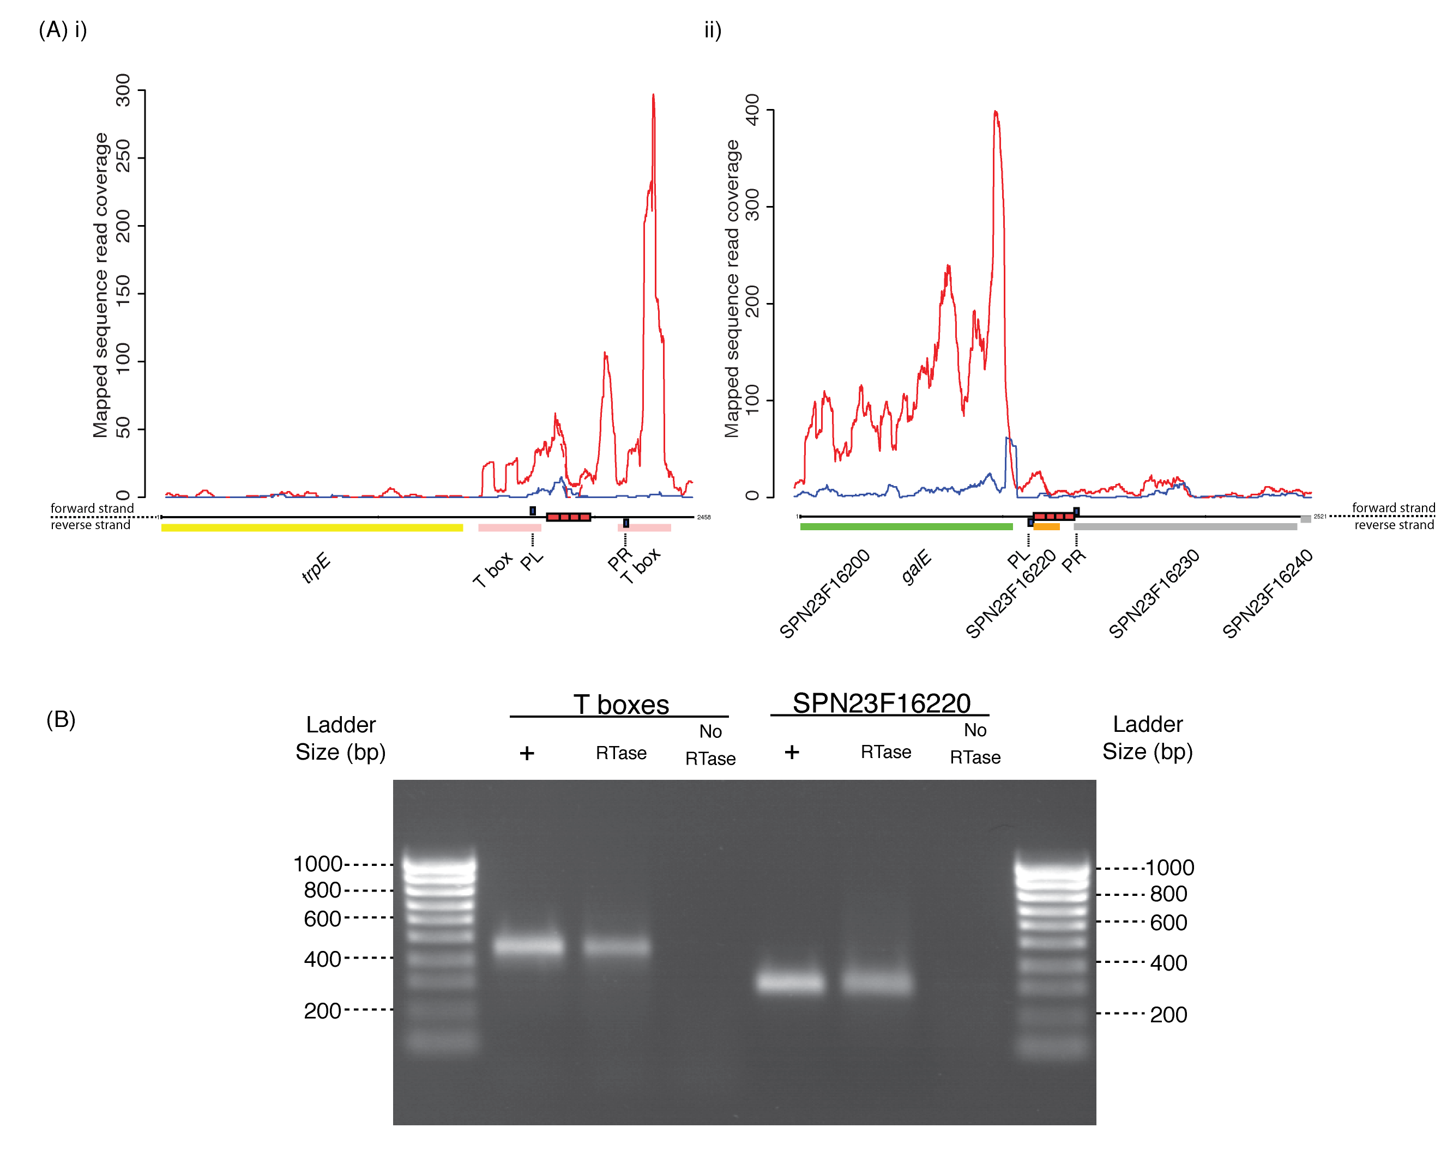
Figure 7.6 Repeat sequence expression congruent with genome annotation. (A) All RNA-seq data is shown as plots of read coverage against the annotation of the represented genomic locus. Along the bottom of these panels, CDSs and non-coding RNAs, coloured according to function as in Chapter 3, are represented as blocks above or below the scale line, depending on their orientation. BOX repeats are shown as red blocks on the scale line. Primer binding sites are indicated by blue blocks labelled using dashed lines. Above the annotation, as part of the coverage plots, blue lines indicate transcription of the upper strand of the genome, while red lines show transcription of the reverse strand. Solid lines represent the result of fully redundant mapping, where reads mapping to multiple sites on the chromosome are randomly distributed between them. Dashed lines represent locally redundant mapping, where reads that might map to regions outside the displayed locus are excluded from the graph (see Materials and Methods). i) The region upstream of the trp operon. The trpE gene is adjacent to two T box riboswitch motifs separated by an intervening BOX element, represented as four adjacent red boxes representing the A₁B₂C₁ structure of the repeat. The RNA-seq data suggests the T box motifs and BOX element are cotranscribed as a composite element, repressing the transcription of the downstream biosynthetic operon. ii) Locus surrounding SPN23F16220. This small CDS is annotated as being encompassed by a BOX element. RNA-seq data suggested it was cotranscribed with SPN23F16230, present on the other side of the repeat relative to the more highly expressed galE gene. (B) RT-PCR to confirm transcription of these BOX elements. The positions of the primers used in these reactions are indicated by the blue boxes labelled PL (left primer) and PR (right primer) in (A) i) and ii). In each case, the three lanes correspond to a positive control reaction using a genomic DNA (+), a test using cDNA produced through reverse transcription of an RNA sample (RTase) and a negative control using a non-reverse transcribed RNA sample (No RTase). The bands indicate that these BOX elements are expressed, as suggested by the RNA-seq data.
A number of protein coding genes are disrupted by repeat insertions. Instances found in genome annotations include orthologues of the S. pneumoniae TIGR4 CDS SP_0243, encoding the extracellular binding protein for a putative iron ABC transporter, which is disrupted by the insertion of a RUP element in all the other pneumococcal genomes except S. pneumoniae AP200, 670-6B and TIGR4 itself. However, another CDS encoding part of the same ABC transporter (SP_0241 in TIGR4) is disrupted through frameshift mutations in these three strains. Both of these CDSs appear to be intact in several incompletely sequenced S. mitis strains, which lack the alternative pit2 iron transport system found on Pneumococcal Pathogenicity Island 1 (Brown et al., 2001). SPN23F05190 (TIGR4 orthologues SP_0574 and SP_0575), encoding a restriction endonuclease in S. pneumoniae ATCC 70069, has a RUP insertion in S. pneumoniae TIGR4 and D39, whilst the orthologous gene in S. pneumoniae AP200 has been disrupted through the insertion of an IS element. Further examination of the repeat insertions reveals a RUP insertion that has knocked out a serine/threonine protein kinase, previously annotated as two separate CDSs (e.g. SPN23F18490 and SPN23F18500 in S. pneumoniae ATCC 700669; SP_1831 and SP_1832 in S. pneumoniae TIGR4), in all strains except S. pneumoniae Taiwan 19F-14 and TCH8431/19A. BOX elements can also cause gene disruption through insertion: a gene encoding a DNA alkylation repair protein is disrupted by a BOX insertion in all the available pneumococcal sequences, whilst an E₁B₁F₁ element appears to have inserted into an acetyltransferase pseudogene in the sequenced S. suis genomes. Hence the mobility of these repeats has the potential to contribute to phenotypic polymorphism in the S. pneumoniae and S. suis populations.

Expressed open reading frames generated by large BOX elements
Fifty-eight CDSs in the S. pneumoniae ATCC 700669 annotation overlap with BOX elements. In 36 cases, this corresponds to the extreme 3’ end of a gene, with the BOX repeat encoding the stop codon; in some cases, these correspond to well-characterised genes such as folE, mtlD, dnaJ and glgP. However, alignments with non-pneumococcal orthologues do not provide strong evidence for truncation of the encoded polypeptide in any case, especially when the relatively weak conservation of the extreme C terminal portion of proteins is taken into account.

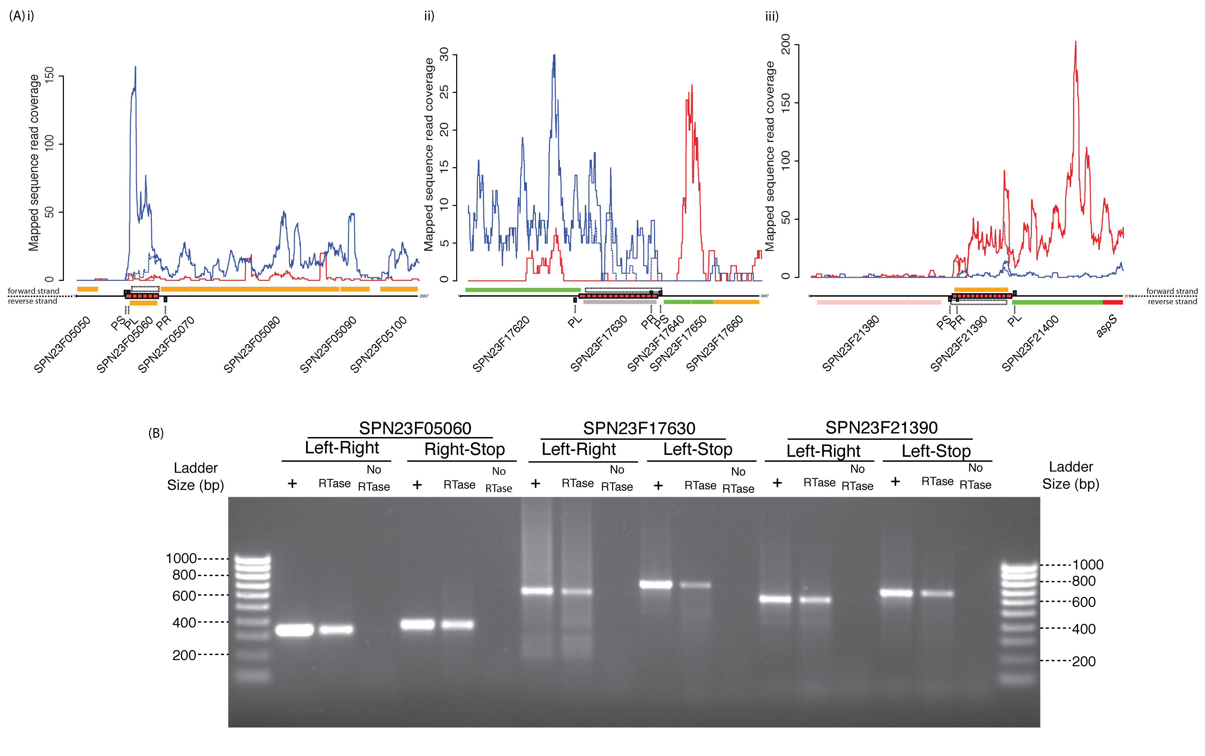
Figure 7.7 Potential misannotation of the S. pneumoniae ATCC 700669 genome. RNA-seq data is displayed as described in Figure 7.6. In addition to the published annotation of S. pneumoniae ATCC 700669, dashed boxes indicate alternative open reading frames encoded by BOX elements. (A) i) The locus around SPN23F05060, encoded by a BOX element. The CDS is annotated on the bottom strand, but the RNA-seq results indicate it is co-transcribed with the operon on the top strand. ii) This BOX element appears to be cotranscribed with the upstream SPN23F17620 CDS at a low level, rather than encoding the 603 bp putative CDS SPN23F17630. iii) The BOX element encompassing putative CDS SPN23F21390 appears to transcribed on the reverse strand, along with the neighbouring CDSs. (B) For each of the three loci displayed in a), two experiments were performed, each as described in Figure 7.6. One, using PL (left primer) and PR (right primer) tested for expression of the BOX element itself. The second used PL or PR and PS (stop codon primer), which tested whether the full-length open reading frame on the transcribed strand was expressed. At all three loci, both reactions were positive using a cDNA sample as template.
A further 19 sequences, which appear to encode proteins on the basis of GC frameplot and correlation scores (Parkhill, 2002), with little or no functional annotation were found to be mostly, or wholly, encoded by BOX elements. Pneumococcal BOX repeats can extend to over 500 bp in length, and these larger elements tend to encode an open reading frame on both strands. Of the CDSs encoded mainly by BOX sequence, all but two (SPN23F00880 and SPN23F08320) were annotated on the opposite strand of genome to that on which the BOX elements are marked. None of the translated BOX-encoded CDSs exhibited significant similarity with any sequence in the public databases other than matches to hypothetical proteins annotated in mitis group streptococcal genomes.

Directional RNA sequencing data was used to determine whether these genes are expressed. In the case of SPN23F16220 (Figure 7.6A, ii), the transcription follows the direction expected from the annotation, with the BOX element forming a 3’ extension to the upstream three CDS operon, as confirmed by RT-PCR (Figure 7.6B). Entirely encompassed within this PCR product is a 42 aa predicted protein encoded by an A₁B₂C₁ BOX. Also confirmed to conform to the genome annotation is the BOX element lying between the T box motifs upstream of the trp operon (Figure 7.6A, i). The pneumococcal culture from which the RNA was extracted was grown in nutrient-rich conditions, hence the T box motifs are expressed, but the downstream trp operon is not. It appears that the riboswitches are still able to function as a regulatory structure, despite the intervening BOX element. Therefore, as anticipated from the genome sequence, BOX elements can be transcribed as extensions to both the 5’ and 3’ regions of operons.

However, in three cases, (SPN23F005060, SPN23F17630 and SPN23F21390), the direction of transcription indicated by the RNA-seq data contradicted the predicted CDS, appearing instead to be continuing from the adjacent operon (Figure 7.7A). SPN23F005060 is contained within a small 289 bp repeat likely to form a 5’ extension to the downstream operon. The relatively high density of reads mapping to this BOX element may reflect mismapping of sequences that correspond to a different, more highly expressed repeat (as the level of locally redundant mapping is lower, and hence more congruent with the level of transcription of the rest of the operon), or indicate that the repeat functions as a transcriptional attenuator due to its highly folded structure. The BOX-encoded putative CDSs SPN23F17630 and SPN23F21390 form long (649 bp and 604 bp, respectively) 3’ structures. The cotranscription of these elements in the direction indicated by the RNA-seq data was confirmed by RT-PCR in all three examples (Figure 7.7B), implying the annotation is likely to be erroneous.

However, in all three cases, there is also an ORF in the transcribed direction; rather than the start codon being in boxC and boxA encoding the stop codon, as predicted, boxC instead encodes the start codon and the stop codon lies beyond the BOX element. These expressed, BOX-encoded potential CDSs are indicated as dashed boxes in Figure 7.7A. Further RT-PCR confirmed that the RNA extended not just to the end of these BOX elements, but extended as far as the stop codon of these ORFs (Figure 7.7B). However, the proteins encoded by these ORFs also failed to significantly match any sequences other than hypothetical CDSs from mitis group streptococci and lacked good candidate Shine-Dalgarno sequences. Nevertheless, this confirmed that these 5’ and 3’ operon adducts, formed by BOX elements, have the potential to become nascent protein coding sequences.

Discussion
The three families of small interspersed repeats found in the pneumococcal chromosome are found, albeit at a reduced frequency, in the closely related species, S. mitis, and very infrequently in other streptococci. These include the previously unidentified SPRITE repeat, which resembles a Rho-independent terminator element in its secondary structure. This is quite unlike the structures of the BOX and RUP elements, which are much more tightly folded and include their TIR hybridised to one another as parts of duplexes. A likely consequence of this form is the observed strong enrichment of this element close to the 3’ ends of convergently transcribed CDSs, such that it does not disrupt normal gene expression patterns.

Even the naturally transformable oral streptococcus S. sanguinis, also part of the mitis group, lacks these elements. This implies that the repeats are unlikely to fulfil any of the possible important functions that might be ascribed to repeated sequences: for instance, chromosome packaging, aiding with replication or incorporation of horizontally transferred DNA. Furthermore, their distribution within the S. pneumoniae ATCC 700669 chromosome, resembling as it does the pattern of IS elements in being enriched between convergently transcribed CDSs, is suggestive of the main alternative explanation of their prevalence: that they are parasitic, non-autonomously mobile elements.

Based on their distribution between different streptococci, it appears that the repeats are likely to have been acquired subsequent to the divergence of the mitis group species. Two possible hypotheses may be advanced to explain the current distribution of repeats in the pneumococcus; one is that they may have been present in the last common ancestor of S. pneumoniae, and the position of some repeat insertions in this progenitor subsequently conserved amongst all pneumococcal strains. Alternatively, the repeats may have been acquired by S. pneumoniae and then spread horizontally through the population, resulting in the repeats being fixed at certain chromosomal loci over time. This second scenario is likely to be more sensitive to negative selection against the repeat insertions. In either case, a period of relatively rapid spread seems to have occurred in the population's past, which now seems to have abated. The proportion of repeats that are 'core' is similar to the proportion of 'core' CDSs in the pneumococcal pan-genome (Donati et al., 2010), and there are few insertions unique to any given chromosome that would indicate recent transposition events, contrasting with the distribution of IS elements between chromosomes.

The only other sequenced streptococcal species to have acquired BOX-type repeats is S. suis, which is also able to colonise the human nasopharynx, suggesting there may be a common source of these sets of elements. Although the S. suis BOX elements are present at a lower density in the chromosome, they are more diverse. It is difficult to assess how 'active' these elements are in this species, given the closely related nature of the currently sequenced S. suis genomes (Chen et al., 2007; Holden et al., 2009), but in the current sample there is little evidence that they are more mobile than in S. pneumoniae. Hence in both species, these elements appear to be currently dormant.

One reason to suggest there may be selection against any mechanism that mobilises such elements is the disruption of CDSs by repeat insertion, which is evident in both S. pneumoniae and S. suis. However, there is also the potential for the formation of novel ORFs by BOX elements. Again, this is observed in both species; as well as the pneumococcal instances, there are two CDSs in the S. suis genomes that appear to be intact despite containing box modules (SSUSC84_0055 and 0899 in S. suis SC84) and three that are mostly, or entirely, encoded by BOX elements (SSUSC84_0048, 0112 and 0453 in S. suis SC84). The RNA-seq and RT-PCR data suggest that in some cases in S. pneumoniae such elements are transcribed, and have the potential to become nascent CDSs. Such instances appear to represent the consequences of three proposed properties of BOX elements: firstly, their mobility allowing them to insert into transcribed regions of the genome; secondly, the formation of an open reading frame on both strands of the element, and thirdly, their modular nature allowing them to expand to longer forms.

Whether the polypeptides they encode are actually expressed is not clear; it seems more likely that they are transcribed as untranslated regions. If so, they may influence the levels of expression of co-transcribed genes; those elements forming 3’ adducts to operons are likely to form stem-loop structures that may impede the action of 3’→5’ exonucleases, the primary RNA degradation pathway in bacteria, thereby stabilising the transcript. However, ERICs are capable of triggering endoribonucleolytic cleavage of transcripts, depending on the orientation of the element and the sequence of the operon, and CE can also trigger cleavage of mRNA. Hence the overall impact of a repeat insertion into an operon is difficult to predict, and is liable to change with the variation in the length of the BOX element and the context of the insertion site. Unfortunately, the sequence read coverage across operons with current RNA-seq techniques is too inconsistent to make any firm inferences about the impact of these BOX elements.

The simplest mechanism by which these repeats may affect transcription is through acting as terminators, especially given the resemblance of SPRITE sequences to such structures. Such a function has been previously been proposed to be performed by a BOX element (Saluja and Weiser, 1995). There is also a precedent for repeats having a similar potential impact in another nasopharyngeal commensal and pathogen: the USS of N. meningitidis which, when found in close proximity to one another, tend to be inversely orientated, allowing them to form a stem loop structure predicted to act as a terminator (Ambur et al., 2007). S. pneumoniae, although naturally transformable, lacks the selectivity in its uptake of DNA exhibited by N. meningitidis and H. influenzae (Smith et al., 1999), and partial SPRITE sequences were not sufficiently abundant to suggest the element described here is a composite of pairs of motifs analogous to DUS or USS. It seems likely, in fact, that the prevalence of the repeat families present in the pneumococcal chromosome exemplifies a potential disadvantage of the intrinsically competent lifestyle these three respiratory pathogens have adopted: the risk of acquiring genomic parasites that may cause considerable disruption whilst they remain mobile.

Achaz, G., E. P. Rocha, et al. (2002). Origin and fate of repeats in bacteria. Nucleic Acids Res 30(13):2987-94.
Ambur, O. H., S. A. Frye, et al. (2007). New functional identity for the DNA uptake sequence in transformation and its presence in transcriptional terminators. J Bacteriol 189(5):2077-85.
Bachellier, S., J. M. Clement, et al. (1999). Short palindromic repetitive DNA elements in enterobacteria: a survey. Res Microbiol 150(9-10):627-39.
Bentley, S. D., G. S. Vernikos, et al. (2007). Meningococcal genetic variation mechanisms viewed through comparative analysis of serogroup C strain FAM18. PLoS Genet 3(2):e23.
Brown, J. S., S. M. Gilliland, et al. (2001). A Streptococcus pneumoniae pathogenicity island encoding an ABC transporter involved in iron uptake and virulence. Mol Microbiol 40(3):572-85.
Chen, C., J. Tang, et al. (2007). A glimpse of streptococcal toxic shock syndrome from comparative genomics of S. suis 2 Chinese isolates. PLoS One 2(3):e315.
Danner, D. B., R. A. Deich, et al. (1980). An eleven-base-pair sequence determines the specificity of DNA uptake in Haemophilus transformation. Gene 11(3-4):311-8.
De Gregorio, E., C. Abrescia, et al. (2002). The abundant class of nemis repeats provides RNA substrates for ribonuclease III in Neisseriae. Biochim Biophys Acta 1576(1-2):39-44.
De Gregorio, E., G. Silvestro, et al. (2005). Enterobacterial repetitive intergenic consensus sequence repeats in yersiniae: genomic organization and functional properties. J Bacteriol 187(23):7945-54.
de Hoon, M. J., Y. Makita, et al. (2005). Prediction of transcriptional terminators in Bacillus subtilis and related species. PLoS Comput Biol 1(3):e25.
Delihas, N. (2008). Small mobile sequences in bacteria display diverse structure/function motifs. Mol Microbiol 67(3):475-81.
Denapaite, D., R. Bruckner, et al. (2010). The genome of Streptococcus mitis B6--what is a commensal? PLoS One 5(2):e9426.
Donati, C., N. L. Hiller, et al. (2010). Structure and dynamics of the pan-genome of Streptococcus pneumoniae and closely related species. Genome Biol 11(10):R107.
Espeli, O., L. Moulin, et al. (2001). Transcription attenuation associated with bacterial repetitive extragenic BIME elements. J Mol Biol 314(3):375-86.
Fitzmaurice, W. P., R. C. Benjamin, et al. (1984). Characterization of recognition sites on bacteriophage HP1c1 DNA which interact with the DNA uptake system of Haemophilus influenzae Rd. Gene 31(1-3):187-96.
Gilson, E., W. Saurin, et al. (1991). Palindromic units are part of a new bacterial interspersed mosaic element (BIME). Nucleic Acids Res 19(7):1375-83.
Goodman, S. D. and J. J. Scocca (1988). Identification and arrangement of the DNA sequence recognized in specific transformation of Neisseria gonorrhoeae. Proc Natl Acad Sci U S A 85(18):6982-6.
Gutierrez-Preciado, A., C. Yanofsky, et al. (2007). Comparison of tryptophan biosynthetic operon regulation in different Gram-positive bacterial species. Trends Genet 23(9):422-6.
Holden, M. T., H. Hauser, et al. (2009). Rapid evolution of virulence and drug resistance in the emerging zoonotic pathogen Streptococcus suis. PLoS One 4(7):e6072.
Hulton, C. S., C. F. Higgins, et al. (1991). ERIC sequences: a novel family of repetitive elements in the genomes of Escherichia coli, Salmonella typhimurium and other enterobacteria. Mol Microbiol 5(4):825-34.
Knutsen, E., O. Johnsborg, et al. (2006). BOX elements modulate gene expression in Streptococcus pneumoniae: impact on the fine-tuning of competence development. J Bacteriol 188(23):8307-12.
Martin, B., O. Humbert, et al. (1992). A highly conserved repeated DNA element located in the chromosome of Streptococcus pneumoniae. Nucleic Acids Res 20(13):3479-83.
Mazzone, M., E. De Gregorio, et al. (2001). Whole-genome organization and functional properties of miniature DNA insertion sequences conserved in pathogenic Neisseriae. Gene 278(1-2):211-22.
Ogata, H., S. Audic, et al. (2002). Protein coding palindromes are a unique but recurrent feature in Rickettsia. Genome Res 12(5):808-16.
Ogata, H., S. Audic, et al. (2000). Selfish DNA in protein-coding genes of Rickettsia. Science 290(5490):347-50.
Oggioni, M. R. and J. P. Claverys (1999). Repeated extragenic sequences in prokaryotic genomes: a proposal for the origin and dynamics of the RUP element in Streptococcus pneumoniae. Microbiology 145 ( Pt 10):2647-53.
Parkhill, J. (2002). Annotation of microbial genomes. Methods in Microbiology 33:3-26.
Parkhill, J., M. Achtman, et al. (2000). Complete DNA sequence of a serogroup A strain of Neisseria meningitidis Z2491. Nature 404(6777):502-6.
Saluja, S. K. and J. N. Weiser (1995). The genetic basis of colony opacity in Streptococcus pneumoniae: evidence for the effect of box elements on the frequency of phenotypic variation. Mol Microbiol 16(2):215-27.
Smith, H. O., M. L. Gwinn, et al. (1999). DNA uptake signal sequences in naturally transformable bacteria. Res Microbiol 150(9-10):603-16.
Snyder, L. A., J. A. Cole, et al. (2009). Comparative analysis of two Neisseria gonorrhoeae genome sequences reveals evidence of mobilization of Correia Repeat Enclosed Elements and their role in regulation. BMC Genomics 10:70.
Tettelin, H., K. E. Nelson, et al. (2001). Complete genome sequence of a virulent isolate of Streptococcus pneumoniae. Science 293(5529):498-506.
van Belkum, A., M. Sluijuter, et al. (1996). Novel BOX repeat PCR assay for high-resolution typing of Streptococcus pneumoniae strains. J Clin Microbiol 34(5):1176-9.
Zhou, F., T. Tran, et al. (2008). Nezha, a novel active miniature inverted-repeat transposable element in cyanobacteria. Biochem Biophys Res Commun 365(4):790-4.

