Chapter 3 Design and generation of knockin mice

This chapter describes the design and creation of four knockin mutant mouse lines, in which different fluorescent proteins (FPs) including enhanced green fluorescent protein (EGFP), mCerulean blue (mCER), mKusabira Orange2 (mKO2) and a variant of yellow fluorescent protein (YFP) Venus, were in-frame fused with the PSD-MAGUK family members (PSD-95, PSD-93 and SAP102) as well as Arc/Arg3.1, respectively. These fluorescently tagged reporter mouse lines allow me to probe the in vivo expression of these paralogues and the PSD-95 specific interactor Arc/Arg3.1, thus shed some light on the molecular diversity of MAGUKs in the mammalian CNS.

The design and rationales of each mouse model are discussed below, followed by the description of constructing targeting vectors, gene targeting in embryonic stem cells and knockin mice colony establishment.

3.1 Experimental design rationale
Detail information about the temporal and spatial expressions of three MAGUK family members and Arc/Arg3.1 in mammalian brains will certainly provide a wealth of knowledge regarding their potential roles involved in the synaptic functions. Although classical analytical methods such as western blotting and RT-PCR assay could provide highly reliable and sensitive detection on the temporal expression of gene products, these approaches are not able to disclose any clues on the spatial expression manner of genes of interest. On the other hand, spatial expression information can be achieved from conventional approaches such as in situ hybridization and immunohistochemistry. However, these methods still have intrinsic limitations. For example, to probe the expression of individual MAGUK family proteins, the immunohistochemical stainings on tissue sections can be largely constrained by the availability of robust and reliable antibody that binds to a specific paralogue but not cross-reacts with other family members. Moreover, these methods would be virtually unpractical provided performing an exhaustive surrey study, where large quantities of tissue sections need to be dealt with.

For last few decades, the genetically labelling by inserting various reporter gene, for example, the bacterial LacZ gene coding for β-galactosidase (β-Gal) has been widely used. Generated by either gene-targeting or transgenic techniques, the LacZ-reporter mice allowed researchers to comprehensively and rapidly analyze gene expression patterns in various domains of mice brain. Furthermore, these reporter mice can be easily studied at different developmental stages.¹⁻³ However, this approach is limited by a specific detection protocol of preparing exogenous substrate for the enzymatic reactions. Furthermore, the fairly large molecular weight of β-galactosidase (~135 kDa) and its tetrameric composition may interfere with the expression and appropriate folding of endogenous gene product.

Compared with LacZ gene product, GFP fluorescent protein is smaller with a molecular weight of only ~27 kDa and functions as a monomer, making it ideal for a fusion reporter. In recent years, the introduction of GFP fluorescent protein and its derivatives (Miyawaki, A. et al., 2003) has enormously facilitated the PSD-MAGUK protein studies on their expression patterns, protein stability, trafficking and dynamics on synapses (Okabe, M. et al., 1997 FEBS). Most of the related researches were carried out by vector - or virus-mediated approach. However, unfortunately two potential pitfalls remain when performing these studies. First, since strong exogenous promoters are often used, the temporal / spatial expression patterns of transgene could not reflect those of endogenous proteins. Secondly, the transgene is usually expressed in much excess of its endogenous counterpart, which then leads to the anomalous subcellular distribution, protein dynamics and even aberrant cellular functions.

These caveats were partly circumvented by the application of BAC transgenic technique, using endogenous promoters for the GFP fusion gene expression. With advanced developments in the novel methods for engineering bacterial artificial chromosomes (BACs), together with the efficient production of BAC transgenic mice, several groups have generated transgenic mice that express bright EGFP fluorescence in the mammalian CNS (Feng, L. and Heintz, N. et al., 1994). These mice allow the direct visualization of EGFP-expressing cellular morphology. Yet, the profile of GFP expression in these transgenic mice might not always faithfully reflect the endogenous protein expression in the animals under physiological conditions. The BAC transgene expression sometimes varies among different animal lines and therefore it is required careful examinations in each single case of study. Moreover, the trangenes must harbour the full transcription unit including all its upstream or downstream regulatory elements, which is sometimes difficult to predict. Particularly when engineering large gene unit, the size of BAC also raised serious concerns.

Compared with BAC transgenic and other strategies, the targeted GFP fusion gene not only maintains the same advances but further extends their benefits. As a vital marker, GFP fluorescent protein can be observed in living organisms on a real-time basis, and only requires oxygen and appropriate excitation light to activate its fluorescent property. Importantly, only a sing-copy of reporter gene is targeted into a specific genomic locus, thus allow the faithful detection of endogenous protein expression.

Understanding the molecular heterogeneity of PSD-MAGUK and Arc/Arg3.1 proteins at individual synapses requires knowing their endogenous expressions within the physiological environment. In order to faithfully recapitulate the undisturbed expressions of these genes, targeted in-frame gene fusions with various fluorescent proteins were designed (Figure 3.1). Based on the previously findings that the N-terminal of the candidate proteins are crucial for their cellular functions such as membrane targeting and protein-protein interactions, the C-terminal fusion strategy was applied: the fluorescent protein coding sequence was in-frame fused to the last exon of candidate gene and immediately before the stop codon (Figure 3.1).

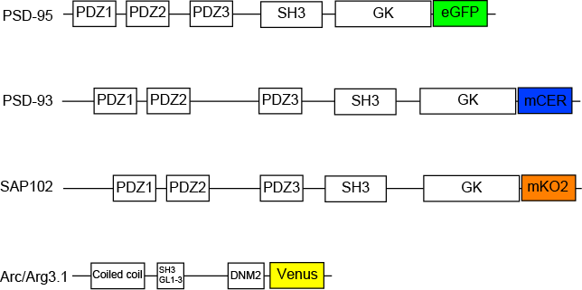

Figure 3.1 Design of fluorescent fusion proteins of PSD-95, PSD-93, SAP102 and Arc.

3.2 Targeting vector construction

PSD95-EGFP
A previously constructed PSD-95 intermediate targeting vector for the generation of PSD95-95 TAP-tag mice (constructed by E. Fernandes) were used and developed into an ubiquitous vector frame work for flexible tagging in the c-terminal of PSD-95 proteins. The template vector (Figure 3.2) contains PSD-95 mini homology arms (GeneID: ENSMUSG00000020886 region: Chr:11 69857620-69858194; Chr:11 69858198-69858766) which were PCR amplified from a BAC clone derived from mouse ES clone AB2.2 corresponding to the mouse strain 129Sv.

Enhanced green fluorescent protein (EGFP) coding sequence was first amplified by PCR using corresponding primers (see Primer Table) from pEGFP-N1 vector (Clontech, GenBank Accession No. U55762). The 5’-end tail of forward primer contains an XbaI site followed by a short artificial linker sequence encoding for four amino acids (Gly-Gly-Gly-Ser) to avoid interference of tagged fluorescent protein on the folding of the endogenous PSD-95. The 5’-end tail of reverse primer contains a BclI restriction site. The ~700 bp PCR products were directionally cloned into pneoflox vector, in which EGFP coding sequence was inserted into the open reading frame of PSD-95 gene on 3’ end and immediately before its stop codon (Figure 3.2). The previously constructed pneoflox vector (constructed by P. Cuthbert) included a neomycin phosphotransferase gene (Neo) driven by a compound phosphoglycerate kinase (PGK) and EM7 promoter. The Neo^{r} gene is then followed by a mouse SV40 polyadenylation signal for kanamycin resistance in bacteria and G418 resistance in mammalian cells, respectively. Two loxP sites were designed to flank the Neo^{r} cassette, thus allowing Cre recombinase-mediated removal of the selection marker.

The DNA fragment flanked by PSD-95 mini homology arms was excised from pneoflox by XbaI and BclI enzymatic digestion and transformed into E.coli strain EL350 cells harboring the recipient vector pTargeter (constructed by P. Cuthbert) (Figure 3.3). The pTargeter vector contains a region of 3’ end genomic sequence of PSD-95 (GeneID: ENSMUSG00000020886 Region: Chr:11 69851809-69858194 and 69858198-69861135) retrieved by homologous recombination from the murine BAC DNA. A Diphtheria Toxin A (DT-A) fragment driven by an MC1 promoter with a mouse SV40 polyadenylation site was also included in the pTargeter as a negative selection cassette (Yanagawa et al., 1999).

By homologous recombination in EL350, the EGFP gene together with Neo^{r} cassette were assembled into the pTargeter vector. This resulted in a final targeting vector contains a 5’ homology arm and 3’ homology arm of PSD-95 at the size of 6.3 kb and 2.9 kb, respectively (Figure 3.4). The final targeting vector was linearized by PvuI for gene targeting in the mouse ES cells. To make sure that no mutations were introduced during cloning procedures, all vector junctions and the PCR cloned coding sequences of PSD-95 as well as EGFP were confirmed by sequencing.

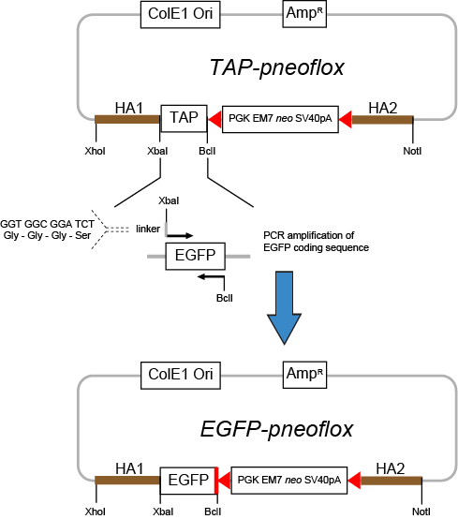

Figure 3.2 Constructing EGFP-pneoflox intermediate vector. The EGFP coding sequence together with the linker sequence were inserted into the intermediate vector, replacing the TAP coding cassette by sequential enzymatic digestion of XbaI and BclI.

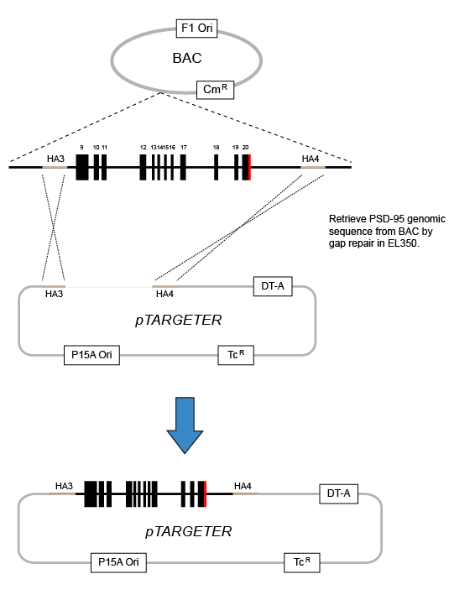
Figure 3.3 Retrieving PSD-95 genomic sequence from BAC by gap repair and construction of intermediate pTARGETER. The intermediate pTARGETER vector carrying HA3 and HA4 homology arms was linearized and transformed into EL350 cells containing corresponding PSD-95 BAC. The PSD-95 genomic sequence was retrieved by homologous recombination, resulting in the pTARGETER vector containing a region of 3’ end PSD-95 genomic sequence (Region: Chr:11 69851809-69858194 and 69858198-69861135).

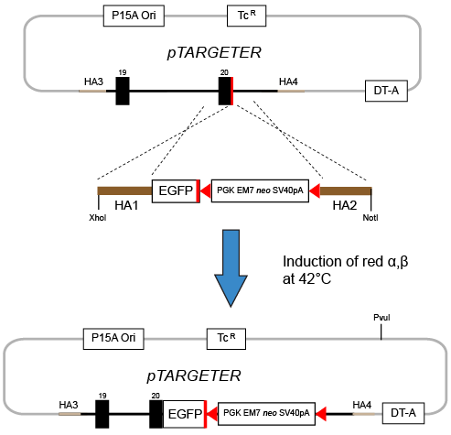
Figure 3.4 Construction of the final PSD-95 targeting vector. The EGFP gene together with Neo^{r} cassette, flanked by HA1 and HA2 homology arms were excised from EGFP-pNeoflox vector by restriction enzyme digestions of XhoI and NotI. The DNA fragment was then transformed into EL350 bacteria cells harbouring pTARGETER as well as the encoding sequence for heat-inducible recombinase Red α and β. By homologous recombination in EL350, the HA1-EGFP-Neo^{r}-HA2 cassette was assembled into the pTargeter vector, resulting in the final PSD-95 targeting vector.

SAP102-mKO2
The backbone of a previously constructed vector pneoflox_delAmp (constructed by Dr. N.H. Komiyama) was modified for the generation of SAP-102 knockin mutations.

The pneoflox_delAmp contains a neomycin phosphstrasferase gene (Neo) driven by a compound PGK and EM7 promoter followed by a mouse SV40 polyadenlytion signal, which allows kanamycin and G418 selection in bacteria and mammalian cells respectively, as previously described.

The 5’ homology arm of SAP102 gene in size of ~ 2 kb, spanning the 3’ end region of wildtype SAP102 locus (Gene ID: ENSMUSG00000000881, Region: Chr: X 98009543-98011664) was PCR amplified from a BAC clone (bMQ312G21) and inserted into pneoflox_delAmp (Figure 3.5) by enzymatic digestion with NotI and NheI. The resulting plasmid was then digested with NheI and SbfI, which reside at the end of 5’ homology arm, and inserted with the sequence encoding for monomeric Kusabira Orange 2 (mKO2) together with a linker sequence encoding Gly-Gly-Gly-Ser, which were PCR amplified from commercial plasmid templates. Particularly, the insertion was designed to create an in-frame fusion of mKO2 coding sequence with the last exon of endogenous SAP102 gene: similar to PSD95-EGFP fusion protein creation, the 668 bp PCR product of mKO2 coding sequence was inserted immediately after the open reading frame of SAP102 gene and before its stop codon. The additional artificial peptide linker sequence encoding Gly-Gly-Gly-Ser was designed to avoid the interference of red fluorescent protein upon SAP102 endogenous protein folding.

Two ~0.5 kb size of ‘mini’ homology arms (5miniHA and 3miniHA, with size of 472bp and 517bp, respectively) from 3’ UTR region of wildtype SAP102 locus were amplified from BAC DNA by two-step nested PCR reactions (Figure 3.6). To ensure the sequence accuracy of mini homology arms, a high-fidelity DNA polymerase, Platium Pfx (Invitrogen) was used. The 5miniHA was selected from the region that was immediately after the stop codon of SAP102 gene (Chr: X region: 98011686-98012138). By AscI and HindIII digestion, the above PCR product was directionally cloned into the pDTA-pA vector. The resulting plasmid (pDTA-pA- SAP102mini) was then subjected to AatII and FseI digestion and electroporated into EL350 bacteria that contained the BAC DNA of SAP102 (bMQ372C21). Followed a short incubation of transformed EL350 at 42 °C to induce the expression of recombinase Red α and β, sequence of SAP102 3’ homology arm was retrieved from BAC by gap repair (Figure 3.7). Thus the retrieval of full-length of 3’ homology arm of SAP102 (~5.7 kb), as a result, generated an intermediate targeting vector named as pDTA-pA-SAP102 3HA.

The final SAP102 targeting vector pDTA-pA-SAP102mKO2 was created by ligating the NotI-AscI digested DNA fragments that consist of ‘SAP102 5HA-mKO2-Neo^{r}’ cassette from the pneoflox_delAmp plasmid with linearized pDTA-pA-SAP102 3HA vector, as shown in Figure 3.8. The ligation products were transformed into chemically competent E.coli DH-5α cells. These cells were then plated onto kanamycin and ampicillin containing plates for positive selections of ligation products. All vector junctions and PCR-cloned coding regions of SAP102 and mKO2 were validated by sequencing.

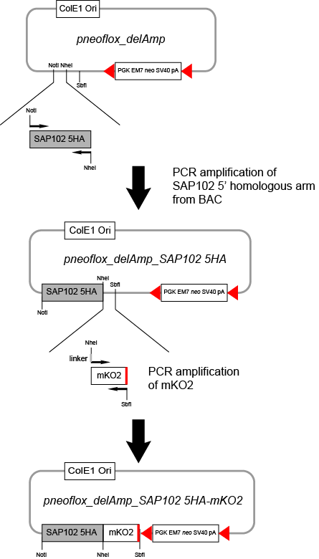
Figure 3.5 Construction of intermediate vector of pneoflox_delAmp_SAP102 5HA-mKO2. The 5’ homology arm of SAP102 gene was amplified from the BAC DNA containing wildtype SAP102 genomic sequence and assembled into pneoflox_delAmp vector after enzymatic digestions of NotI and NheI, resulting in the vector named as pneoflox_delAmp_SAP102 5HA. The sequences encoding for an artificial peptide linker as well as the mKO2 fluorescent protein were amplified by PCR and cloned into the pneoflox_delAmp_SAP102 5HA vector by NheI and SbfI digestions, generating the intermediate vector pneoflox_delAmp_SAP102 5HA-mKO2.
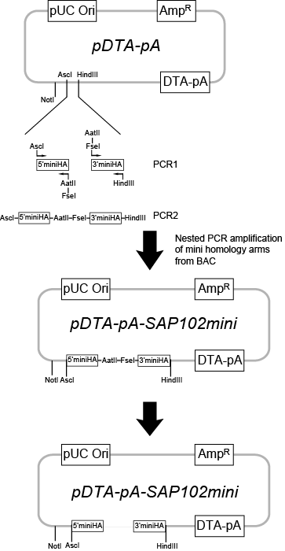
Figure 3.6 Assemble intermediate targeting vector for the retrieval of SAP102 3’ homology arm. Two ‘mini’ homology arms (5’miniHA and 3’miniHA, ~0.5 kb) from 3’ UTR region of wildtype SAP102 locus were amplified from BAC DNA by two-step nested PCR reactions. The PCR product was directionally cloned into the pDTA-pA vector by AscI and HindIII digestion, resulting in pDTA-pA-SAP102mini vector. This plasmid was then subjected to AatII and FseI digestion and the linear DNA fragment was electroporated into EL350 bacteria that contained the BAC DNA of SAP102.

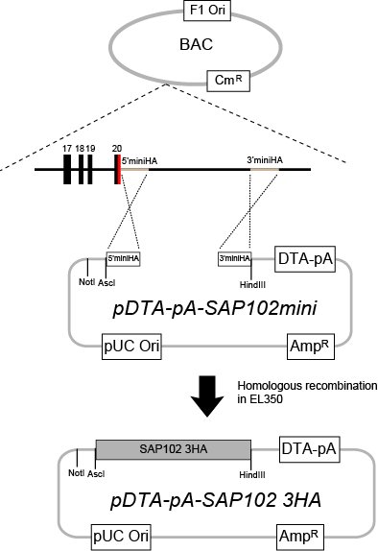
Figure 3.7 Retrieval of SAP102 3’ homology arm from BAC by gap repair. The linear DNA fragment of pDTA-pA-SAP102mini was electroporated into competent EL350 cells that contained the BAC DNA of SAP102. Followed a short incubation of transformed EL350 at 42 °C to induce the expression of recombinase Red α and β, sequence of SAP102 3’ homology arm was retrieved from BAC by gap repair, resulting in the vector pDTA-pA-SAP102 3HA.

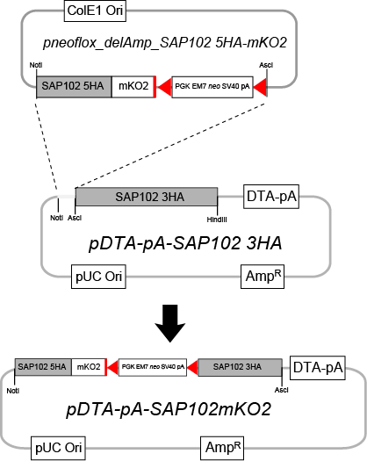

Figure 3.8 Construction of final targeting vector pDTA-pA-SAP102mKO2. The final SAP102 targeting vector pDTA-pA-SAP102mKO2 was created by ligating the NotI-AscI digested DNA fragments that consist of ‘SAP102 5HA-mKO2-Neo^{r}’ cassette from the pneoflox_delAmp plasmid with linearized pDTA-pA-SAP102 3HA vector.

PSD93-mCER
A strategy similar to the construction of SAP102-mKO2 targeting vector was applied to create PSD93-mCER vectors.

Firstly, the 5’ homology arm of PSD-93 gene (Gene ID: ENSMUSG00000052572, Chromosome 7, region: 99590927-99593128), approximately in size of 2.2 kb, was PCR amplified from its genomic sequence of BAC DNA (bMQ-296019) and inserted into pneoflox_delAmp which is followed by digestions using restriction enzymes NotI and NheI. Similar to SAP102-mKO2 fusion protein design, monomeric Cerulean blue fluorescent protein (mCER) coding sequence together with an artificial linker sequence (encoding for amino acids Gly-Gly-Gly-Ser) were PCR amplified from a commercial vector (Plasmid 15214: Cerulean, Addgene). After double enzymatic digestions with NheI and SbfI, mCER cassette was then inserted into pneoflox_delAmp-PSD93 5HA vector, resulting in pneoflox_delAmp-PSD93 5HAmCER vector (Figure 3.9), in which mCER cassette was fused immediately after the last exon of wildtype PSD-93 gene.

Next, to generate an intermediate targeting vector, two ~0.5 kb size of mini homology arms (5’miniHA and 3’miniHA, in size of 527bp and 637bp, respectively) corresponding to the 3’ UTR region of PSD-93 (ENSMUSG00000052572, Chromosome 7, region: 99593128-99598827) were PCR amplified using the genomic sequence from BAC DNA (bMQ-338M14) as template (Figure 3.10). The PCR product was cloned into pDTA-pA vector following digestions with AscI and HindIII restriction endonucleases. The resultant plasmid, pDTA-pA-PSD93mini was subjected to enzymatic double digestions with AatII and FseI to create linearlized DNA fragments, which were then electroporated into EL350 bacteria harbouring BAC DNA of PSD-93 (bMQ-338M14) for homologous recombination. As a result, the full-length 3’ homology arm of PSD-93, with a size of 5.1 kb, was retrieved from the BAC DNA, generating pDTA-pA-PSD93 3HA intermediate vector (Figure 3.11).

The final targeting vector was created by NotI and AscI digestions of both pneoflox_delAmp and pDTA-pA-PSD93 3HA vectors, releasing the PSD93 5HA-mCER-Neor cassette and its cloning into pDTA-pA-PSD93 3HA vector (Figure 3.12). All junctions and PCR-cloned genomic sequence of PSD-93, as well as the PCR-amplified coding sequence for mCER within the final targeting vector, pDTA-pA-PSD93-mCER were confirmed by sequencing.

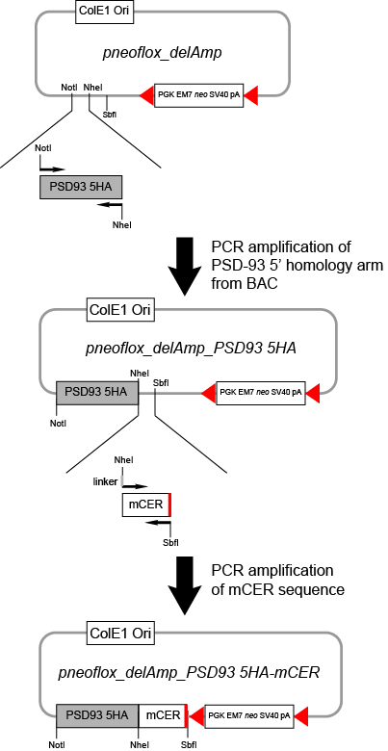
Figure 3.9 Construction of intermediate vector pneoflox_delAmp_PSD93 5HA-mCER.The 5’ homology arm of PSD-93 was PCR amplified from its corresponding genomic sequence of BAC DNA and then cloned into the pneoflox_delAmp vector after Not I and NheI digestions, resulting in pneoflox_delAmp_PSD93 5HA vector. The mCER coding sequence together with an artificial linker sequence (coding for amino acids Gly-Gly-Gly-Ser) were PCR amplified and assembled into the pneoflox_delAmp_PSD93 5HA vector by NheI and SbfI enzymatic digestions, thus generating pneoflox_delAmp_PSD93 5HA-mCER intermediate vector.

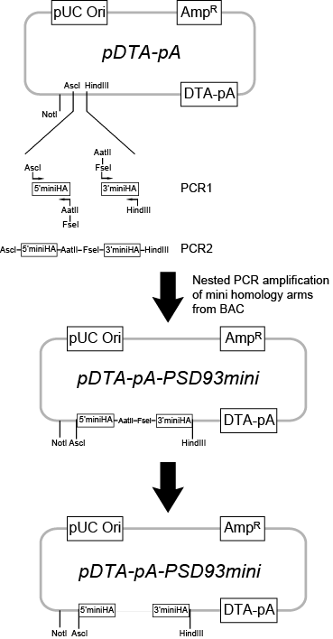
Figure 3.10 Construction of an intermediate vector of pDTA-pA-PSD93mini. Two ‘mini’ homology arms (5’miniHA and 3’miniHA, ~0.5 kb) from 3’ UTR region of PSD-93 gene were amplified from BAC DNA by two-step nested PCR reactions. The PCR product was directionally cloned into the pDTA-pA vector by AscI and HindIII digestion, resulting in pDTA-pA-PSD93mini vector. This plasmid was then subjected to AatII and FseI digestion and the linear DNA fragment was electroporated into EL350 bacteria that contained the BAC DNA of PSD93.
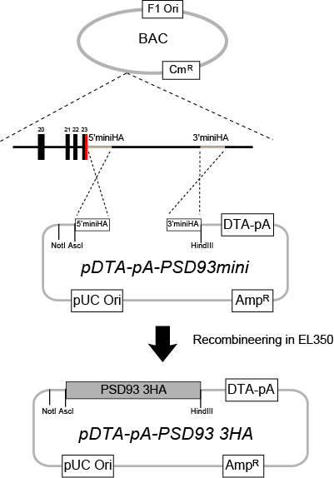
Figure 3.11 Recombineering in EL350 to retrieve 3’ homology arm of PSD-93. The linear DNA fragment of pDTA-pA-PSD93mini was electroporated into competent EL350 cells that contained the BAC DNA of PSD-93. Followed a short incubation of transformed EL350 at 42 °C to induce the expression of recombinase Red α and β, sequence of PSD-93 3’ homology arm was retrieved from BAC by gap repair, resulting in the vector pDTA-pA-PSD93 3HA.

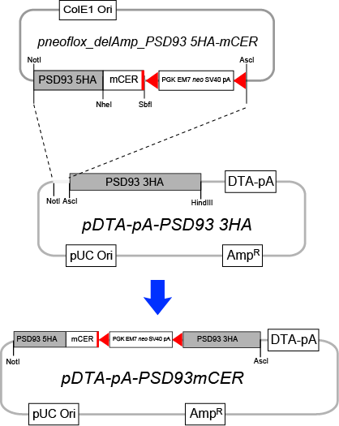
Figure 3.12 Construction of final targeting vector pDTA-pA-PSD93mCER. The final PSD93 targeting vector pDTA-pA-PSD93mCER was created by ligating the NotI-AscI digested DNA fragments that consist of ‘PSD93 5HA-mKO2-Neo^{r}’ cassette from the pneoflox_delAmp plasmid with linearized pDTA-pA-PSD93 3HA vector.

Arc-Venus
A similar design and strategy of constructing PSD95-EGFP targeting vector was applied to generate Arc-Venus vectors. A previously constructed vector, pneoflox-ArcTap (by E. Fernandes) containing Arc/Arg3.1 mini homology arms was used. These mini homology arms of Arc were PCR amplified from the genomic sequence of Arc BAC DNA (Gene ID: ENSMUSG00000022602 Chromosome 15, region: 74500995-74502425). This pneoflox-ArcTap also includes a neomycin resistance cassette, driven by a compound PGK and EM7 promoters, and followed by a mouse SV40 polyadenylation signal. As pneoflox-PSD95EGFP vector, the Neo^{r} gene cassette is also flanked by two loxP sites, which allows the Cre-mediated deletion of the selection marker.

First, the yellow fluorescent protein (YFP) variant Venus coding sequence with an artificial linker encoding for Gly-Gly-Gly-Ser at its 5’ end were amplified by PCR reactions. Following the sequential digestions with XbaI and BclI of both pneoflox-ArcTap vector and Venus PCR products, the fluorescent protein coding sequence was directionally cloned into pneoflox vector by ligation, resulting in pneoflox-ArcHA12-Venus vector (Figure 3.13).

Next, the pneoflox-ArcHA12-Venus vector was digested with XhoI and NotI to release ‘HA1-Venus-Neo^{r}-HA2’ cassette. This DNA fragment was then electroporated into EL350 competent cells that harbour the intermediate targeting vector, pTARGETER-Arc (constructed by E. Fernandes) which contains retrieved genomic sequence of Arc (Gene ID: ENSMUSG00000022602 Chromosome 15: region 74494937-74508362) (Figure 3.14). The transformed cells were incubated at 42 °C to induce the expression of recombinase and facilitate recombination between DNA fragment and the recipient plasmid. As a result, the final targeting vector pTARGETER-ArcVenus was created, in which Venus sequence is in-frame fused with the last exon of Arc/Arg3.1 gene (Figure 3.15). All junctions and genomic sequence of Arc/Arg3.1, as well as the coding sequence of Venus were confirmed by sequencing.

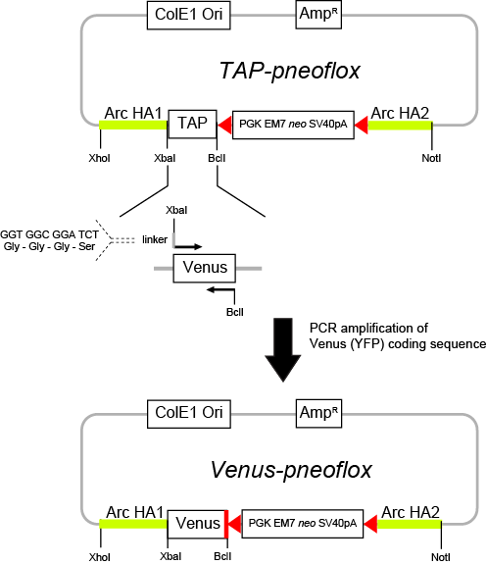
Figure 3.13 Constructing Venus--pneoflox intermediate vector. The Venus (YFP) coding sequence together with the linker sequence were amplified by PCR and inserted into the pneoflox vector, replacing the TAP coding cassette by sequential enzymatic digestions of XbaI and BclI.

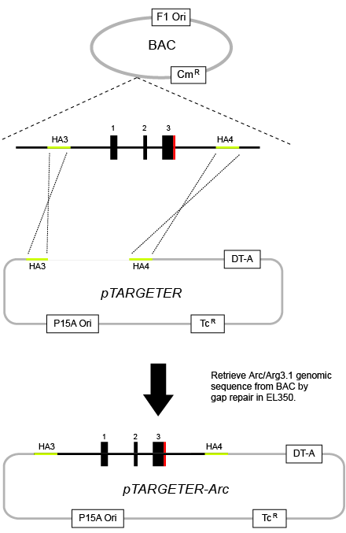
Figure 3.14 Retrieving Arc/Arg3.1 genomic sequence from BAC by gap repair and construction of intermediate pTARGETER-Arc. The intermediate pTARGETER vector carrying HA3 and HA4 homology arms was linearized and transformed into EL350 cells containing the BAC DNA of Arc. The Arc genomic sequence was retrieved by homologous recombination, resulting in the pTARGETER-Arc vector.

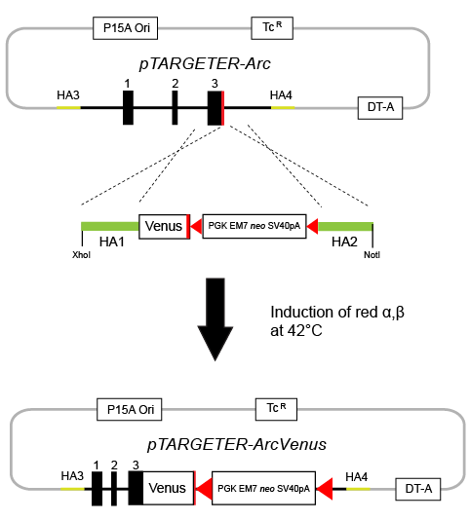
Figure 3.15 Construction of the final Arc-Venus targeting vector pTARGETER-ArcVenus. The Venus coding gene together with Neo^{r} cassette, flanked by HA1 and HA2 homology arms of Arc were excised from Venus-pneoflox vector by restriction enzyme digestions of XhoI and NotI. The DNA fragment was then transformed into EL350 cells harbouring pTARGETER-Arc as well as the encoding sequence for heat-inducible recombinase Red α and β. By homologous recombination in EL350, the HA1-Venus-Neo^{r}-HA2 cassette was assembled into the pTargeter-ARc vector, resulting in the final targeting vector pTARGETER-ArcVenus.

3.3 Gene targeting and mouse generation
The above four targeting vectors were used to target the three MAGUKs (PSD-95, PSD-93 and SAP102) and Arc/Arg3.1 gene in E14Tg2A mouse embryonic stem (ES) cells, which were originated from 129P2/OlaHsd mouse strain (Hooper, M et al., 1987). Each targeting vector was linearised by the digestion of an appropriate restriction enzyme that only recognizes and cuts at a single site on the backbone of the plasmid. One hundred microgram purified linear vector DNA was electroporated into the mouse ES cells. Targeted cells were cultured in ES media and G418 (Geneticin) incubation was usually performed for 8-10 days to select the positive ES clones that contain the Neo^{r} gene. Genomic DNA was extracted from individually picked ES cell colonies and long range PCR was applied using designed primer set to screen the correctly targeted ES clones.

Targeted ES clones were injected into C57BL/6J mouse blastocysts. Injected embryos were then transferred into the uterine horns of an appropriate scheduled pseudopregnant female recipient mouse. Coat colour percentage was determined from 10 days after birth of the chimaeras. The ES cells derived from 129 mouse strain contain genes coding for a chinchilla coat colour, whereas the recipient C57BL/6J mouse carries genes that result in a black coat colour. Moreover, the chinchilla coat colour of 129 strain is dominant to the black coat colour of C57BL/6J strain. Therefore, when 129 ES cells are injected into C57BL/6J recipient blastocyst, the resulting chimaera will present patches of coat colours comprising dark grey and black. To start to establish the transgenic mouse colony, adult male chimaeras (~8 weeks old) with 60-70% chinchilla coat colour were selected to mate with C57BL/6J wildtype mice. Coat colours of offspring from this breeding will be either dark grey when 129 ES cells contribute to chimaeras’ germline or be black when C57BL/6J recipient blastocyst contributes to the germline. To confirm the genotypes, genomic DNA was extracted from all F1 progeny ear clip and genotyping PCR was performed using designed primer set. As expected, a proportion of chinchilla F1 pups were identified as heterozygous genotype in each mouse line. About 8 weeks old F1 heterozygous male mice were selected and bred with transgenic mice expressing Cre recombinase driven by the chicken beta actin promoter/enhancer coupled with a cytomegalovirus enhancer (CAG, imported from The Jackson Laboratory, ME stock number: 4682, CAG-Cre) or the human cytomegalovirus (CMV) promoter to excise the loxP site-flanked Neo^{r} selection marker (Hayashi, S. and McMahon, AP 2002; Schwenk, F. et al., 1995). The Cre-mediated Neo^{r} cassette deletion in F2 generation was confirmed by genotyping PCR. Those F2 mice whose genotypes showed a mix partial deletion of Neo were backcrossed with C57BL/6J wildtype mice again to excise the selection marker. Those F2 or F3 heterozygotes were used as founder mice to establish the working mouse colony.

PSD95-EGFP
Two hundred and fifty eight G418 resistant ES cell colonies were picked and expanded. Genomic DNA was extracted from individually picked colonies and analyzed. To screen correctly integrated clones, long range PCR, which employed designed forward primer P1, which hybridises Neo^{r} cassette and reverse primer P6, which anneals with the genomic region of PSD-95 gene that is beyond the 3’ homology arm of the targeting vector (ENSMUSG00000020886, Chromosome 11, region: 69861278-69861299) (Figure 3.16 A). As a result, a product of 3388bp in size will be generated only if the engineered cassette correctly integrates into the PSD-95 gene locus. Two positive ES clones (AA1 and AD5) displaying the band with the expected size of ~3.4 kb were identified (Figure 3.16 B). The PCR products were further confirmed by enzymatic digestion to ensure the correctly targeted locus of PSD-95 (data not shown).

Following blastocyst injection and chimaera generation, F1 progeny was genotyped by PCR using primer set P2, P3 and P5 (Figure 3.16 A). Primer P2 was designed to anneal with Neo^{r} cassette, whereas P3 was designed to hybridize to the last exon of PSD-95 gene (ENSMUSG00000020886, Chromosome 11, region:69858129-69858150). A reverse primer P5 hybridises to the 3’UTR region that is immediately after Neo^{r} cassette (ENSMUSG00000020886, Chromosome 11, region: 69858273-69858294). As a result, the wildtype allele will give rise to a product of 184bp, whereas the mutant allele will generate a 268bp product (Figure 3.16 C). Those chinchilla F1 pups that were genotyped to have both product bands (184 bp and 268 bp) were considered as successful germline transmitted heterozygotes. To remove the Neo^{r} cassette, the heterozygous PSD-95 ^{EGFP/+} mice were bred with Cre recombinase expressing transgenic mice, driven by CMV or CAG promoter. The F2 progeny of this mating was genotyped by two PCR reactions. The first PCR reaction utilises primer set P2, P3 and P5 in order to detect any presence of Neo^{r} marker. The second PCR reaction was performed using primer set P4 and P5. Primer P4 is designed to hybridise to EGFP coding sequence. Therefore, in the absence of Neo^{r} gene, a PCR product of 377bp will be produced. Those mice that were genotyped and displayed only a wildtype band (184bp) and an EGFP band (377bp) were considered as heterozygotes with complete removal of Neo^{r} gene (data not shown).

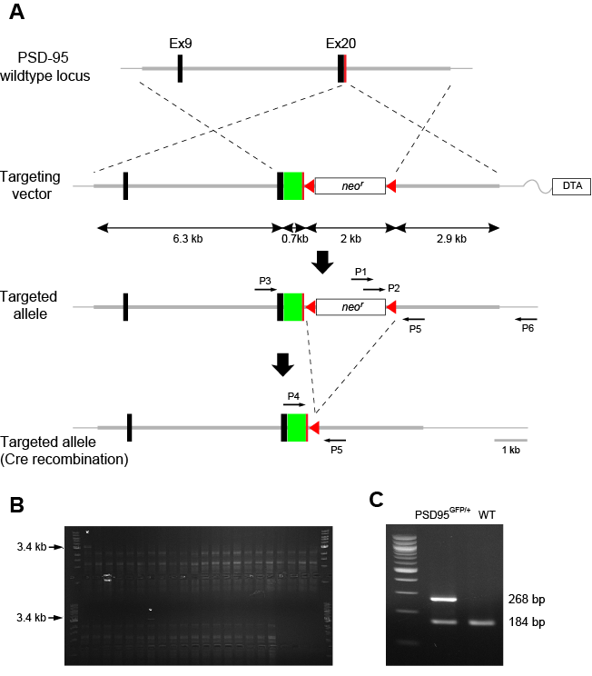
Figure 3.16 A) Schematic illustrations of the targeted genomic PSD-95 locus. The PSD-95 allele was targeted with the EGFP sequence inserted into its open reading frame and before its stop codon by homologous recombination. Recombination events are shown by dashed lines. neo^{r}: neomycin-resistance gene; DTA: diphtheria toxin gene. B) Example of long-range PCR screening results of correctly targeted ES clones (asterisk) using primers P1 and P6. C) Example of genotyping PCR results of genomic DNAs from PSD-95^{EGFP/+} and wildtype mice, using primers P2, P3 and P5.

SAP102-mKO2
About two hundred Geneticin-resistant ES colonies were individually picked and expanded until each clone reached a confluent growth in 48-well plate. Genomic DNA extracted from these colonies was subjected to a long range PCR for the screening of correctly targeted clones. A forward primer P1 was designed to hybridize to the genomic sequence of SAP102 that is beyond the 5’ homology arm of targeting vector (ENSMUSG00000000881, Chromosome X, region: 98009344-98009365). A reverse primer P4 was designed to anneal with the coding region of mKO2 (Figure 3.17 A). As a result, a product of 2551bp will be amplified only if the engineered cassette correctly integrates into the SAP102 gene locus (Figure 3.17 B). Four positive clones were identified by the long range PCR reaction and further confirmed by enzymatic digestion of the products as well as their full-length sequencing (data not shown).

After blastocyst injection with two positive ES clones (clone ID: BC8 and FD3), 9 chimaeric mice with high percentage (40% - 80%) of albino/chinchilla coat colours were generated. The F1 progeny mice were ear-clipped and tissue samples were then subjected to a genotyping PCR utilizing designed primer set P2, P6 and P5 to determine any individuals carrying germline transmission (Figure 3.17 A). Primer P2 was designed to hybridize to the Neo^{r} cassette, whereas primer P6 was designed to anneal with the last exon of SAP102 gene (ENSMUSG00000000881, Chromosome X, region:98011459-98011480). Similar to PSD95-EGFP genotyping strategy, a reverse primer P5 hybridises to the 3’UTR region of SAP102 gene that is immediately after Neo^{r} cassette (ENSMUSG00000000881, Chromosome X, region:98011753-98011777). As a result, the wildtype allele will give rise to a PCR product of 312 bp in size, whereas the mutant allele will generate a product of 192bp. Those chinchilla F1 pups that were genotyped to have both products (312bp and 192bp) were indentified as successful germline transmitted heterozygotes (Figure 3.17 C). F1 heterozygous SAP102^{mKO2/+} adult mice were further bred with the Cre recombinase expressing transgenic mice to remove Neo^{r} cassette. The progeny of this breeding was genotyped by two separate PCR reactions using designed primer set P2 and P5, P3 and P5, to identify the presence or absence of Neo^{r} cassette respectively. As shown in Figure 3.16A, primer P3 was designed to anneal with mKO2 coding sequence and primer P2 hybridises to the Neo^{r} cassette. Therefore, in the absence of Neo^{r} gene, only a 279bp product will be amplified from genotyping PCR (data not shown).

Further confirmation of SAP102-mKO2 fusion protein expression by western blot, however, needs to be carried out in the future.

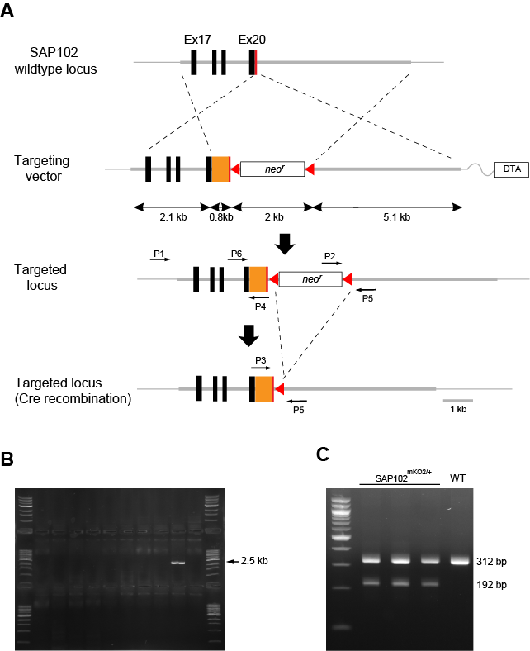
Figure 3.17 A) Schematic illustrations of the targeted genomic SAP102 locus. The SAP102 allele was targeted with the mKO2 sequence inserted into its open reading frame and before its stop codon by homologous recombination. Recombination events are represented by dashed lines. neo^{r}: neomycin-resistance gene; DTA: diphtheria toxin gene. B) Example of long-range PCR screening results of correctly targeted ES clones using primers P1 and P4. C) Example of genotyping PCR results of genomic DNAs from SAP102^{mKO2/+} and wildtype mice, using primers P2, P5 and P6

PSD93-mCER
Approximately two hundred G418 resistant ES cell colonies were carefully picked and expanded. Genomic DNA was extracted from each individual clone and analyzed by long range PCR to determine correctly targeted clones. A similar design rationale to the screening SAP102-mKO2 targeted ES clones was employed. A forward primer P1 was designed to hybridize to the genomic sequence of PSD-93 that is beyond the 5’ homology arm of targeting vector (ENSMUSG00000052572, Chromosome 7, region: 99590866-99590890). A reverse primer P4 was designed to anneal with the coding region of mCER cassette (Figure 3.18 A). The correctly targeted ES clones therefore should give rise to a PCR product of 2.3kb in size, whereas no amplification product should be generated from the un-targeted wildtype clones. As a result, two positive clones were identified by the long range PCR reaction (Figure 3.18 B) and further confirmed by enzymatic digestion of the products as well as their full-length sequencing (data not shown).

Two correctly targeted PSD93-mCER ES clones (clone ID: 4B2 and 5A6) were then subjected to blastocyst injection and chimaeric mice generation. The F1 progeny pups derived from two chimaeric mice, which displayed 40%-60% chinchilla coat colour, were genotyped to determine germline transmission. Similar to SAP102-mKO2 genotyping strategy, a primer set comprising an internal primer P2, hybridizing to the Neo^{r} cassette, and an external primer P5, annealing with the 3’UTR region that is immediately after Neo^{r} cassette (ENSMUSG00000052572, Chromosome 7, region: 99593152-99593176) was designed and utilized. Therefore the mutant allele carrying the Neo^{r} gene should give rise to a PCR product in size of 126bp, while no PCR product should be generated from the wildtype allele (Figure 3.18 C, left panel). Those F1 pups that were genotyped to present the 126bp product were considered as germline transmitted heterozygotes. F1 heterozygous PSD-93^{mCER/+} mice were further bred with Cre-recombinase expressing transgenic mice to remove the Neo^{r} cassette. The offsprings of this breeding were genotyped by two separate PCR reactions using designed primer set P2 and P5, P3 and P5, to identify the presence of Neo^{r} or mCER coding sequence, respectively. As shown in Figure 3.17A, primer P3 was designed to anneal with mCER coding sequence and primer P2 hybridises to the Neo^{r} cassette. Therefore, upon the complete removal of Neo^{r} gene, a 215bp product will be amplified from genotyping PCR. (Figure 3.18 C, right panel)

Further confirmation of PSD93-mCER fusion protein expression by western blotting needs to be carried out in the future.

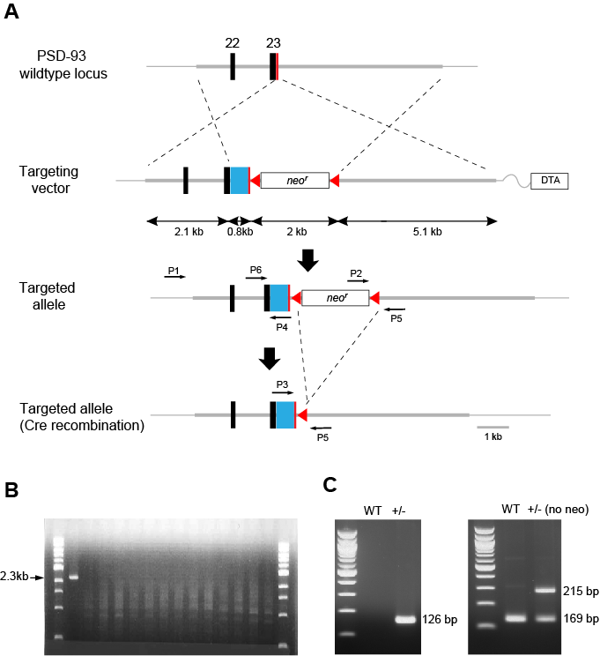
Figure 3.18 A) Schematic illustrations of the targeted genomic PSD-93 locus. The PSD-93 allele was targeted with the mCER sequence inserted into its open reading frame and before its stop codon by homologous recombination. Recombination events are represented by dashed lines. neo^{r}: neomycin-resistance gene; DTA: diphtheria toxin gene. B) Example of long-range PCR screening results of correctly targeted ES clones using primers P1 and P4. C) Example of genotyping PCR results of genomic DNAs from PSD-93^{mCER/+} (carrying the neo^{r} gene) and wildtype mice using primers P2 and P5, as well as PSD-93^{mCER/+} (after removing the neo^{r} gene) mice using primers P3, P5 and P6.

Arc-Venus
Genomic DNA extracted from ~200 individually picked G418-resistant ES clones was analyzed by long range PCR. A forward primer (internal primer P1) was designed to hybridize to the Neo cassette, a reverse primer (external primer P6) was designed to anneal with the genomic region of Arc/Arg3.1 gene that is beyond the 3’ homology arm of the targeting vector (ENSMUSG00000022602, Chromosome 15, region: 74497407-74497431) (Figure 3.19 A). Therefore, a product of 4625 bp in size will be generated only if the engineered cassette correctly integrates into the Arc gene locus. Eleven positive clones were identified by the long range PCR (Figure 3.19 B) and further confirmed by the enzymatic digestion of these PCR products (data not shown).

Blastocyst injections were carried out using two correctly targeted Arc-Venus ES clones (clone ID: DD4 and EB4). Two chimaeric mice with high percentage (40%-60%) chinchilla/albino colours were generated. The F1 progeny pups of these chimaeric mice were genotyped to determine germline transmission utilizing a designed primer set P2, P3 and P5 (Figure 3.19 A). A forward primer P2 was designed to hybridize to the Neo^{r} cassette, while a second forward primer P3 was designed to hybridize to the last exon of Arc gene (ENSMUSG00000022602, Chromosome 15, region: 74501632-74501656). A reverse primer P5 was designed to anneal with the 3’UTR region that is immediately after the Neo^{r} cassette (ENSMUSG00000022602, Chromosome 15, region: 74501515-74501539). As a result, the mutant allele carrying the Neo^{r} gene should give rise to a PCR product in size of 337 bp, whereas the wildtype allele should generate a product with a size of 261 bp from the genotyping PCR. Those F1 pups which showed the presence of both products (337 bp and 261 bp) were considered as successful germline transmitted heterozygous mice (Figure 3.19 C, left panel). F1 heterozygous Arc^{Venus/+} adult mice were bred with Cre-recombinase expressing transgenic mice to remove the Neo^{r} cassette. The progeny of this breeding were firstly genotyped by a PCR reaction using designed primers P2 and P5, to determine the presence or absence of Neo^{r} cassette. Upon a complete removal of Neo^{r} gene, no PCR product should be generated (data now shown). Those genomic DNA samples showing the absence of Neo^{r} gene were then subjected to a second genotyping PCR using designed primers P4 and P5. The forward primer P4 was designed to hybridize to Venus coding sequence. As a result, the mutant allele with a complete removal of Neo^{r} gene will give rise to a product of 358 bp (Figure 3.19 C, right panel).

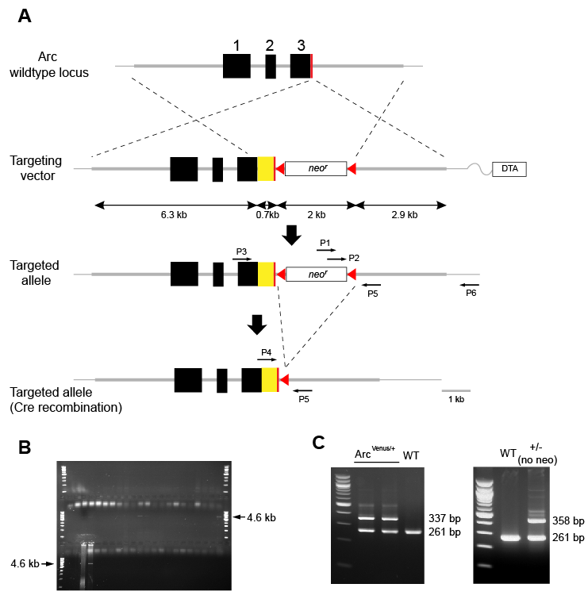
Figure 3.19 A) Schematic illustrations of the targeted genomic Arc locus. The Arc allele was targeted with the Venus (YFP) sequence inserted into its open reading frame and before its stop codon by homologous recombination. Recombination events are shown by dashed lines. neo^{r}: neomycin-resistance gene; DTA: diphtheria toxin gene. B) Example of long-range PCR screening results of correctly targeted ES clones (asterisk) using primers P1 and P6. C) Example of genotyping PCR results of genomic DNAs from Arc^{Venus/+} that carry neo cassette and wildtype mice, using primers P2, P3 and P5, as well as Arc^{Venus/+} mice (after removing neo cassette) using primers P3, P4 and P5.

1. Komiyama, N.H. et al. SynGAP regulates ERK/MAPK signaling, synaptic plasticity, and learning in the complex with postsynaptic density 95 and NMDA receptor. J Neurosci 22, 9721-9732 (2002).
2. Migaud, M. et al. Enhanced long-term potentiation and impaired learning in mice with mutant postsynaptic density-95 protein. Nature 396, 433-439 (1998).
3. Mansour, S.L., Thomas, K.R., Deng, C.X. & Capecchi, M.R. Introduction of a lacZ reporter gene into the mouse int-2 locus by homologous recombination. Proc Natl Acad Sci U S A 87, 7688-7692 (1990).

