Chapter 5 Characterization of SAP102-mKO2 mice
A second strain of knockin mouse line termed as SAP102-mKO2 mouse was generated, in which the red fluorescent protein-coding gene monomeric Kusabira Orange 2 (mKO2) was inserted in-frame to the 3’ end of wildtype SAP102 locus. Previous studies have shown that SAP102 is highly expressed in both young and adult forebrains and like PSD-95, it is also enriched at the PSD in excitatory synapses (Fukaya, M. and Watanabe, M., 2000; Sans, N. et al., 2000; Zheng C-Y. et al., 2010).

In this chapter, I first described the characterization and validation of SAP102-mKO2 mutant mice by examining the anatomical distribution of endogenous SAP102 protein fused with mKO2 in the adult mouse forebrain, followed by double-immunofluorescence staining experiments on the mutant mice brain slices using different neuronal markers including MAP2 and VGluT1 antibodies. Lastly, a brief examination by confocal fluorescence microcopy on a PSD-95^{EGFP/+}/SAP102^{mKO2/Y} compound mutant mouse was carried out to compare the in vivo subcellular distributions of these two MAGUK members (PSD95-eGFP and SAP102-mKO2) in the forebrain slices.

5.1 Overall distribution of SAP102-mKO2 in the mouse brain
A knock-in mouse line expressing SAP102-mKO2 fusion gene in place of wildtype SAP102 gene was generated as described in Chapter 3. The F1 heterozygous mice carrying the loxP-Neo^{r}-loxP cassette were further mated with CMV-Cre mice that carry Cre recombinase to remove the neomycin selection marker. The homozygous/hemizygous and heterozygous SAP102-mKO2 mice are viable, fertile and display normal development, body weight, life span and normal behaviour (data not shown).

Figure 5.1 shows a direct fluorescence image demonstrating an overview of the forebrain of an adult SAP102^{mKO2/Y} hemizygous knock-in mouse. The SAP102^{mKO2/Y} mutant brain tissue showed normal brain anatomical structure and exhibited bright red fluorescence, whereas only weak fluorescence was observed from the wildtype brain slice (Figure 5.1 inset). Many brain regions such as cerebral cortex, hippocampus, thalamus, hypothalamus and caudate-putamen all displayed bright red fluorescence signals. Notably, intense mKO2 fluorescence was detected in various subregions of the hippocampus, in particular the dentate gyrus.

Magnified images in Figure 5.1 showed that the red fluorescence of SAP102-mKO2 was highly concentrated within the dendritic layers of each subregions of the hippocampus, although some weak fluorescent signals were also detected in the pyramidal cell body layers (Figure 5.2A). Additionally, different from the distinctive subregional distribution patterns of PSD95-eGFP, the SAP102-mKO2 fluorescence in the hippocampus was homogenously distributed throughout CA1 to CA3 area with a suggestive slight increase fluorescence in the CA2 area. However, the molecular layer of dentate gyrus showed the most intense SAP102-mKO2 fluorescence (Figure 5.2 A).

Immunocytochemical and ultrastructural studies have shown that SAP102 is concentrated at the PSD as well as in neuronal processes such as dendrites and axons (Fukaya, M. and Watanabe, M., 2000; Sans, N. et al., 2000; Zheng C-Y. et al., 2010). To examine in more detail the distribution of SAP102-mKO2 fluorescent fusion protein in the knockin mice, fixed forebrain slices from SAP102^{mKO2/Y} knockin mice were examined by direct fluorescence using confocal microscopy. As shown in Figure 5.3, SAP102-mKO2 red fluorescence in the cortex, CA1 and CA3 regions appeared as bright, tiny punctate structures with weak diffuse fluorescence also detected in the neuropil (Figure 5.3 B). The SAP102-mKO2 fluorescent signal within the soma was very low, showing the dark cell body silhouettes in contrast with the surrounding fusion protein fluorescence. Specifically, in the cortex and CA3 area of the hippocampus, the majority of SAP102-mKO2 fluorescence presented in the form of discrete tiny puncta, whereas in the CA1 area, some weak diffuse fluorescence was also detected inside neural processes. These observations are in line with immunostaining for this protein using an anti-SAP102 antibody staining (Figure 4.13) and suggest that SAP102-mKO2 may localize to synaptic sties.

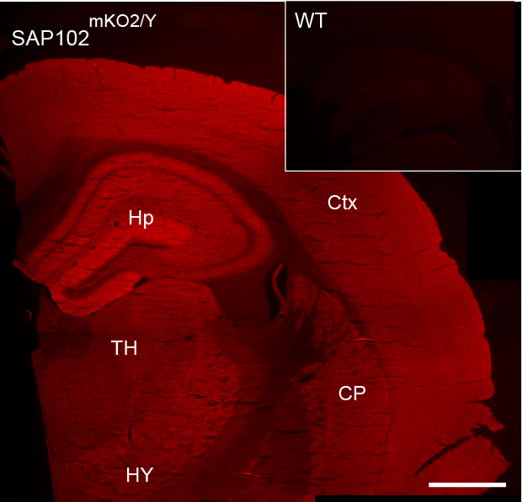
Figure 5.1 Overall distribution of SAP102-mKO2 fusion protein in the hemizygous mutant mouse. Low magnification of direct fluorescent micrograph montage demonstrates the general distribution of SAP102-mKO2 fusion protein in the adult SAP102^{mKO2/Y} mutant mice. Various brain regions are indicated (see abbreviations). Inset shows lack of red fluorescence in a wildtype mouse hippocampus. Note the strong mKO2 red fluorescence is detected in the forebrain including the cortex, hippocampus and striatum. Abbreviations: Hp, hippocampus; Cx, cerebral cortex; TH, thalamus; HY, hypothalamus; CP, caudate-putamen (striatum). Scale bar: 1mm

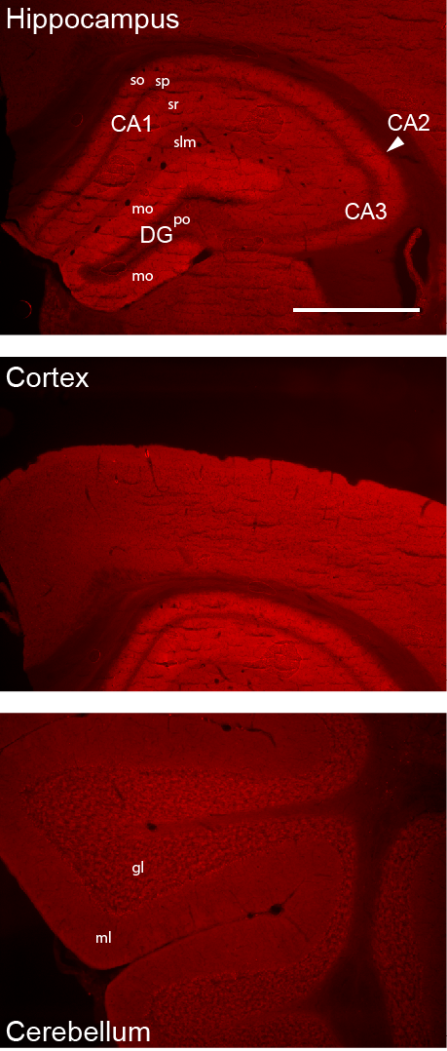
Figure 5.2 Low magnification fluorescence images of various brain regions of SAP102^{mKO2/Y} hemizygous mutant mouse. Abbreviations: so, stratum oriens; sr, stratum radiatum; slm, stratum lacunosum moleculare; sp, pyramidal cell layer; po, polymorphic layer; gl, granule cell layer; ml, molecular layer. Scale bar: 1mm.

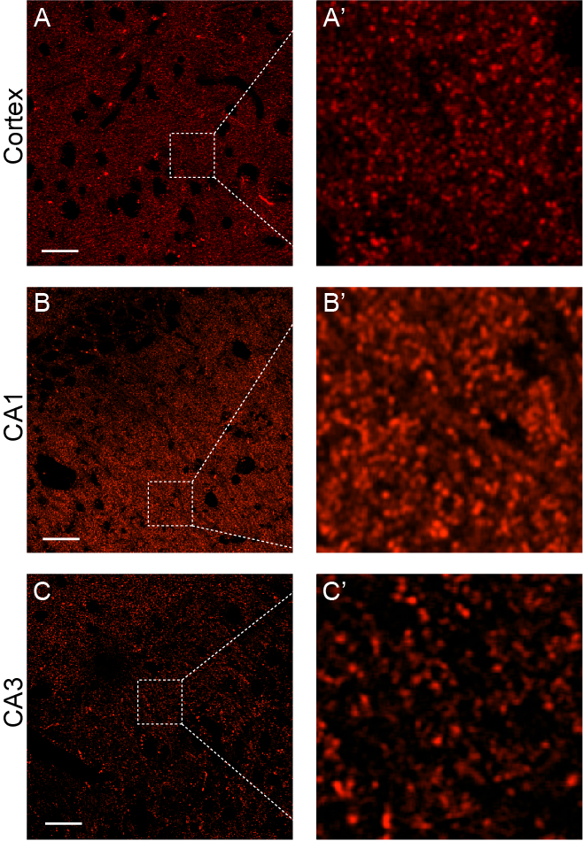
Figure 5.3 High magnification fluorescence confocal images of forebrain slices in SAP102^{mKO2/Y} mouse. Direct red fluorescence of SAP102-mKO2 in the cortex, CA1 and CA3 regions appeared as bright, tiny punctate structures with weak diffuse fluorescence also detected in the neuropil. Scale bar: 20 μm.

5.2 Postsynaptic localization of SAP102-mKO2 in mutant mouse brain.
Mounting evidence has shown that SAP102 is highly enriched at the PSD (Sans N. et al., 2000; Zheng CY et al., 2010). The direct fluorescence data so far has also shown that majority of the SAP102-mKO2 fluorescence appears as discrete puncta in the mouse brain, therefore, it might be expected that these mKO2-positive puncta localize to the postsynaptic sites of excitatory synapses.

To confirm the subcellular distributions of the SAP102-mKO2 fusion protein, immunofluorescence staining experiments were performed on fixed brain slices of an adult SAP102^{mKO2/Y} mutant mice. Mutant brain tissue was fixed by 4% PFA and sectioned into coronal or parasagittal slices. Similar to PSD-95, a large amount of SAP102 has also previously been reported to be located in the excitatory PSD (Zheng, C. and Petralia, R.S. et al., 2011). Therefore, antibodies against VGluT1 or MAP2 were used to label the excitatory presynaptic terminals or neural dendritic processes, respectively. The SAP102-mKO2 fusion protein was visualized by direct red fluorescence.

As shown in Figure 5.4, confocal fluorescence images of the CA1 area revealed that SAP102-mKO2 fluorescence was observed as intense, densely packed puncta discontinuously located along the MAP2-immunoreactive neuropil processes (Figure 5.4 B). Moreover, most of the mKO2-positive puncta were located in close opposition to VGluT1-immunoreactive puncta (Figure 5.4 A).

Taken together, these results demonstrate that SAP102-mKO2 is localized to the postsynaptic sites of excitatory synapses, suggesting that the fluorescent fusion protein labels bona fide SAP102-containing synapses.

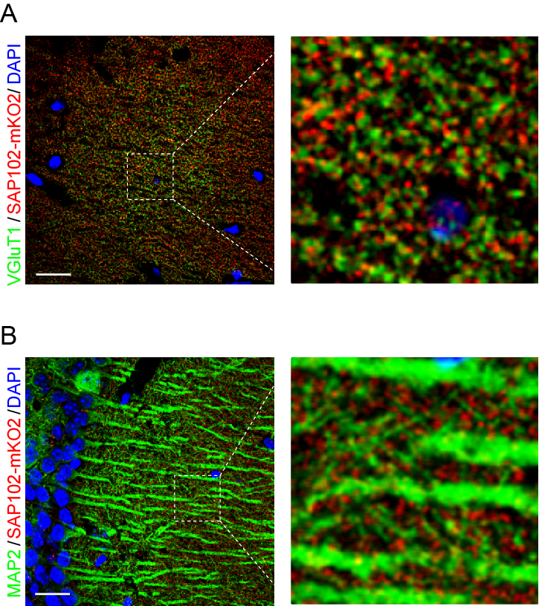
Figure 5.4 Triple fluorescence confocal images of forebrain slices of SAP102^{mKO2/Y} mutant mouse. (A) Confocal images of immunofluorescence staining with VGluT1 antibody (in green) combined with direct fluorescence of SAP102-mKO2 (in red) in the CA1 region of the hippocampus. The cell nuclei were counterstained by DAPI (in blue). (B) Immunofluorescence staining with MAP2 antibody (in green) combined with direct fluorescence of SAP102-mKO2 (in red) in the CA1 region of the hippocampus. The cell nuclei were counterstained by DAPI (in blue). Scale bar: 20 μm.

5.3 Expression of SAP102-mKO2 and glutamatergic receptors in the mouse brain
Previous biochemical analysis has shown that the three MAGUK family members (PSD-95, PSD-93 and SAP102) are all capable of direct binding to the NMDA receptor GluN2 (NR2) subunits. Several lines of evidence also imply that there seems to be a binding preference between SAP102 and GluN2B (NR2B), and between PSD-95/PSD-93 and GluN2A(NR2A) (Sans, N. et al., 2000). However, immunofluoresence staining of GluN2A in PSD-95^{EGFP/EGFP} mutant mice showed that only a small fraction of GluN2A-immunoreactive (IR) puncta were colocalized with PSD95-eGFP positive puncta in the hippocampus (see Figure 4.10, Chapter 4). This finding raised the question of whether there are other members of the MAGUK family of proteins besides PSD-95 that are closely associated with GluN2A puncta in the mouse hippocampus.

To examine this, double immunofluorescence staining experiments were performed on parasagittal sections of adult SAP102^{mKO2/Y} mice hippocampus. An antibody raised against the GluN2A subunit was used. The SAP102-mKO2 fusion protein was visualized by direct red fluorescence. As shown in Figure 5.5A, low-power light microscopy revealed a distinctive overall distribution pattern of GluN2A and SAP102-mKO2 fluorescence in various subregions of the hippocampus. Consistent with previous immunolabelling results, GluN2A immunoreactivity was detected in the dendritic layers of all hippocampal subregions and was particularly prominent in the CA1 area (Watanabe M. et al., 1998). In comparison, SAP102-mKO2 expression showed greatest fluorescence levels in the dentate gyrus, and relatively lower fluorescence intensity in the CA1 and CA3 area. As a result, these differential distribution patterns gave a merged color spectrum which was most green in the CA1 subregion (indicative of greater GluN2A expression) to relatively most red in the dentate gyrus area (suggestive of higher SAP102 expression) (Figure 5.5A).

Confocal fluorescence images were acquired to examine in more detail the subcellular expression patterns of SAP102-mKO2 and GluN2A. As shown in Figure 5.5B, the majority of SAP102-mKO2 fluorescence and GluN2A-IR was detected as densely packed punctate structures in the dendritic layer of CA1 pyramidal cells. Interestingly, comparison of SAP102-mKO2 and GluN2A-positive puncta in the overlay image showed that a substantial population of SAP102-mKO2 punta colocalized with GluN2A-IR puncta.

Taken together, these results clearly show that in the hippocampus, a proportion of GluN2A-immunolabelled puncta are also colocalized with SAP102-mKO2 positive puncta, which would be consistent with a substantial association between SAP102 and GluN2A in the mouse hippocampus.

Additional quantitative analysis to precisely measure the overlap between the expression of the different individual MAGUKs and GluN2A is needed in the future. An alternative experimental plan is to perform GluN2A immunostainings in PSD-95^{EGFP/EGFP}/SAP102 ^{mKO2/mKO2} double knockin mice. Direct comparison of the colocalization between PSD95-eGFP/SAP102-mKO2 and GluN2A will provide important clues for the binding preference of different MAGUKs and NMDA receptor GluN2 subunits, thus it may provide insight into the differing functional roles of these molecules within particular brain regions.

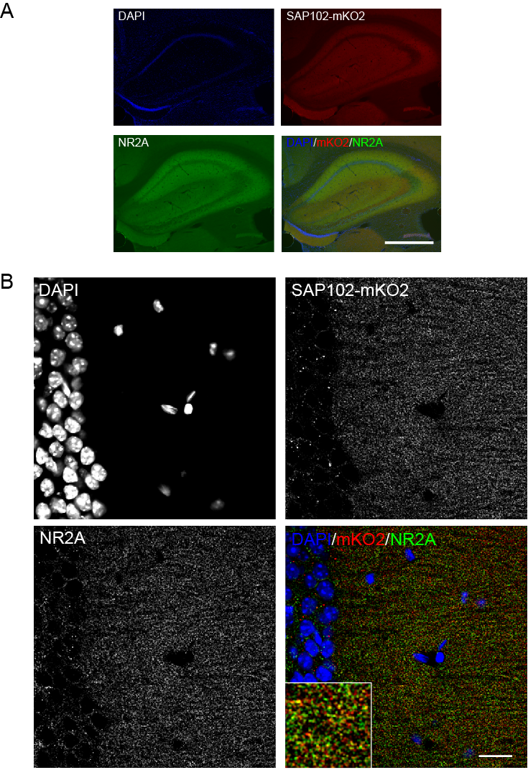
Figure 5.5 Fluorescence confocal images of hippocampal slices from SAP102^{mKO2/Y} mice. SAP102-mKO2 protein was visualized by direct red fluorescence (in red); NMDA receptor GluN2A(NR2A) subunit was immuno-labelled by a specific monoclonal antibody (in green); cell nuclei were counterstained by DAPI (in blue). A) Low magnification triple fluorescence images of the hippocampus of SAP102^{mKO2/Y} mice. B) A representative confocal fluorescence image of the CA1 region in SAP102^{mKO2/Y} mice. Scale bar: A) 0.5mm, B) 20 μm.
5.4 Distribution of PSD95-eGFP and SAP102-mKO2 in the PSD-95^{EGFP/+}/SAP102^{mKO2/Y} double mutant mouse brain.

Based on the validation results attained from the single PSD-95^{EGFP/EGFP} and SAP102^{mKO2/Y} knockin mice lines, I carried on to generate a line of double knockin mice by crossing the PSD-95^{EGFP/EGFP} with SAP102^{mKO2/+} mice. The F1 progeny mice are viable and fertile without any apparent phenotypic abnormalities.

First, to examine the overall distribution of the two genetically labeled MAGUKs, fixed brain tissues derived from a young adult (6 weeks-old) PSD-95^{EGFP/+}/SAP102^{mKO2/Y} mouse were sectioned into parasagittal slices. Both PSD95-eGFP and SAP102-mKO2 was detectable by direct green or red fluorescence, respectively (Figure 5.6). Consistent with previous results (Figure 4.3 and Figure 4.14), PSD95-eGFP and SAP102-mKO2 fluorescence were prominent in the forebrain including the cortex and hippocampus (Figure 5.6 A and B), with relatively weaker fluorescence in the cerebellum (Figure 5.6 C). As expected, differences in the general distribution pattern of PSD95-eGFP and SAP102-mKO2 in hippocampus was also observed: the CA1 area was strongly labeled by PSD95-eGFP and relatively weaker by SAP102-mKO2, whereas more abundant SAP102-mKO2 expression was found in the dentate gyrus as well as a suggestive increase in mKO2 fluorescence intensity in the CA2 area. As a result, the merged fluorescence micrograph showed a color spectrum changing from a dominantly green CA1 subregion to a predominantly red CA2 and dentate gyrus area (Figure 5.6 B).

The differential overall distribution pattern of PSD95-eGFP and SAP102-mKO2 fusion proteins raised two possibilities: this may reflect the different expression levels of both PSD95-eGFP and SAP102-mKO2 at the same synapse, or alternatively, such differential distribution could be due to different populations of individual synapses that largely express only one or other of PSD95-eGFP and SAP102-mKO2. To address this issue, I further examined the in vivo subcellular distribution patterns of PSD95-eGFP and SAP102-mKO2 puncta in the mouse forebrain by high magnification confocal fluorescence analysis. As shown in Figure 5.7, both eGFP and mKO2 fluorescence was present as small, discrete punctate structures in the cortex and hippocampus. In the cortex, it was found that the majority of PSD95-eGFP positive puncta were colocalized with SAP102-mKO2 positive puncta, with only few puncta displaying either eGFP or mKO2 fluorescence (Figure 5.7 A right panel). Interestingly, in various subregions of the hippocampus, a dissociation of PSD95-eGFP and SAP102-mKO2 expressing synapses was found: only a small fraction of PSD95-eGFP positive puncta were colocalized with SAP102-mKO2 labeled puncta in the CA1, CA2 and dentate gyrus. Furthermore, PSD95-eGFP expressing puncta were more prominent in the CA1 with decreased numbers in the dentate gyrus, whereas the SAP102-mKO2 positive puncta were most abundantly expressed in the dendtate gyrus with relatively fewer numbers of mKO2 positive puncta in the CA1 area (Figure 5.7 B, C and D, right panels).

Taken together, these data show that SAP102-mKO2 is localized on the postsynaptic side of excitatory synapses, suggesting that the fluorescent fusion protein faithfully represents the subcellular distribution of endogenous SAP102 gene expression. Double immunofluorescence staining experiments on SAP102^{mKO2/Y} hippocampal slices using a GluN2A antibody showed that a subpopulation of SAP102-mKO2 positive puncta were colocalized with GluN2A-IR puncta, suggesting that association between SAP102 and GluN2A also occurs in a group of CA1 synapses. Finally, high magnification fluorescence images of PSD-95^{EGFP/+}/SAP102^{mKO2/Y} double mutant knockin mice revealed that only a small fraction of PSD95-eGFP positive puncta were colocalized with SAP102-mKO2 labeled puncta. This result is consistent with my previous findings using antibodies for immunostainings, showing that instead of a mixture of different MAGUKs being expressed at single synapses, there were substantially different subsets of synapse populations that only express a single MAGUK member. Thus these data strongly suggest that a high degree of molecular diversity of these two PSD-MAGUK proteins (PSD-95 and SAP102) exists in the adult hippocampus.
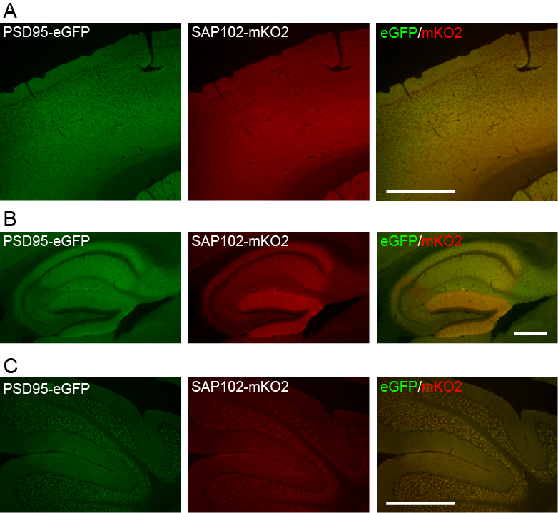
Figure 5.6 Low magnification fluorescence images of brain slices of PSD-95^{EGFP/+}/SAP102^{mKO2/Y} double mutant mice. A) Images of cerebral cortex. B) Images of hippocampus. C) Images of cerebellum. Scale bar: A and C) 0.5mm, B) 250 μm.

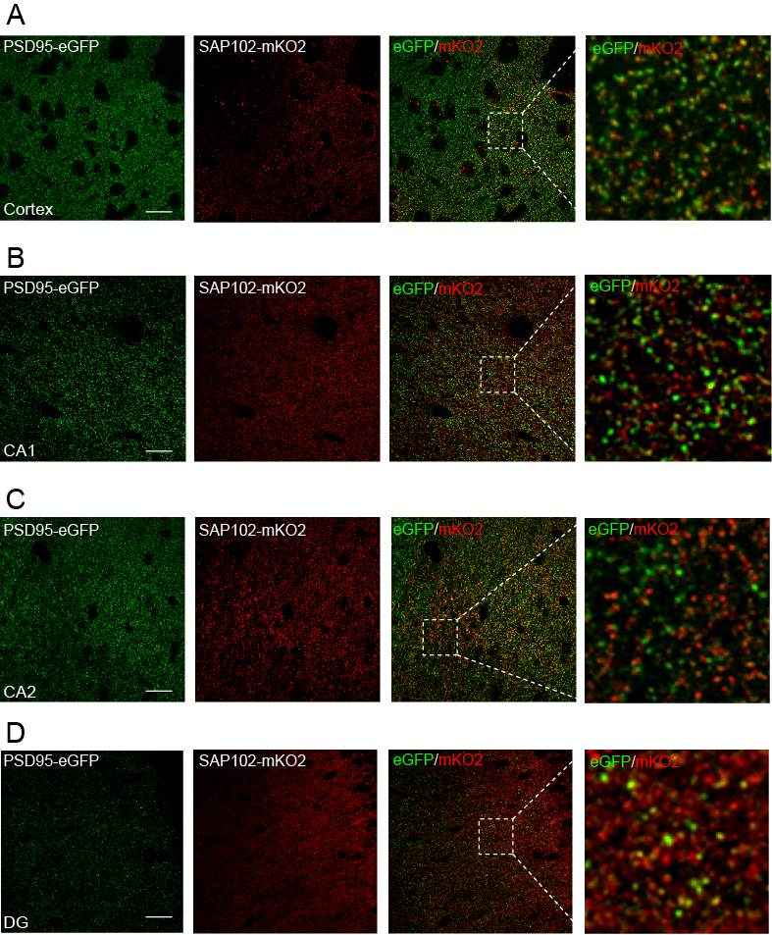
Figure 5.7 High magnification fluorescence images of forebrain slices of PSD-95^{EGFP/+}/SAP102^{mKO2/Y} double mutant mice. PSD95-eGFP (in green) and SAP102-mKO2 (in red) proteins were detected by direct fluorescence. A) Images of cortex. B) Images of CA1 area of hippocampus. C) Images of CA2 area of hippocampus. D) Images of dentate gyrus (DG) of hippocampus. Scale bar: 20 μm.

