Chapter 6 Characterization of Arc-Venus knockin mouse
Previous studies reported that the Arc/Arg3.1 gene is translated at low levels under basal conditions, whereas its expression level was greatly elevated following a variety of behavioral or pharmacological stimulations (Ramirez-Amaya et al., 2005). In this chapter, I report the generation and basic characterization of a strain of knockin mouse line, termed as Arc-Venus, in which a YFP variant Venus fluorescent protein coding sequence was fused in-frame with the last exon of Arc/Arg3.1 gene. Direct fluorescence microscopy was applied to examine the basal expression levels of Arc-Venus protein as well as its induction in response to a pharmacological stimulus.

6.1 Baseline expression of Arc-Venus in the mutant mice brains
A knock-in mouse line expressing an Arc-Venus fusion protein in place of wildtype Arc/Arg3.1 gene was created as described in chapter 3. The F1 heterozygous mice carrying the loxP-Neo^{r}-loxP cassette were further mated with CMV-Cre mice that carry cre recombinase to remove the neomycin selection marker. The homozygous and heterozygous Arc-Venus mice are viable, fertile and display normal development, body weight, life span and behaviour (data not shown). Furthermore, electrophysiological tests on the homozygous mutants did not detect any significant difference compared with the wildtype littermate control (Appendix Figure A6, personal communication Dr. Kopanitsa).

Firstly, to examine the in vivo basal expression levels of Arc-Venus protein in the mutant mice, fixed brain tissues of Arc^{Venus/+} mice were sectioned into parasagittal slices. Direct fluorescence of the fusion Arc-Venus protein was detected by confocal micrscopy, and cell nuclei were counterstained by DAPI. As Figure 6.1 shows, in the subregions of hippocampus, only a small subset of cells displayed YFP yellow fluorescence (Figure 6.1 A and B). In addition, it appeared that the fluorescent signals of YFP (Venus) detected within the cytoplasm of Venus positive cells were low, wherein the fluorescence contrast between Venus-positive cells and surrounding cells was low (Figure 6.1 A and B, middle panels). These results are consistent with previous findings (Wang KH. Et al., 2006).

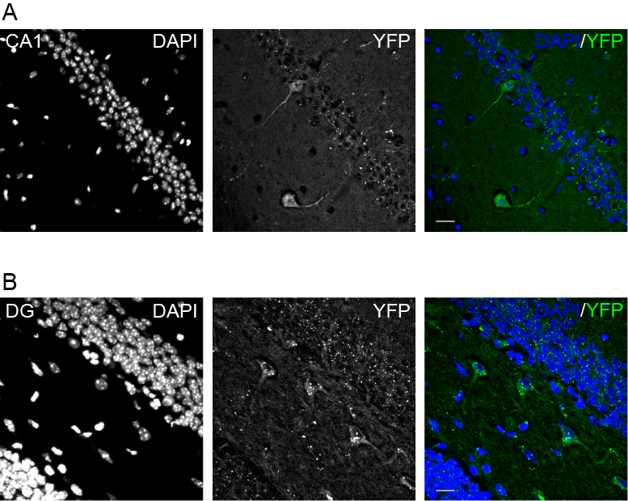
Figure 6.1 Confocal fluorescence images of forebrain slices of Arc^{Venus/+} mice. Only a small subset of cells displays cytoplasmic Arc-Venus yellow fluorescence (in green), cell nuclei were counterstained by DAPI (in blue). Scale bar: 20μm.

6.2 In vivo expression of Arc-Venus after PTZ-induced seizure in Arc^{Venus/+} mutant mice
Several lines of evidence showed that Arc/Arg3.1 expression is highly induced in the cortex following a generalized seizure (Link, W. et al., 1995). To further investigate whether Arc-Venus fusion proteins could reflect the neural activity-regulated transcription of endogenous Arc/Arg3.1 gene, I performed Pentylenetetrazol (PTZ)-induced seizure experiments in the heterozygous Arc^{Venus/+} knockin mice. After intraperitoneal (i.p) injection with superthreshold dose of PTZ (80mg/kg), all animals displayed typical seizure behaviors including hind limb kicks and generalized tonic and clonic convulsions of four limbs within 2 hours post injection. The control group of Arc^{Venus/+} mice were i.p injected with similar amount of 0.9% saline and closely monitored after the injection, no seizure behaviors were detected. Twenty minutes or two hours after injection, mice were sacrificed and acute brain slices were sectioned and examined by the confocal fluorescence microscopy. As shown in Figure 6.2, 20 minutes after PTZ injection, the induced seizure caused an increase in the number of YFP positive cortical cells, compared with the negative control group (Figure 6.2 A and B). Two hours after the injection, it is found that not only the cytoplasmic YFP fluorescence intensity was greatly increased, large amounts of yellow fluorescence also occurred as discrete puncta-like forms in the cortex (Figure 6.2 C and D).

Although more experimental work including confirming the Arc-Venus expression by immunostaining with antibodies against endogenous Arc/Arg3.1 protein, as well as other neuronal markers to label the pre/postsynaptic terminals is needed, the observations showing that a suggestive increase in Arc-Venus fluorescence following an in vivo stimulus strongly suggests that the fusion protein is able to report the neuronal cell activity in the mouse brain.
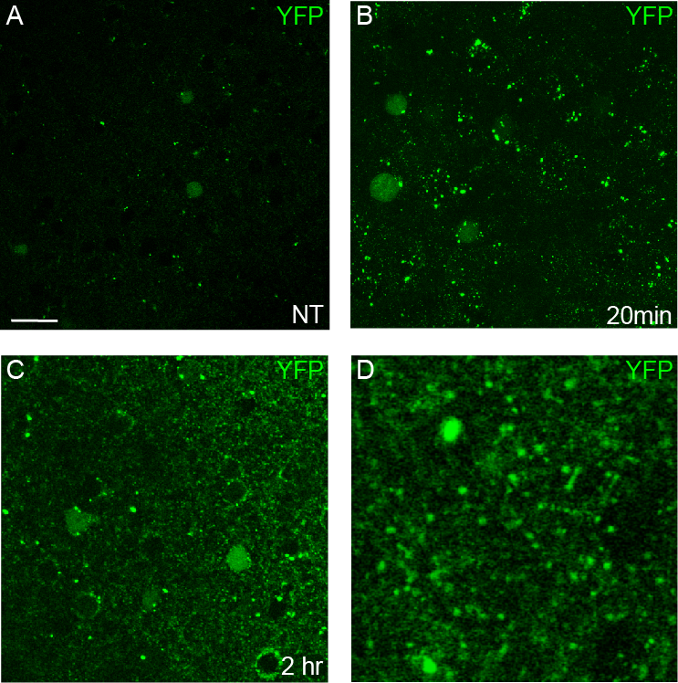
Figure 6.2 Confocal fluorescence images of acute cortical slices after PTZ-induced seizure in Arc^{Venus/+} mice. (A) Fluorescence image from non-treatment Arc^{Venus/+} brain slices. (B) Fluorescence image from non-treatment Arc^{Venus/+} brain slices. (C) Fluorescence image from non-treatment Arc^{Venus/+} brain slices. (D) 4x magnified image of (C). Scale bar: 20 μm.

