Averager Program
Averager performs calibration and gathers averages of various types including Compound Action Potentials and Cochlear Microphonics. The program supports four different categories of average, with different characteristics and constraints. Within each category any number of different, user-defined configurations can be set up and stored for re-use.

Stimuli
The stimuli generated by the program may consist of up to three components – two pure tones generated internally, and a waveform component (e.g. white noise) read from a .WAV file. Some of the attributes of each component can be set to change systematically between one stimulus and the next (see below for details).

Gathering data
Gathering data consists of –
- Specifying the animal name (a unique name must be supplied before the program will proceed)
- Selecting the type of averaging required from the ‘File’, ‘Load setup’ menu
- Adjusting parameters on the screen as required
- Clicking the ‘Run’ button.
Note that the first operation must always be a calibration, and that the ‘Run’ button is disabled until a setup file has been loaded

Averaging categories
The four averaging categories (or modes) are as follows –

Calibration
Outputs bursts of white noise and, by taking the average of the FFTs of the resulting outputs from the calibration microphone, and taking into account the attenuation imposed by the probe tube, estimates the sound level at the ear that would result from outputting a sine wave at a ‘standard’ RMS level at each 500Hz frequency step in the calibration range. The trace stored in the data file is the resulting calibration curve.
Key features –
- Output waveform taken from waveform (.WAV) file – assumed to be white noise, can be generated by, for example, the CoolEdit program
- Output level may be controlled by specifying settings for the PA5 attenuator (PA5 setting is automatic in all other averaging modes)
- ‘Repetitions per step’ is forced to one - a separate ‘average’ captured for each stimulus played

Compound Action Potentials
Outputs brief tone bursts and, by taking averages of the resultant signals from the electrode, generates a plot of the compound action potential.
Key features –
- The averages are obtained using a very high sampling rate – far higher than needed to capture the frequencies involved in the low-frequency CAP. An option is available to apply low-pass filtering to the input from the electrode and then down-sample the average accordingly in order to reduce the size of the data files generated.
- Unlike the other averaging modes, a separate average is not obtained for each different stimulus, but all repetitions of all stimuli are averaged together, giving one overall average. This allows any contribution of the precise details of the stimuli to the average to be eliminated (e.g. the phase of successive stimuli could be set to change by 180° each time in order to eliminate the effect of phase on the CAP, or successive tone bursts could have different frequencies).
- If required, clicks can be produced (instead of tone bursts) by specifying a very low tone frequency, setting the initial phase to around 90°, and setting the tone duration to the click duration required. Similarly, noise bursts could be produced by using the waveform stimulus component.

Cochlear microphonics
A separate average is gathered for each stimulus - this average is then scanned to determine the strength within it of the frequency corresponding to the first tone component in the stimulus. This value is stored and the next stimulus then generated and presented. The trace plotted, and stored in the data file, consists of one such value for each stimulus presented (i.e. for each frequency).
Key features –
- ?

Other
Removes the constraints imposed by the other averaging modes, and enables various options, in order to allow other averaging regimes to be implemented. One possible use would be to request the output of a tone at a particular level and then, using the input from the calibration microphone, verify that that level was in fact being presented.
Key features –
- Flexible
- One average per stimulus, or one average for all stimuli
- Input from calibration microphone or electrode
- Store either average or FFT of average
- Option to gather averages without storing them (e.g. to experiment with different stimuli without gathering data)

Saving configurations
Once a particular averaging regime has been set up, by setting values on the screen, it may be saved for future re-use by entering an appropriate title in the ‘Title’ box, clicking on ‘File’, ‘Save Setup…’ and storing it in the program’s configuration directory. Existing configurations can, when necessary, be over-written in the same way. Note that configurations saved in this way will not appear in the menu until the program is restarted.

Stimulus generation
The number of stimulus ‘steps’ determines how many (possibly different) stimuli are generated, while the number of ‘repeats’ determines how many times each stimulus is played out once generated.
As mentioned above, each stimulus may contain up to three components – two pure tones and one wave component taken from a .WAV file (e.g. a file of white noise).
All three components have the following attributes –
- Duration
- Onset/offset ramp times (ramping is within duration, not added to it)
- Output level
- Start time (relative to start of stimulus)
In addition, the two tone components have –
- Frequency
- Phase
While the wave component has –
- Waveform file name
- Position within file of segment to use
Some of these attributes may be set up to change systematically in successive stimuli –
- The start time can be modified so that one component moves in time relative to the others
- The frequency of a tone component can be made to rise or fall
- The phase of a tone component can shift
- For the wave component, the segments of the .WAV file used for successive stimuli can be the same, sequential in the file, or randomly-chosen.

Data storage
All the traces gathered for an animal are stored in a single data file - each trace is written to the data file as soon as it is gathered in order to minimise the risk of data loss. The name of the data file is formed by taking the animal’s name and appending “.csv”. Data files may all be stored in one directory (specified in the ‘averager.ini’ control file) or in subdirectories chosen by taking the first letter of the animal’s name.
Data is stored as text using a format described below. The data files can be read by Excel, though each trace may be split over more than one row in the spreadsheet (see description of ‘Data_line_limit’). A second program (‘TraceView’) allows the traces in data files to be viewed and plotted.

Downsampling
In CAP and General modes, the user has the option to downsample the gathered averages, in order to reduce the amount of data stored.
If –
- a value has been entered in the Input filter cut-off frequency box,
- low-pass filtering has been selected, and
- Downsample average is ticked
then the program computes (very conservatively!) the degree to which the average has been oversampled, given the filter cut-off frequency, and then downsamples it accordingly. This can result in significant reductions (e.g. 20-fold) in data files sizes.

The main screen
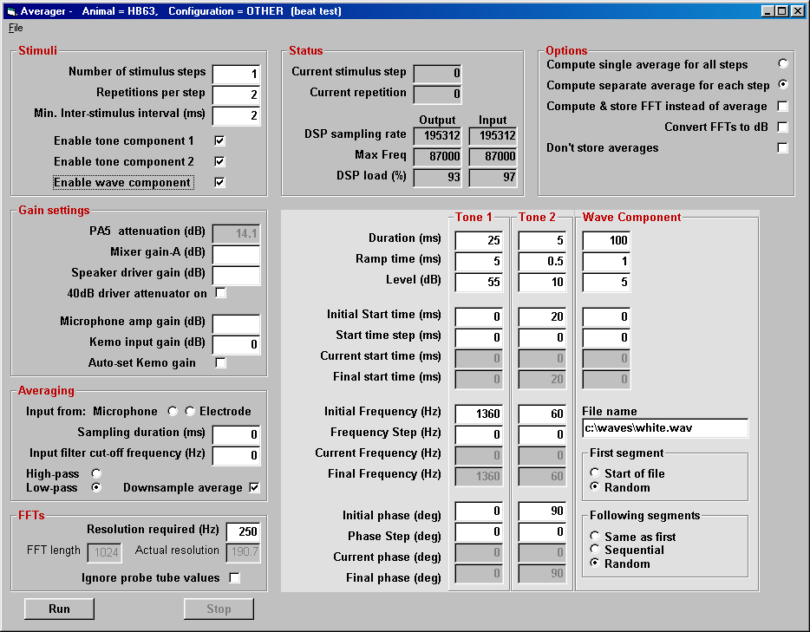
The main program screen is shown above – related items are grouped together into boxes and, depending on the type of averaging chosen, some boxes may be disabled and hidden from view. The individual items in the boxes are described below.

Title bar
Shows –
- Program name (“Averager”)
- Animal name
- Category (“Calibration”, “Compound Action Potentials”, “Cochlear Microphonics” or “Other”)
- Configuration title (as supplied by user when configuration saved)

‘File’ menu items
Load | loads a stored configuration from .CFG file. A sub-menu shows the four categories supported and, within each category, the title of each available stored configuration.
Save | prompts for a title for the current configuration, then saves it to a .CFG file using current category
Exit | exits from the program

‘Stimuli’ box
Stimulus steps | controls how many distinct stimuli are generated
Repetitions | controls how many times each individual stimulus is played out
Inter-stimulus interval | controls the minimum time between the onset of successive stimuli. Actual time may be greater
Enable components | determine whether corresponding stimulus component is generated (and corresponding component setup panel displayed). Note that tone 2 cannot be enabled unless tone 1 is also enabled

‘Tone 1’ & ‘Tone 2’ boxes
Duration | overall length of the component (including onset & offset ramps)
Ramp time | length of the (raised cosine) onset & offset ramps
Level | output level of this component (dB SPL)  not available during calibration – use PA5 setting instead to control level
Initial start time | start of this component relative to start of average (for first stimulus).
Start time step | amount by which start time changes for each successive stimulus.
Current start time | updated for each stimulus
Final start time | shows what the start time of the final stimulus will be
Initial frequency | Initial frequency for this component (i.e. frequency for first stimulus).
Frequency step | amount by which frequency changes for each successive stimulus.
Current frequency | updated for each stimulus
Final frequency | shows what the frequency of the final stimulus will be
Initial phase | Initial phase for this component (i.e. phase for first stimulus).
Phase step | amount by which phase changes for each successive stimulus.
Current phase | updated for each stimulus
Final phase | shows what the phase of the final stimulus will be

‘Wave’ box
Duration | As for tone components  N.B. the average value of the calibration table is used when attempting to set the requested waveform output level
Ramp time
Level
Initial start time
Start time step
Current start time
Final start time
File name | Name of (.WAV) file holding waveform to be played. Note that the file must be at least as long as the duration specified
First segment | Position within waveform file of segment to be used for first stimulus
Following segments | Position within file of segments to be used for subsequent stimuli

‘Averaging’ box
Input from | Select input source – microphone or electrode. Normally selected automatically, only under user control when averaging category is ‘Other’
Sampling duration | Determines length of each average. If value is shorter than overall stimulus duration then the stimulus duration is used instead
High-pass  Low-Pass | Control how the Kemo filter is used on input
Input filter cut-off frequency | Sets cut-off frequency for input filter – ignored if zero (i.e. set to zero if high-pass, or maximum input frequency if low-pass)
Downsample average | If ticked then, when low-pass filtering is in force, averages are down-sampled appropriately in order to reduce the size of data files

‘Gain settings’ box
N.B. Many of the amplifiers, attenuators, etc, in the rig are not (unfortunately) computer-controlled and the user must, therefore, tell the software their settings. Failure to do so may result in the wrong sound level being presented and input signals being wrongly interpreted.

PA5 attenuation | May be set by user during calibration, in order to avoid overloading the system or deafening the animal.  For all other types of average, displays the attenuation automatically chosen by the software in order to achieve the sound level requested
Mixer gain A | Enter the gain set on the TDT signal mixer (or 0 if not in use)
Speaker driver gain | Enter the gain set on the TDT speaker driver (or 0 if not in use)
40dB driver attenuator on | Tick this box if the 40dB attenuation is switched on on the IHR-built microphone driver
Microphone amp gain | Enter the gain set on the TDT microphone amplifier.  N.B. if using the B&K measuring amplifier instead, note that it amplifies by 120 dB as well as attenuating by the amount selected by the front panel knobs. If the attenuation is set to 70, enter 50 in this box (i.e. 120 – 70)
Kemo input gain | Enter here the gain required on the Kemo input filter (if automatic setting is not required)
Auto-set Kemo gain | Tick this box to have the software automatically set the Kemo gain to optimise use of the analogue-to-digital converters.  (Before averaging starts, a dummy stimulus will be generated, using the current stimulus parameters, and repeatedly played out. The Kemo gain will be adjusted until the input voltage is as close as possible to ± 8Volts p-p)

‘FFTs’ box
Resolution required | Specifies the FFT resolution required. Higher resolutions (i.e. smaller values) require longer FFTs and will take longer to process.
FFT length | Displays the FFT length needed to achieve the resolution requested
Actual resolution | Displays the actual resolution resulting from the chosen FFT length
Ignore probe tube values | Normally, FFT traces will be adjusted to reflect the attenuation imposed by the microphone probe tube. Tick this box if you want to prevent this adjustment and see the ‘raw’ FFTs

‘Options’ box
Compute single average for all steps | A single average is generated, representing the average response to all the different stimuli presented.
Compute separate average for each step | Each stimulus step generates a separate average
Compute & store FFT instead of average | Takes FFTs of each average, thus converting from time domain to frequency domain.
Convert FFTs to dB | If ticked, FFT’s are converted from volts to dB SPL using the microphone K-factor and the probe tube attenuation values.
Don’t store averages | Allows the user to experiment with different settings without storing any data. Because of the risk of losing ‘real’ data, this option turns red when selected!

‘Status’ box
Current stimulus step | Displays the number of the current stimulus
Current repetition | Displays the number of the current repetition (counts down to zero)
DSP sampling rate | Displays the actual sampling rates being used by the two RP2’s (output & input)
Max Freq | Displays the maximum frequencies supported by the software, based on the sampling rates
DSP load | Shows how busy the two RP2 processors are. The numbers are a conservative estimate and occasional values above 100% are acceptable

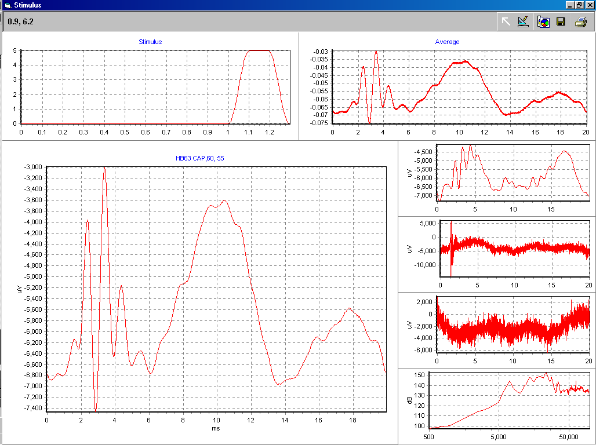
The plotting screen
The three main windows on the plotting screen shows the current stimulus, the most recent average and the most-recently gathered trace. On the right-hand side, the previous four traces are also displayed.
To the left of the menu bar, the current cursor position is reported, in data coordinates, as the mouse pointer passes over any of the three main windows. To the right are buttons that allow the plots to be edited, printed and saved to disk – for details, see the TeeChart documentation at www.steema.com/products/teechart/ax/overview.html

Internals

Control files
The program uses one main control file (‘averager.ini’) for information common to all operations, plus a configuration file for each stored setup. All these files have the structure of a Windows .INI file, consisting of named sections and ‘keys’ with values within each section. Lines starting with a semicolon are ignored, and may be used to insert comments.

Averager.ini
Key | Explanation |  | Default value
[files] section
Configuration_Directory | Directory where setup files are stored (for saved configurations)  N.B. <root_dir> indicates the directory where the program itself (averager.exe) is stored |  | <root_dir>\config
Waveform_Directory | Directory where stimulus waveforms are stored |  | <root_dir>\waves
Data_Directory | Directory where data files will be stored |  | <root_dir>\data
Use_Data_Subdirectories | Specifies whether data files are stored in main data directory or in subdirectories (using first character of animal name as subdirectory name) |  | True
Data_line_limit | When writing data files, limits the number of trace points written before a new line is started (Excel can only hold 256 items per row) |  | 250
[calibration] section
Microphone_millivolts_per_pascal |  | Microphone sensitivity | none
Calibration_Step | Spacing (Hz) between tube attenuation values |  | 500
Calibration_Limit | Frequency corresponding to final tube attenuation value |  | 50000
Calibration_level | Nominal RMS voltage for stored calibration values.  I.e. the values indicate, for each frequency step, the sound level that would be expected if a tone with an RMS value of ‘Calibration_level’ volts were output without any attenuation. |  | 7
[tube attenuations] section
<freq> (e.g. 3500) | Probe tube attenuations at each frequency from Calibration_Step to Calibration_Limit |  | none

Configuration (.CFG) files
These files save the settings for an individual configuration and are created by the program when ‘File’, ‘Save…’ is used. A section is generated in the file for each box (or ‘frame’) on the program screen and, within each section, a key is created for each item in the frame. The files are not intended for editing (the sections appear in no particular order) but, being text files, they can be edited if necessary.

Data file format
For each trace, the following lines are stored –
[Trace_<nn>] | <nn> is the number of the trace – numbering may not be consecutive if some averages are abandoned before completion.
TraceName | Name composed of animal name, average category, stimulus frequency (or file name) and output level
Counts = <ns>, <nr>, <sn> | <ns> = number of stimulus steps  <nr> = number of stimulus repetitions  <sn> = number of stimulus for this trace (-1 indicates all stimuli)
StimInfo_1 = <o>,<d>,<r>,<l>,<f>,<p> | Initial settings for tone 1 component  <o> = onset time  <d> = duration  <r> = ramp time  <l> = output level  <f> = frequency  <p> = phase
StimInfo_2 = <o>,<d>,<r>,<l>,<f>,<p> | Changes (per stimulus) for tone 1 component
StimInfo_3 = <o>,<d>,<r>,<l>,<f>,<p> | Initial settings for tone 2 component
StimInfo_4 = <o>,<d>,<r>,<l>,<f>,<p> | Changes (per stimulus) for tone 2 component
StimInfo_5 = <o>,<d>,<r>,<l>,<f>,<p> | Initial settings for waveform component  <f> = filename  <p> = position (0=start, 1=random)
StimInfo_6 = <o>,<d>,<r>,<l>,<f>,<p> | Changes (per stimulus) for waveform component  <f> = filename  <p> = position (0=same as first, 1=sequential, 2=random)
TraceInfo = <d>,<u>,<np>,<x0>,<dx> | Details of following trace  <d> = domain (F = frequency, T = time)  <u> = units (dB, ms, etc)  <np> = number of points in trace  <x0> = x-value for first point  <dx> = x-spacing between points
TraceData_<n> = v1,v2,v3... | One or more lines of actual data points, <n> is line number

Connections
See PowerPoint file ‘components.ppt’
Note that the software was designed for use with new microphones and TDT amplifiers but has been tested using some components – the connections required are also outlined in the PowerPoint file.

Internals

Startup sequence
Configuration details are read from ‘averager.ini’ (in the directory from which the program was run)
The ‘File’, ‘Load Setup’ menu is populated by reading each .CFG file found in the nominated configuration directory and using the ‘category’ and ‘title’ items in the ‘setup’ section.
The two TDT program files ‘TrigPlay.rco’ and ‘TrigAvg.rco’ are loaded (from the program directory) into the RP2s
The other hardware (Kemo filters and PA5 attenuators) is initialised
The program is then ready to run

Programming
Written in Visual Basic (version 6.0, SP5).
Structured (hopefully) to facilitate the addition of other types of averaging in the future.
Uses two Tucker-Davis RP2’s programmed using TDT ‘RPvdsEx’ software. One ‘circuit’ for each RP2 – ‘TrigPlay.rpx’ to play out stimuli, and ‘TrigAvg.rpx’ to gather averages.

Third-party code –
- Tucker-Davis OCXs (zBUSx.ocx, RPcoX.ocx & PA5x.ocx) provide interface between Visual Basic and TDT hardware
- FFT DLL from http://www.fullspectrum.com/deeth/programming/fft.html
- Graphing implemented using TeeChart ActiveX graphics control from www.steema.com

RP2 software
Uses two RP2 ‘circuits’ built using ‘RPvdsEx’– ‘TrigPlay’ to play out stimuli, and ‘TrigAvg’ to gather averages.

TrigPlay

Samples to be played are loaded into the serial buffer through DataOut
Samples beyond end of stimulus are zeroed, so some overrun is OK
Output channel to be used (OUT-1 or OUT2) selected by setting OpChan (in practice, only channel 1 is used)
Pulse generator generates a pulse for each repetition of stimulus (controlled by nPulses)
Each pulse stays high for duration of stimulus (PulseHigh), then goes low briefly (PulseLow)
Rising edge of pulse causes serial buffer pointer to be reset to start of stimulus
High level of pulse (delayed slightly by ‘or’ circuit) enables output of stimulus
Visual Basic code can determine how many repetitions have been played (nDone) and whether entire set of repetitions has been finished (Stage = 0)

TrigAvg

Input channel to be used (IN-1 or IN-2) selected by setting InpChan
IN-2 used for calibration, IN-1 for all other averages
Pulse generator generates a pulse for each repetition of stimulus (controlled by nPulses)
Each pulse stays high for duration of stimulus (PulseHigh), then goes low briefly (PulseLow)
Rising edge of pulse causes averaging pointer to be reset to start of buffer
High level of pulse (delayed slightly by ‘or’ circuit) enables averaging of input
On completion, values in average can be retrieved through DataIn
Visual Basic code cannot monitor what’s going on – averaging is assumed to stay in step with stimulus output.

Jitter between RP2’s
When the two RP2’s receive the Zbus trigger command that causes them to start, they may be at slightly different points in their internal processing loops and the averaging may, on different occasions, be perfectly in synch with the stimulus output, or out of synch by one sample. The designs shown above overcome this by dealing with the repetition of stimuli and averages within the RP2’s – all the averages then have the same phase relationship to the stimuli and the only effect of the jitter is the possible shift of the entire average, relative to the stimulus, by one sample time. If, however, the output of each stimulus repetition, and the capture of the corresponding input, is triggered separately by the Visual Basic program, then successive inputs may be shifted in time by different amounts relative to their respective stimuli and ‘blurring’ of the average will result.

