TraceView Program
TraceView allows data files produced by the ‘Averager’ and ‘TSA_Convert’ programs to be loaded, displayed and printed. More than one data file may be loaded at the same time, though this feature is unlikely to be used very often. The program uses two windows – one displays a list of the traces in the data file(s), and plots of selected traces, the other displays details of the current trace.
The program should, preferably, be run from the same directory as ‘Averager’ as it attempts to use the averager.ini file to determine where data files are stored.

The screen
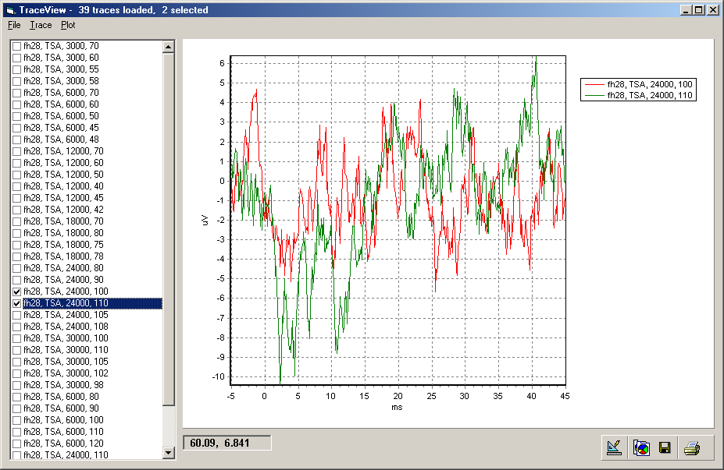

The screen has two main components – the trace list and the plot area, together with a cursor readout and four plot control buttons. The screen’s title bar shows how many traces are loaded in memory, and how many are currently selected.

Trace list
The trace list show a list of all the traces currently loaded. For each trace, the animal name, trace type, stimulus frequency and stimulus level are shown, together with a check box that indicates whether the trace is ‘selected’ or not.
At any one time, one of the traces in the list may be highlighted – traces may be highlighted by clicking on them, or the highlight may be moved up or down with the cursor control keys. When a trace is highlighted, it is plotted in the plot area and its details are shown in the trace details window.
Traces may be ‘selected’ by clicking on the corresponding check box in the trace list, or by clicking twice on the trace name. There are also various options for selecting and de-selecting traces in the Trace menu (described below)

Plot area
The plot area is used to display traces graphically. When a trace is displayed you can ‘zoom in’ on an area by pressing down the left mouse button and, keeping the button pressed, dragging the mouse pointer downwards and to the right. This process can be repeated to zoom in further. To ‘un-zoom’, drag upwards and to the left (this un-zooms all the way out). Avoid using the right mouse button by mistake, as this puts the plot into some form of 3D mode…

Cursor readout
The cursor readout shows, in data coordinates, the current position of the mouse pointer whenever the mouse moves over the plot area.

Plot control buttons
These come as part of the graphing software (TeeChart) that is used for plotting the traces. The four buttons, from left to right, are Edit, Copy (to clipboard), Save and Print. For more information, click on the Edit button and refer to the on-line help!

File menu
Load… Loads a data file into memory, replacing any data previously loaded.
Append… Loads a data file into memory, appending traces to any already loaded.
Clear Removes all traces from memory
Exit Exits

Trace menu
Select All (ctrl-A) Selects all traces
Select None (ctrl-N) De-selects all traces
Select Block(s) (ctrl-B) Finds first currently-selected trace, then selects all traces up to and including next selected trace. Continues in this way to end of trace list.
Select by Frequency (ctrl-F) Finds first selected trace, then selects all following traces that have same animal name, trace type and stimulus frequency (and de-selects all other traces)
Select by Level (ctrl-L) Finds first selected trace, then selects all following traces that have same animal name, trace type and stimulus level (and de-selects all other traces)
Toggle Selection (ctrl-T) Makes selected traces unselected, and vice versa
Discard Selected Traces Removes all selected traces from memory

Plot menu
Print current graph (ctrl-P) Prints the graph currently displayed in the plot window to the default printer
Overlay selected traces (ctrl-O) All the currently-selected traces are displayed in the plot window
Print selected traces… All the currently-selected traces are printed individually on the default printer, with the number printed per page being selected from a drop-down menu.

