APPENDIX B

Screen Shots and Source Code of the CTF Correction Program

B.1 Overview

The CTF correction program described in chapter 3 was written in Perl, utilising the common gateway interface module (CGI). The program can be executed using any Web browser (see Figure B.1), hence is platform independent. The theory and implementation behind the program is discussed in chapter 3. The following pages are a syntactically formatted copy of the Perl code.
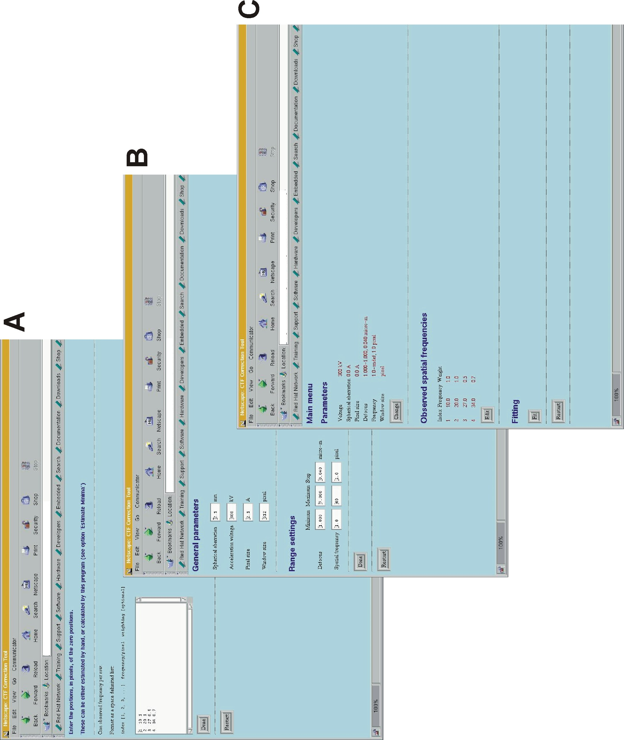

Figure B.1 Screen shots of the CTF correction program. A - Estimated zero positions are entered into the textfield. Each zero position is defined by the zero index (i.e. whether the zero position corresponds to the first, second, third and so on, zero position) the spatial frequency of the zero position and the weighting or confidence factor of the zero position (between 1, absolute confidence, and 0, no confidence). B - The imaging parameters settings. The top section deals with the microscope imaging conditions, the bottom section deals with the pixel scale and the granularity of the search used to fit the defocus to be applied. C – Summary page of user entered parameters and experimental data prior to defocus estimation.
