CHAPTER 6

Domain Organisation of σ⁷⁰ in the Escherichia coli RNA Polymerase σ⁷⁰ Holoenzyme

6.1 Overview
DNA-directed RNA polymerase (RNAp) is responsible for all transcription in cellular organisms and is the final target in many regulatory pathways that control gene expression. The bacterial enzyme, although sharing much structural and sequence similarity to eukaryotic RNAp, differs from the eukaryotic RNAp by binding different accessory proteins, termed σ-factors, to from a holoenzyme. Only in the holoenzyme form is the RNAp able to perform promoter specific binding. Complexes of the core RNAp (E) with different sigma factors allows the differentiation of transcription initiation at different sets of promoters. During vegetative growth in Escherichia coli (Ec), most gene transcription is initiated from promoters bound by a holoenzyme containing the primary σ-factor, σ⁷⁰. The Ec σ⁷⁰ holoenzyme (Eσ⁷⁰) structure has been solved by single particle cryo-electron microscopy. The electron density map of the Eσ⁷⁰, together with the model structure of the Ec E, Ec σ⁷⁰ fragment and structures of σ⁷⁰ homologs, has enabled the derivation of an α-carbon-backbone model for Eσ⁷⁰. Comparisons of the mesophilic Ec holoenzyme are made to a thermophilic holoenzyme. It has been possible to identify the location of the promoter-DNA sequence specific binding elements within the Eσ⁷⁰. In addition, the position of the primary sigma-factor specific autoinhibition region, conserved region 1.1 has been clearly identified within the DNA binding channel. A structural comparison between the Ec E and Eσ⁷⁰ highlights the many domain movements that occur in Ec RNAp upon binding the σ⁷⁰-factor. Many of these differences are mirrored as differences between the thermophilic core enzyme and holoenzymes when they are compared.

6.2 Introduction
Control over gene expression is primarily exerted at the level of transcription. In cellular organisms, the DNA-dependent RNA polymerase (RNAp) is the vital enzyme in transcription and therefore the fundamental target of transcriptional regulation [Chamberlin, 1976 #534]. In bacteria, an essential step in transcription is the binding of one of a number of dissociable accessory proteins, termed σ-factors, to a core RNAp (α₂ββ'ω, mass of 379 kDa in Escherichia coli), to form a holoenzyme (e.g. α₂ββ'ωσ⁷⁰ , mass 449 kDa) [Burgess, 1969 #223; Gross, 1998 #303]. Only as a holoenzyme can RNAp specifically initiate transcription [Burgess, 1969 #223].

Sequence alignments of primary sigma-factors (σ⁷⁰ in Ec) have demonstrated that they are comprised of four conserved regions punctuated by regions of less well conserved sequence [Lonetto, 1992 #358], also see [Bateman, 2002 #670]. These conserved regions can be further subdivided [Gross, 1998 #303]. The crystallised regions of three different primary sigma-factors [Malhotra, 1996 #363; Campbell, 2002 #785; Murakami, 2002 #668; Vassylyev, 2002 #669] shows that the σ⁷⁰ is comprised entirely of α-helices. The most highly conserved region is region 2 [Lonetto, 1992 #358]. This region contains both the main core binding determinant (region 2.2) [Arthur, 2000 #2; Datwyler, 2000 #561; Burgess, 2001 #9] and –10 promoter recognition element (region 2.4 ) [Gross, 1998 #303; Murakami, 2002 #668; Murakami, 2002 #667]. Region 4, comprised of two helix-turn-helix (HTH) motifs, specifically recognises the –35 promoter element [Campbell, 2002 #785; Murakami, 2002 #667; Murakami, 2002 #668; Vassylyev, 2002 #669]. Region 1.1 performs two distinct functions; first is prevention of promoter binding by the free σ⁷⁰ [Dombroski, 1993 #93]. Upon E binding, region 1.1 undergoes a substantial rearrangement, which is believed to relive the inhibition [Callaci, 1999 #234]. Second it has a positive role in accelerating open complex formation at some promoters [Vuthoori, 2001 #532].

Crystal structures of the Thermophius thermophilus (Tth) and Thermus aquaticus (Taq) holoenzymes have provided many insights to the structural arrangement of two thermophilic holoenzymes [Murakami, 2002 #668; Vassylyev, 2002 #669]. In both the free and holoenzyme unbound forms, the structural ordered regions of the sigma-factors display three discrete domains (comprised of the conserved regions 2, 3 and 4 respectively) [Campbell, 2002 #785; Murakami, 2002 #668; Vassylyev, 2002 #669]. These discrete domains are connected by extended linkers [Campbell, 2002 #785 ;Murakami, 2002 #668; Vassylyev, 2002 #669]. The σ-factors form an extended interface along the RNAp, with the majority of mass located on the upstream half (with respect to the orientation of the DNA) of the RNAp [Murakami, 2002 #668; Vassylyev, 2002 #669]. Furthermore, the higher-resolution Tth holoenzyme also demonstrated the presence of the two Mg²⁺ ions chelated at the active site, conclusively supporting the two-metal ion mechanism of catalysis for multisubunit RNAps [Vassylyev, 2002 #669]. Nevertheless, the thermophile holoenzyme structures represent relatively poorly biochemically characterised enzymes, whereas the mesophilic Ec RNAp is the most extensively studied multisubunit RNAp [Darst, 2001 #729]. Elucidation of the Ec holoenzyme structure is important and would provide a significant resource for structure function studies and verification of the theromphilic RNAps as models for Ec RNAp.

Previously, the cryo-electron microscopy (cryo-EM) structure of the Eσ⁷⁰ has been reported [Finn, 2000 #21]. Subsequent refinement of the structure and docking of high resolution structures and homology models into the density map has been performed, as was carried out with the Ec core RNAp (chapter 4). The fitting procedure has enabled the formulation of an α-carbon backbone model that represents 70% of the Ec Eσ⁷⁰. Comparisons of the Ec E and Eσ⁷⁰ backbone models have enabled the accurate determination of the domain movements that occur during holoenzyme formation and demonstrate the dynamic events that occur in the core enzyme subunits upon binding the σ⁷⁰. The positions of mobile, core enzyme domains and the movements of the corresponding domains in Tth and Taq structure are related to Ec [Vassylyev, 2002 #669; Murakami, 2003 #767]. Finally, the position of σ⁷⁰ has been clearly identified. In particularly, we have located the position of the promoter binding elements and structurally demonstrated the location of the autoinhibtion domain, region 1.1. The position of region 1.1 in relation to promoter engagement is discussed.

Subunit | Segment (residues) | % Coverage
αI | 1-329 | 100
αII | 1-329 | 100
β | 23-103, 125-132, 154-215, 370-506, 564-734, 750-804, 831-891, 914-1342 | 70
β' | 20-40, 88-248, 262-332, 349-547, 558-698, 751-932, 1032-1121, 1154-1159, 1204-1384 | 74
ω | - | 0
σ⁷⁰ | 113-167, 173-191, 212-237, 242-518 | 59
Total |  | 72
Table 6.1 – Segments of the Ec Eσ⁷⁰ sequences present in the final modelled.

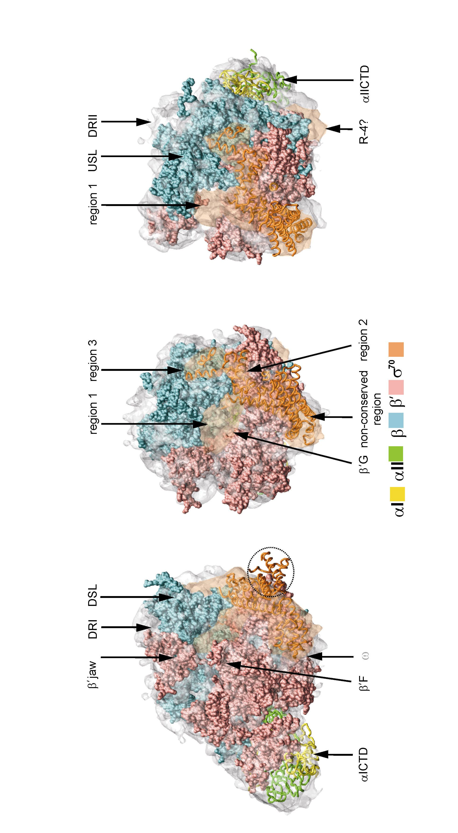

Figure 6.1 – Three views around the Ec Eσ⁷⁰. The experimentally derived density map is represented as a grey semi-transparent surface, except for the unmodelled density assigned to σ⁷⁰, which is coloured orange. The C-α backbone model is shown inside the density map (also see table 6.1). The α-subunits and σ⁷⁰ are represented as a worm. The β and β' subunits are shown as spacefill. The subunits of the holoenzyme are coloured as indicated by the code at the bottom of the figure. This channel roughly divides the RNAp into two halves, thereby giving the crab-claw shape. The upper pincer (predominately formed by the β subunit downstream lobe (DSL) and upstream lobe (USL)) and lower pincer (predominately formed by the β' subunit), as referred to in the text are indicated. The holoenzyme is approximately 170Å long from the (α-subunits) to the tips of the pincers. The polymerase is 120Å wide, across the α₂ dimer. The distance from one pincer tip to the other in the direction out of the plane of the page is 130Å, slightly greater than found in the core RNAp. Left - View of the downstream face of Eσ⁷⁰. The space fill representation of the β and β' subunits clearly demonstrates the position of dispensable region I (DRI), located between the DSL and the β' jaw domain (also thought to be a DR). Unlike the Ec E modelled, it has been possible to model the position of the β'F domain, that contains the β' jaw domain insertion. The position of the α_{I}CTD domain is marked, unmistakably occupying a near identical position in both the Ec E and Eσ⁷⁰. The positions of the non-conserved domain helices not bound by density are marked with the dashed line. These helices are thought to form a mobile region, explaining why they are no observed (see the text for details). The unmodelled density found at the tips of the long helices is like to correspond to ω. Middle – View of the front of the DNA binding channel, the view clearly shows the distinctive pincers. The two conserved regions and non-conserved region of σ⁷⁰ modelled are labelled. Also labelled in the position of region 1, which is located between β'G and the DSL, also see right. The justifications for the assignments are discussed at length in the body of the text. Right - View of the upstream region of the DNA binding channel. The whole arrangement of the σ⁷⁰ density can been in this. The non-conserved helices are located in a functionally neutral area if the holoenzyme and extend the length of the tip of the lower pincer. Another piece of unmodelled density is found in a position close to where region 4 is found in the Tth and Taq Eσ^{A} holoenzymes. As no unmodelled segments of the core subunits are found in this area, this region is tentatively assigned to region 4 of σ⁷⁰. This view, of the holoenzyme also demonstrates the location of DRII and the α_{II}CTD.

6.3 Results
6.3.1 The Global Structure
The refined structure of the Eσ⁷⁰ (figure 6.1) has been determined to a resolution of 17Å [van Heel, 1986 #119] (see figure 6.2). The overall morphology of the refined structure resembles that of the other homologous holoenzymes and Ec core RNAp generally resembling a "crab claw" shape (see figure 6.1) [Murakami, 2002 #668; Vassylyev, 2002 #669; Darst, 2002 #663; Finn, 2000 #21; Polyakov, 1995 #408; Darst, 1989 #261]. As the refined holoenzyme map clearly contains many structural features that correspond to the core enzyme, a direct docking of the core enzyme subunit models into the Eσ⁷⁰ was performed (see figure 6.1). This revealed, as previously demonstrated for Taq E and hence indirectly for Tth, that a large central portion of the core-enzyme (which includes the α-subunits and the regions of β and β' that form the active site) remains fixed, while those domain found at the edges of the pincer (β upstream and downstream lobes, β flap, the β' clamp) undergo a repositioning [Murakami, 2002 #668; Vassylyev, 2002 #669]. These mobile modules border the central DNA binding channel. Having docked the β and β' subunits and based on their positions in E (see chapter 3), it was possible to locate the three dispensable regions (DR) in these subunits (β' jaw, βDRI and βDRII, figure 6.1), by constructing difference maps between the docked model and the density map. The difference map also revealed the likely position of the ω subunit.

The most striking differences between the docked core subunits model [Darst, 2002 #663] and the Eσ⁷⁰ density map was the presence of a significant region of density that is largely associated with the β' clamp, which corresponds to the bound σ-factor (orange, figure 6.1). Generally, the orange density forms a large interaction surface with the core enzyme subunits and domain-domain interactions are confined to the mobile domains that frame the active site. The detailed analysis of the σ⁷⁰ density is presented below.
Figure 6.2 – Resolution of the Eσ⁷⁰ 3D reconstruction as determined by Fourier Shell Correlation (FSC). The FSC from the Eσ⁷⁰ reconstruction (red line) crosses the 3σ curve (blue) at a spatial frequency of 0.096 Ǻ⁻¹, indicating a resolution of ~10.5 Ǻ. However, low-pass filtering of the C-α model structure indicates that the level of structural detail between the model and density map is comparable to a resolution nearer 17.5Ǻ, as does the 0.5 threshold criteria Thus, the reconstruction was assessed to have a resolution of 17.5Å

6.3.2 Transition from core-enzyme to holoenzyme
6.3.2.1 The α subunits
The α subunits occupy a near identical position between the Ec E and Eσ⁷⁰, with a route mean standard deviation less than 1.5 Å for the C-α backbone models. The DNA binding and transcription activating regions of the α-subunits C-terminal domain (αCTDs) [Ishihama, 1992 #324; Ebright, 1995 #276] are found on the to the DNA binding channel as in E. Therefore, this suggests that between the "ground state" core RNAp and formation of Eσ⁷⁰, there is no repositioning of the αCTD. The energy from non-specific interactions with the DNA many be required before the αCTDs are orientated specifically on the DNA at promoters that carry UP elements. Other biochemical and biophysical evidence does not contradict the placement of the αCTDs [Naryshkin, 2000 #50; Mekler, 2002 #773; Benoff, 2002 #665; Lloyd, 2002 #664].

The observation that the Tth αI rotates towards the DNA binding face when compared to the Taq core enzyme [Vassylyev, 2002 #669] appears not to be evident when comparing the Ec E and Eσ⁷⁰ froms. Similarly to Ec, such a rotation between the Taq core enzyme and holoenzymes is not evident [Murakami, 2002 #668]. Thus, the difference in the position of αI in the Tth holoenzyme may reflect a Tth specific repositioning and may be independent of the binding of the σ-factor, a general difference in α-dimer structure, or more probably a crystallization artefact.

6.3.2.2 Identification of the β domain
The docking of the β-subunit was not as straightforward as that of the α-subunits. The gross bi-lobed shape was readily identifiable, but the holoenzyme density (expected to be β) did not precisely match the backbone model of the Ec E β subunit. The β structural domains 1, 2 and 3 form the distinctive bilobed structure present in both bacterial and eukaryotic multisubunit RNAps [Zhang, 1999 #508; Cramer, 2001 #18 Cramer]. The lobe that lies downstream, with respect to the DNA orientation [Korzheva, 2000 #34; Murakami, 2002 #668], is formed by β domain 2 [Zhang, 1999 #508] (labelled DSL in figure 6.1). The upstream lobe (USL) is formed by β domains 1 and 3 (labelled USL in figure 6.1). The lobes interact with two distinct regions of σ⁷⁰ density within the holoenzyme(see figure 6.1, discussed further below). The USL has undergone some modest movement, a rotation of ~5º. A similar, but less substantial movement is observed for the downstream lobe (DSL). Movements have been suggested to occur in corresponding domains in both the thermophilic holoenzymes [Murakami, 2002 #668; Vassylyev, 2002 #669]. However, the difference in the resolution of the two density maps used to validate the Ec E (12Å) and Eσ⁷⁰ (17Å) homology models may result in such variation in interpretation. Nevertheless, when the lobes are compared between the Tth and Taq holoenzymes, these domains have been displaced by between 7 and 12 Å relative to each other [Vassylyev, 2002 #669]. This is unsurprising as these domains have been demonstrated to be flexibly attached to the rest of the holoenzyme [Darst, 2002 #663] and work in this thesis.

The β flap domain, comprised of conserved region G (N-terminal region of structural domain 6), has undergone the most dramatic movement of all of the β domains (figure 6.3, bottom). The β flap domain is also associated with the σ⁷⁰ density within the holoenzyme. The movement of the β flap domain is in general agreement with the observed change between the Taq core enzyme and holoenzyme, although the movement of the flap domain is more modest [Murakami, 2002 #668].

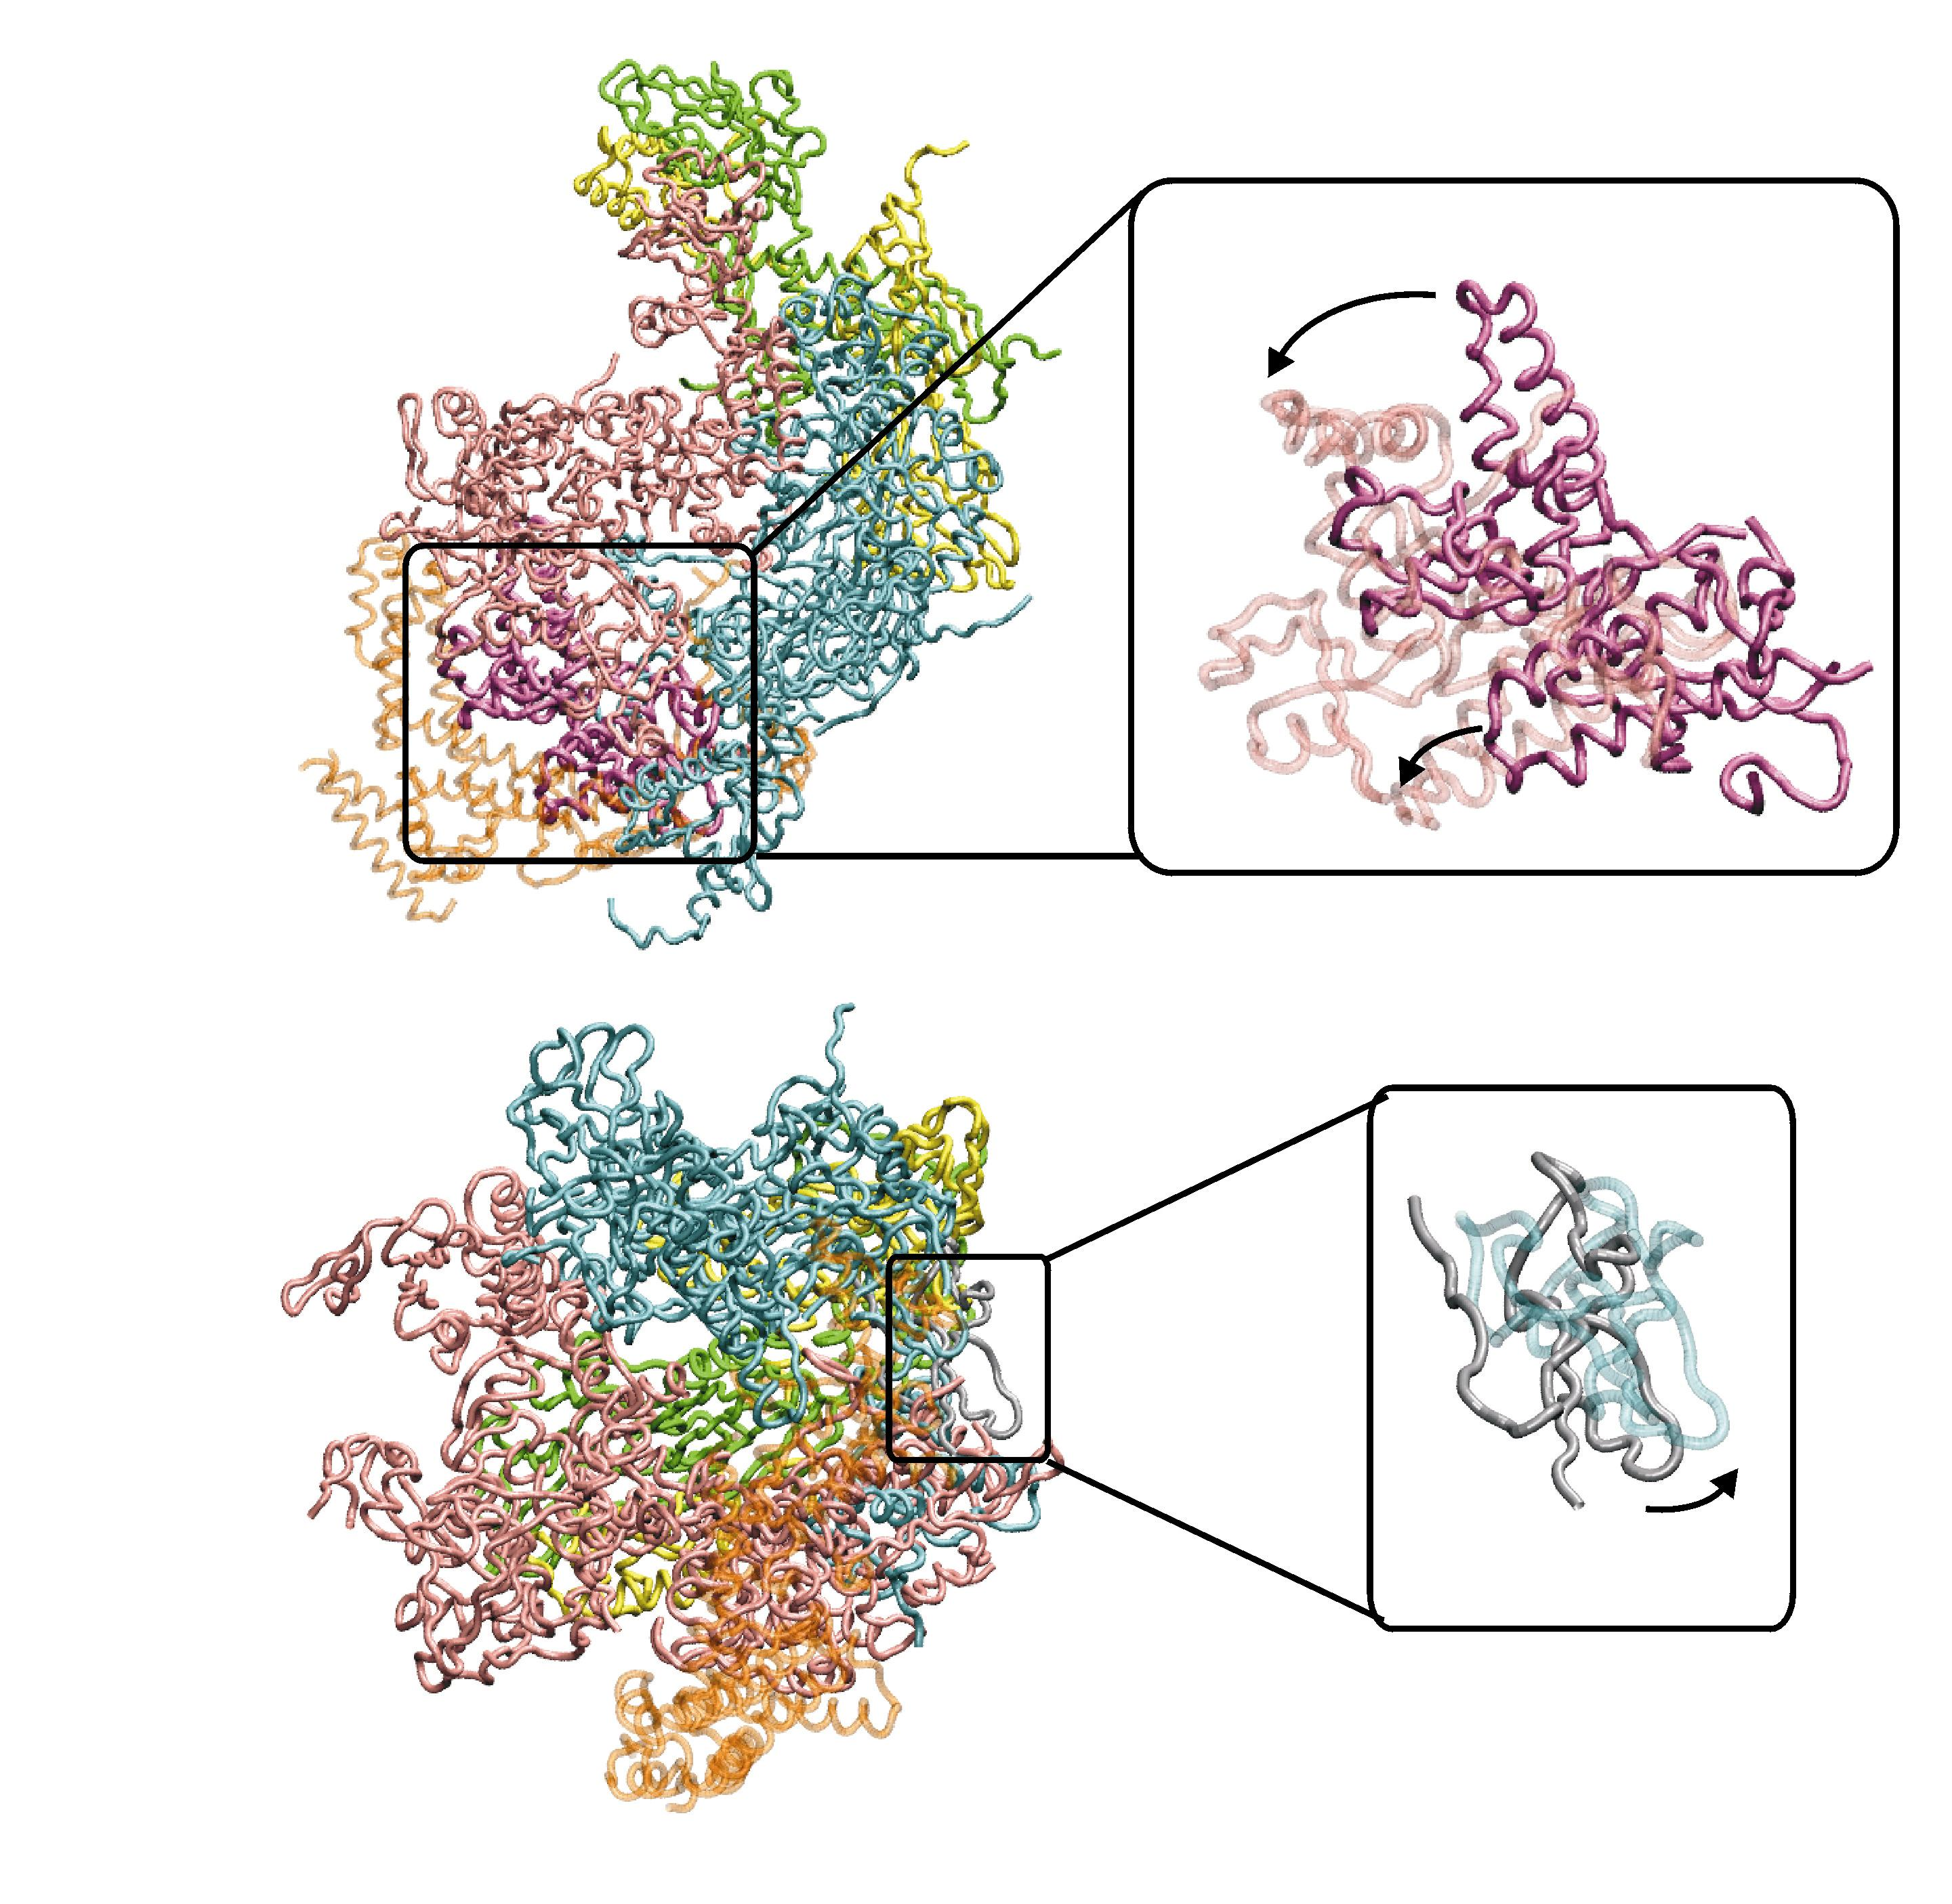
Figure 6.3 – Domain movements associated with the conversion of E to Eσ⁷⁰. Top – The movement of the β' clamp domain. Top, Left shows the position of the clamp domain (magenta) within the Eσ⁷⁰. Top, right shows just the β' clamp from Ec E (semi-transparent) and Eσ⁷⁰ (solid). The clamp in Eσ⁷⁰ swung in an upstream direct and slightly up, towards the upper pincer. Bottom – Movement of the β flap domain. The overview and detailed view are as above. The β flap domain is coloured silver. Compared to the E position, the β flap domain is found slightly in a slightly more downstream position in Eσ⁷⁰.

6.3.2.3 β' Clamp Domain
The β' clamp module is a structural feature present in both the bacterial and eukaryotic RNAp enzymes [Zhang, 1999 #508; Cramer, 2001 #18; Ebright, 2000 #19; Murakami, 2002 #668; Vassylyev, 2002 #669;[Murakami, 2003 #767]. The different crystallisation procedures applied to the Pol II RNAp resulted in the clamp module being crystallised in two very distinct conformations [Cramer, 2001 #18]. The clamp is the module that exhibits the most dramatic movement when the Ec and Taq core RNAps are compared and when Eσ⁵⁴ is compare to Ec E and exhibits much structural variability between homologous bacterial RNAp structures [Ebright, 2000 #19; Murakami, 2002 #668; Vassylyev, 2002 #669, Murakami, 2003 #767]. In the Ec holoenzyme the clamp domain has been displaced by up to 20Å, a result of a rotation of ~15º at the point of linkage connecting β' domain 1 to the rest of the β' subunit. The clamp domain is directly associated with a large proportion of the holoenzymes extra density (figure 6.3), that is unassigned to any of the common core enzymes subunits. The motion of the clamp, in the absence of σ⁷⁰ has opened up the DNA interacting channel by 12Å (figure 6.3) in the vicinity where the upstream DNA (approx -10bp to -17bp) would be localised.

As with the Ec core RNAp there are regions that have not been modelled [Darst, 2002 #663], the ω subunit (due to conformational differences) and β dispensable regions (due to the lack of an appropriate model). However, by comparison to the positions of these regions in the core enzyme, it is possible to identify unambiguously these region (marked as ω and β DRI/DRII in figure 6.1). Having assigned all of the E subunits in Eσ⁷⁰and taking into account the unmodelled regions, difference mapping readily identified the unassigned density which must be attributable to σ⁷⁰ (orange, figure 6.1). In the following sections the assignment of the remaining density to σ⁷⁰, indicating the location of the σ⁷⁰ conserved regions is described.

6.3.3 Identification of σ⁷⁰ within the Unassigned Density
The density remaining after the placement of the core RNAp subunits within the holoenzyme density map is assigned to σ⁷⁰. This density lies predominantly at the upstream edge of the holoenzyme between the β lobes and the β' clamp. A similar docking procedure that was used to fit the core enzyme subunits was applied to the fitting of a crystal structure fragment of the Ec σ⁷⁰ [Malhotra, 1996 #363] (residues 114-446 which encompasses regions 1.2, the region and region 2) which closely resembles the conformation of corresponding σ^{A} regions in the thermophilic holoenzymes and to a homology model of the σ⁷⁰ conserved region 3 (residues 447-510) and region 4 (residues 530-633). The templates for the homology models were based on the corresponding structures from both the Tth and Taq holoenzymes. The latter two regions were modelled separately as structures of the σ⁷⁰ homologs from Taq and Tth demonstrated that each conserved region or structure were joined by flexible linkers [Campbell, 2002 #785; Murakami, 2002 #668; Vassylyev, 2002 #669]. Consequently, the Ec σ⁷⁰ fragment and models of region 3 and 4 were docked as independent subunits. The connecting linkers were not modelled. Below, the position of each structural model in relation to the surrounding domains from other subunits is described.

6.3.3.1 σ⁷⁰ fragment - Regions 1.2, non-conserved and 2
Region 2 contains the primary core enzyme and DNA binding determinants. From the Tth and Taq structures and from other biophysical methods, region 2 is known to make an extensive interaction with the β' clamp domain (figures 6.1 and 6.5). More specifically, region 2.2 forms the core binding structure and comprises of a single helix, which interacts with the β' coiled-coil located within the β' clamp domain. Both the β' coiled-coil and σ⁷⁰-region 2.2 are very well conserved in sequence and structure, thus the interaction between these two structures is likely to be highly conserved. So, based on the three helical arrangements in Tth and Taq, the Ec σ⁷⁰ fragment was docked as a rigid body on to the already docked β' clamp domain. Consequently, a similar orientation of region 2 with respect to the β' clamp is found when compared to Tth and Taq holoenzyme. Interestingly the rigid fit of the Ec σ⁷⁰ fragment resulted in a good match between the structural detail of the density and the structure of the σ⁷⁰ fragment. Only two helices were found not to match the density (highlighted by the dashed line in figure 6.1). These helices form a discrete module that may independently move within the σ⁷⁰ fragment, as these helices are part of the σ⁷⁰ fragment containing the very high temperature factors, with the loops connecting these helices not even modelled in the σ⁷⁰ fragment structure. This suggests that this may be a region of structure variability. Furthermore, these helices correspond to a unique segment in σ⁷⁰ compared to either the Tth or Taq holoenzymes. No density was found in this area, possibly due to the resolution of the map and/or variability in position of these helices. Alternatively, these helices may not correspond to their native position as the σ⁷⁰ fragment is genetically engineered segment of σ⁷⁰. Overall, the position of σ⁷⁰ fragment in Eσ⁷⁰ density is consistent with all Ec biochemical analyses [Sharp, 1999 #445; Arthur, 2000 #2; Wigneshweraraj, 2000 #77; Datwyler, 2000 #561; Burgess, 2001 #586; Gruber 2001; Murakami, 2002 #668; Vassylyev, 2002 #669].

More specifically, σ⁷⁰ region 2.4, the DNA interacting helix [Gross, 1998 #303], is found on the outer face of the holoenzyme and its orientation with respect to regions 2.2 and 3.0 are closely similar to that found in the Tth and Taq holoenzymes [Murakami, 2002 #668; Vassylyev, 2002 #669], forming a distinctive v-shape with the helix formed by region 3.0, at the edge of the primary DNA binding channel (see figure 6.5). This is contrary to the rigid movement of regions 2 and 3 when the Tth or Taq Eσ^{A} are compared.

A noticeable difference between the σ-factor in Ec compared to the thermophilic holoenzymes is the position of the non-conserved region located in the primary sequence between regions 1.2 and 2. This is primarily due to the fact that the Ec non-conserved region is much larger than that in Tth and in Taq (for example the non-conserved region is ~60 amino acids in Tth compared to ~200aa in Ec) and that the fold of the Taq and Tth non-conserved regions are completely different to that in Ec non-conserved region [Vassylyev, 2002 #669]. In Ec the helices forming the non-conserved region are wrapped around the β' clamp domain (figure 6.5). The position occupied by the non-conserved region is Ec is close to that of the position of the large insertion in the Tth β' clamp. Both the thermophilic β' subunits contain these large insertions in the β' clamp domain and both have significantly shorter non-conserved regions in the σ-factor. Thus, the absence of a β' insertion in Ec may explain why such a large insertion can be tolerated in Ec.

6.3.3.2 Location of σ⁷⁰ Regions 3 and 4
Region 3 is found to interact with the USL (figure 6.1) and occupies a near identical region to the corresponding structures in the other holoenzymes (green in figure 6.5). In this position, region 3 is juxtaposition to the key elements in the β' clamp, the β' rudder and the β' lid, which are both postulated to be interacting directly with nucleic acids.

Both structural and mutagenesis experiments had demonstrated the role of the β flap in positioning of σ⁷⁰ region 4 [Murakami, 2002 #668; Vassylyev, 2002 #669; Kuznedelov, 2002 #560]. Deletion analysis of the Ec β flap has lead to the hypothesis that this structural element may orchestrate the positioning of the HTH at promoters with different promoter element spacings [Kuznedelov, 2002 #560]. The β flap structure is thought to be flexibly attached to the rest of the β subunit due to the lack of secondary structure and structural variability in its positioning [Zhang, 1999 #508; Murakami, 2002 #668; Vassylyev, 2002 #669]. In both the Ec core enzyme and holoenzymes models it has not been able to model the tip of the β flap domain, as the structural detail of the density weakens in this region, also suggesting flexibility of the protein in this area. As the flap and region 4 are though to form a mobile module it is not surprising that it has not been possible to accurately model region 4 in the density map. Nevertheless, there is density that does not contain any model in the vicinity of where region 4 is expected. As there are no unmodelled regions of the core subunits found in this area, it seems probable that this unoccupied density corresponds to region 4. The fact that the structural details are weak in this area is an interesting observation, suggesting that in a population of σ⁷⁰ holoenzyme molecules, there maybe a distribution of spacing between the –10 and –35 promoter binding elements.

6.3.3.3 Identification of Region 1.1
For differing reasons, region 1.1 of σ^{A} is missing from both Tth and Taq holoenzyme structures. Subsequent to the placement of structures of σ⁷⁰ regions 2 and 3 in the density map and identifying the location of region 4, a region of unaccounted density remained (see figure 6.1). This density is found to occupy the region between the two pincers on the basic surface of the channel, just behind region 1.2 when viewed from the front as in figure 6.5. The density makes contacts with both the β'G and β DSL, occupying much of the DNA binding channel. The density is both in an appropriate location and suitably sized to accommodate the unmodelled N-terminal ~100 amino acids of σ⁷⁰, which includes region 1.1. The physical location of region 1.1 has been indicated by independent fluorescence resonance energy transfer (FRET) analysis which positioned region 1.1 between the pincers, close to β DSL [Mekler, 2002 #773]. Furthermore, biochemical experimentation has also implemented the β lobe in binding σ⁷⁰ in the holoenzyme, subsequent to an initial interaction with the β flap domain [Gruber, 2001 #783]. These observations clearly imply the density located between the β DSL and β'G as σ⁷⁰ region 1.1.

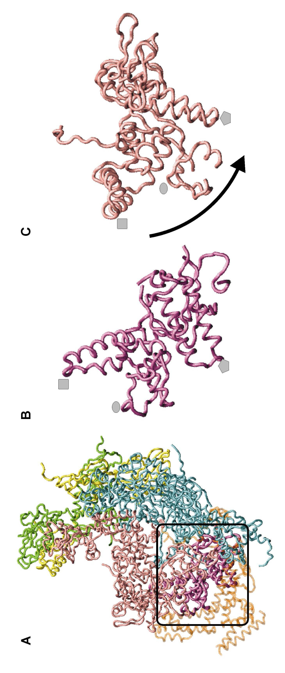
Figure 6.4 – Difference in the position of the β' clamp between two homologous holoenzymes. A – the position and context of the β' clamp domain (coloured magenta) with respect to the rest of the Ec holoenzyme. After supposition of the Tth Eσ^{A} (C) on Ec Eσ⁷⁰ (B) the two β' clamp domains positions were excised, as before, so that their relative positions in the two holoenzymes could be compared. The grey symbols denote the corresponding positions of the structures between (B) and (C).

6.3.4 Comparison of two homologous holoenzymes
Next, the domain organisation of Ec Eσ⁷⁰ was compared to that in the Tth Eσ^{A} structure. Given that homologous holoenzymes are being compared (similar, but not identical) and the relatively low resolution of Ec Eσ⁷⁰ the resolution compared to Tth Eσ^{A}, only large differences between the holoenzymes will be discussed. Differences that are accountable to the presence of an insertion found in either Ec or Tth are not considered.

Unsurprisingly, the major difference between these two holoenzymes is the domain organisation associated with the β' clamp and the domain bound to it, σ⁷⁰ region 2. Figure 6.4 demonstrates the difference between the β' clamp domain in the two holoenzymes. The Tth β' clamp is located in a more upstream direction having swung out more from the core enzyme position than the Ec β' clamp. This difference is the only major difference between the core enzyme subunits of the holoenzymes.

Form the aligned holoenzyme structures, it was possible to compare to the domain organisation of σ⁷⁰ and σ^{A}. Overall the domain organisation of σ⁷⁰ and σ^{A} are comparable (see figure 6.5). Unlike Taq and Tth, where regions 2 and 3 move as relatively fixed modules over the surface of the USL, the angle of orientation of σ⁷⁰ region 2 with respect to σ⁷⁰ region 3 is more acute than σ^{A} in the view presented in figure 6.5. σ⁷⁰ region 2 tightly binds the β' clamp, so the difference in the positioning of this domain compared to σ^{A} is paralleled in the positional difference of the β' clamp domain between the two holoenzymes. However, it is impossible to suggests whether the β' clamp domain dictates the position of the σ⁷⁰ region 2 domain or vice versa, as both domains are flexibly connected to their surrounding domains. σ⁷⁰ region 3 is found in a very similar position to σ^{A} region 3. The conservation of its positioning is unsurprising, as the β USL lobe that region 3 is found to interact with occupies a similar position in both the holoenzymes. In the orientation presented in figure 6.5, the position of the density that is assigned to σ⁷⁰ region 1, predominantly region 1.1, is depicted by the red oval. σ⁷⁰ region 1 is located between region 3 and the long helices of the σ⁷⁰ non-conserved domain. Although intact, the majority of region 1 was not resolved in σ^{A}. However, the helices of σ^{A} region 1.2 that were resolved are found leading up to a similar position to where the σ⁷⁰ region 1 density is found. As with σ⁷⁰ region 1, the position of the density expected to be σ⁷⁰ region 4 by a blue oval. The position of the σ⁷⁰ region 4 domain is similar in both holoenzymes, but this is to be expected as the density was identified by its similarity in positioning. However, it is interesting to note, that it appears to be regions 3 and 4 that are conserved in position, while region 2 appears to be more variable in its position.
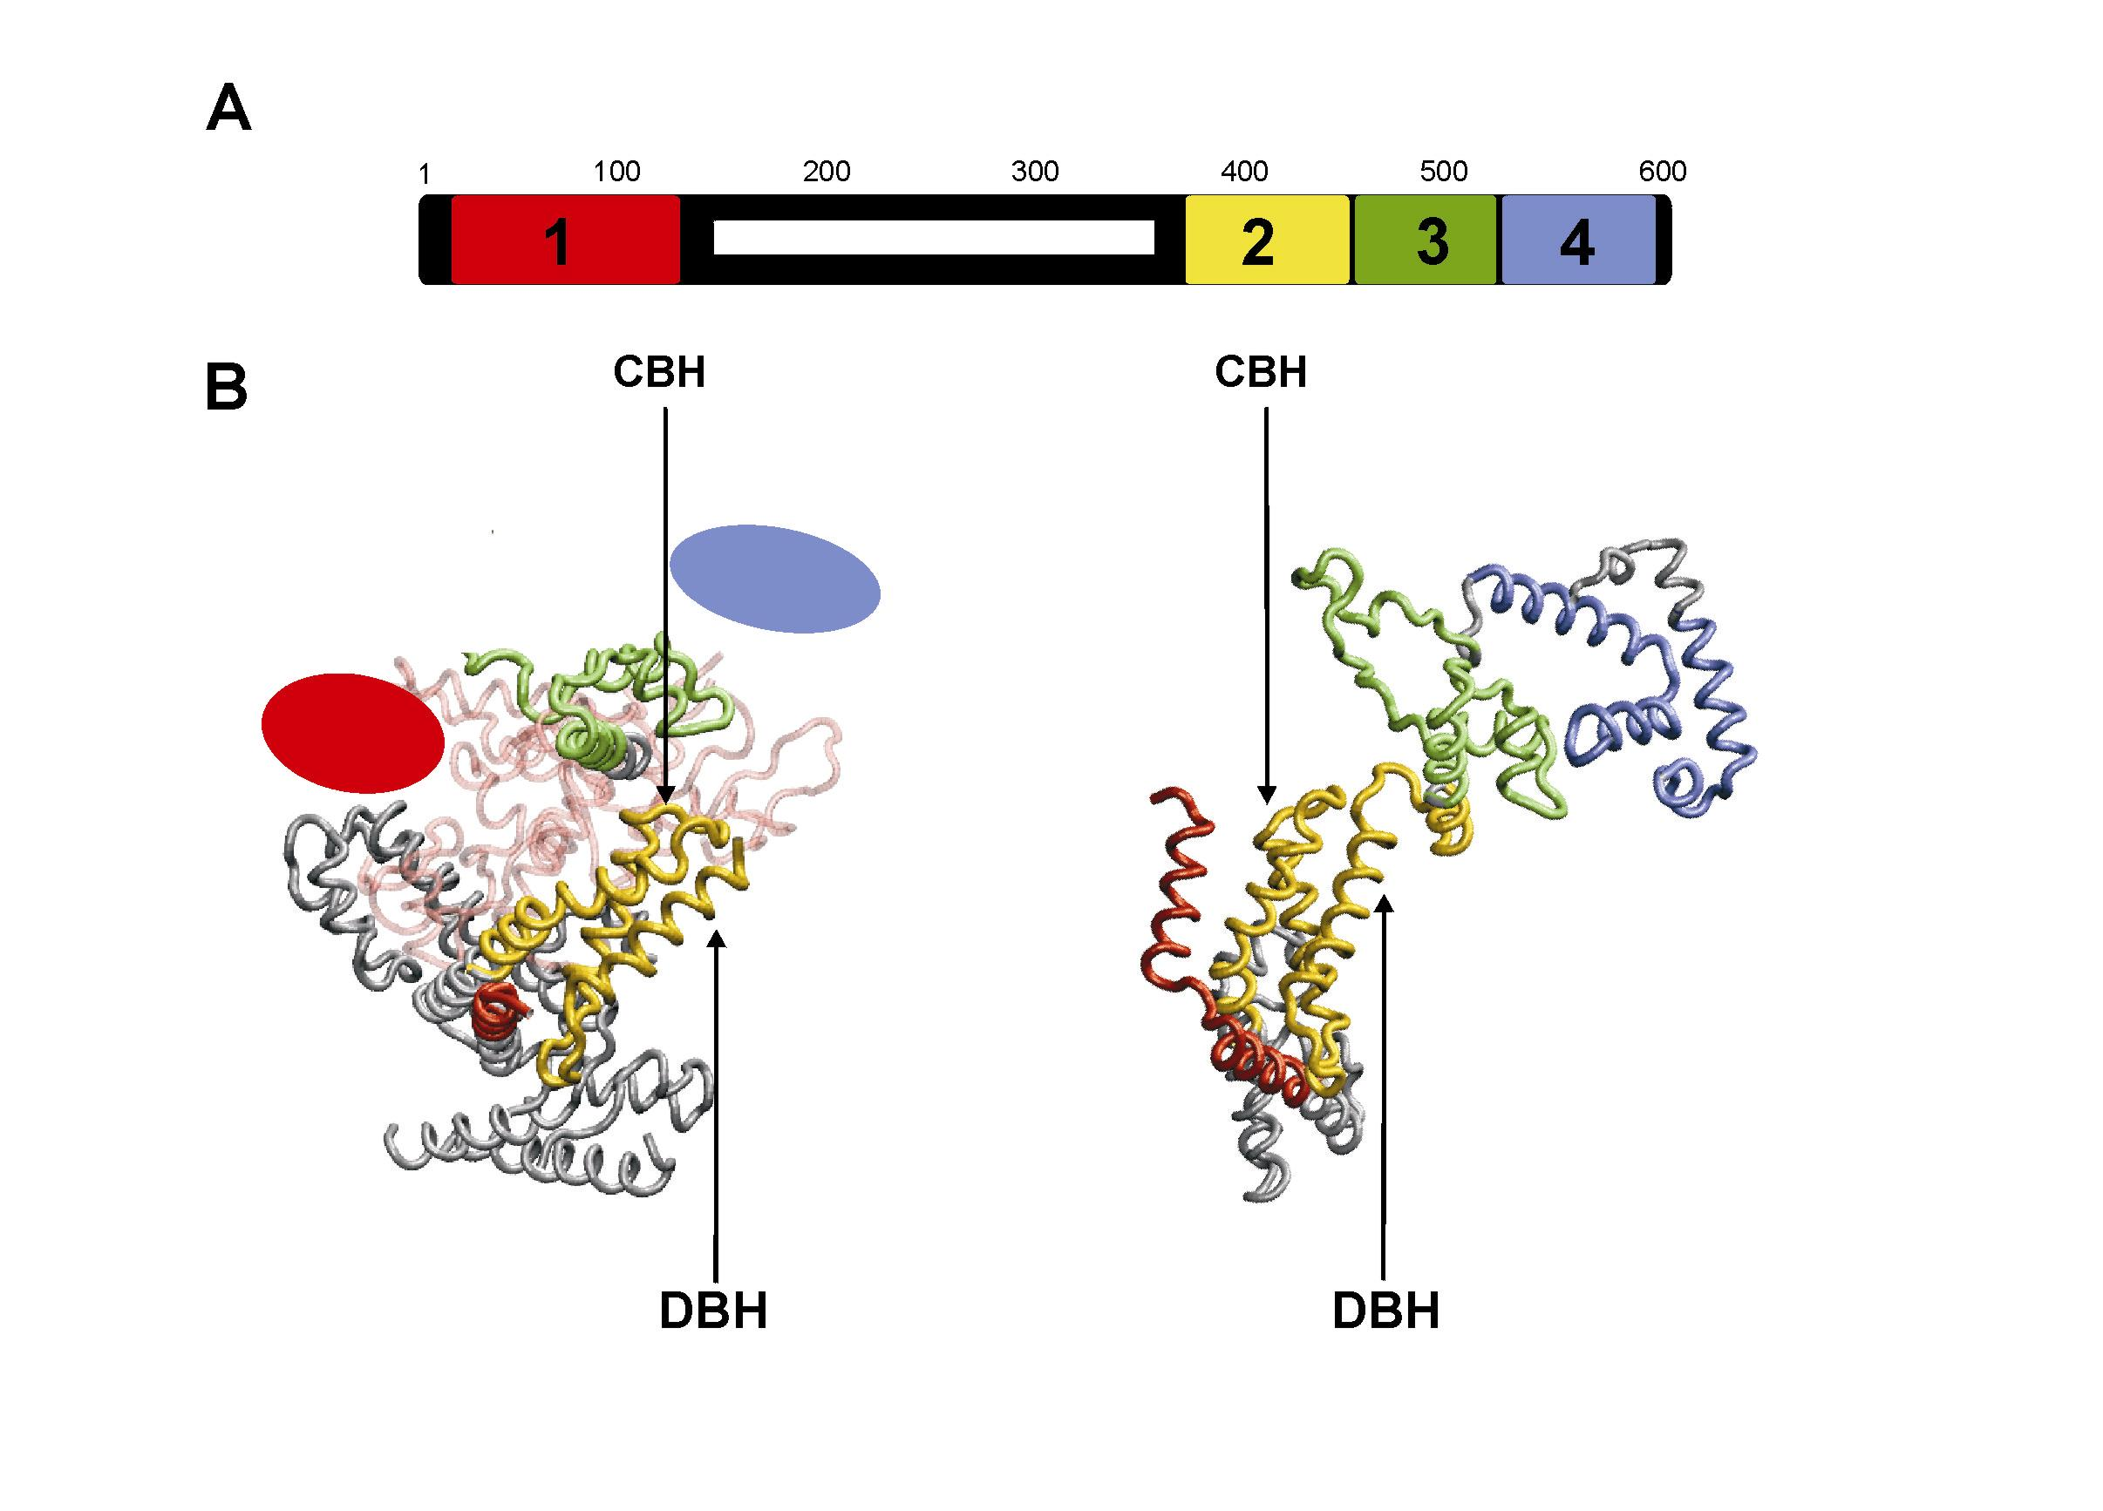
Figure 6.5 – Domain organisation of σ⁷⁰. (A) Schematic of the arrangement of the conserved regions or domains of σ⁷⁰. The white bar indicates the non-conserved region in σ⁷⁰. The same colouring is used in (B). (B) Comparison of the domain arrangement of the Ec σ⁷⁰ (left) and Tth σ^{A} (right) in their respective holoenzymes. This view roughly corresponds to looking though the top of the pincer formed by β. The positions of the domains that are absent from the Ec Eσ⁷⁰ structural model are presented as ovals. The Ec β' clamp domain is also shown. Generally, these two σ-factors show an amazing similarity in their domain organisation. Important helices in region 2 are marked.

6. 4 Conclusions
The structure of the wild-type Ec Eσ⁷⁰ has now been revealed and analysed in detail. Where previous density to density matching procedures were applied to try and locate the core enzyme subunits in the holoenzyme, docking of the C-α backbones of the subunits and use of the corresponding geometric constraints have allowed a much less ambiguous interpretation than was previously possible [Finn, 2000 #21]. Here, it has been demonstrated that σ⁷⁰ primarily interacts with the β flap, β lobes, β' clamp and β'G. The interaction between the β' clamp domain and σ⁷⁰ is mediated by region 2.2, while the non-conserved sequence of σ⁷⁰ between regions 1 and 2 wrap around the β' clamp domain. Finally, region 4 of σ⁷⁰ is likely to interact with the flap domain.

The organisation of σ⁷⁰ in the holoenzyme is consistent with the other structures, FRET studies carried out by the Ebright group [Mekler, 2002 #773], the patterns of peptide fragmentation studies [Owens, 1998 #165; Datwyler, 2000 #561], cross-linking [Naryshkin, 2000 #50] and mutagenesis studies [Gross, 1998 #303]. This work clearly demonstrates that the high-resolution structures of the thermophilic RNAp provide a reasonable framework upon which biochemical data derived from Ec RNAp can be interpreted. However, there are areas of significant structural differences between the mesophilic Ec and the thermophilic holoenzymes that must be taken into account and the structural model presented here provides an excellent platform for understanding such differences, both functionally and structurally.

That a number of conformational changes occurs during the formation of Ec Eσ⁷⁰ from the core RNAp and is unsurprising. All of the observed changes, such as the position of the β flap, β lobes and β' clamps, are observed in Taq Eσ^{A} compare E. Indeed, the motion of the β' clamp is were the biggest conformational difference between E and Eσ⁷⁰, consistent with data from both bacterial and eukaryotic polymerases. The motion of the β' clamp is necessary to allow the binding of both the DNA and σ-factor into the complex. Comparison of the thermophilic Tth Eσ^{A} to the Ec Eσ⁷⁰ revealed a number of differences. In many cases, the observed differences are mirrored when either holoenzyme is compared to Taq Eσ^{A}. These were confined to one area, the position of the β' clamp domain and σ⁷⁰ region 2, which bind to each other. The movement of the β' clamp domain is necessary to allow the binding of σ⁷⁰, which is known to undergo a series of discrete conformational changes.

The difference in the positioning of the β' clamp is paralleled in the difference in the position of σ⁷⁰ region 2. The binding of σ⁷⁰ region 2 may be thought to help stabilise the position of the mobile β' clamp domain. However, the individual domains of σ⁷⁰ are connected by long flexible linkers, so there is no structural evidence for the stabilisation of the σ⁷⁰-region-2: β' clamp module. Furthermore, σ⁷⁰ recognises a range of promoters DNA elements, many of which have sub-optimal promoter spacings. Thus, some flexibility between the promoter binding domains is necessary to recognise the range of σ⁷⁰ promoters. Furthermore, after the binding of DNA, further conformation changes are necessary to form open complexes.

Interestingly, the position of σ structure between the pincers is not restricted to σ⁷⁰ region 1. In the previous chapter, density from σ⁵⁴ was demonstrated to occupy a similar location to σ⁷⁰ region 1.1. The fact that σ⁷⁰ density is located between the pincers extends the principle that the two divergent σ-factors occupy a homologous binding pocket in the core enzyme. The functional role performed by these regions of σ in the DNA binding remains to be clearly identified. However, given the structural conservation it would suggest that it is functionally important. Furthermore, in both holoenzymes, this density must undergo further conformational changes during the binding of the DNA as the density occupies the path taken by the DNA.

Region 1.1 of σ⁷⁰ interacts with both the β'G and the β DSL. Both of these domains structurally delimit the DNA binding channel and are functionally important for position of the DNA during initiation and elongation. Furthermore, a loop of β'G interacts with the bridge helix and is proposed to from part of a molecular switch that triggers the translocation of the RNAp. The bridge-helix is thought to act as a switch based on that the helix is found to be bent in the crystal structure of Taq core enzyme structure [Zhang, 1999 #508], yet straight in the yeast Pol II structure [Cramer, 2001 #18] and Tth holoenzyme [Vassylyev, 2002 #669]. Therefore, the location of region 1.1, suggest that it may have an indirect effect, mediated by β'G, on the bridge helix. Preventing translocation of the RNAp would represent an excellent method of preventing transcription from a non-specific interaction with DNA. However, the fact that region 1.1 was disordered in Tth suggest any interaction by region 1.1 and β'G may be weak and/or transient. A number of studies, especially the FRET studies, have suggested that region 1.1 undergoes a major repositioning upon binding promoter DNA, moving from inside the channel in the holoenzyme to likely to reside outside of the channel in the DNA-holoenzyme complexes [Mekler, 2002 #773].

Two hypotheses have been put forward to the role of region 1.1. Firstly, region 1.1 acts as a molecular mimic for the DNA and occupies the DNA binding channel thereby preventing DNA entering the channel until it is bound in a sequence specific manor [Mekler, 2002 #773]. Second, that region 1.1 may facilitate in holding the jaws open, thereby allowing the DNA to enter [Murakami, 2002 #668]. The location of the whole of region 1.1 has been clearly demonstrated. From the position of region 1.1, it could well perform both roles. In support for the molecular mimic hypothesis, region 1.1 occupies a near identical position to position occupied by +5 to -10 of the promoter DNA, whilst support for the later hypothesis is that region1.1 is associated with two domains that form the downstream channel. Both of these hypotheses seem plausible and are not mutually exclusive. Furthermore, region 1.1 may function in alternative manor. The function of the downstream lobe has been essential for the positioning of the DNA and formation of the open complex. Region 1.1 directly interacts with DSL and close to the β' jaw, and may alter their properties by positioning the DSL or simply stabilising DNA-lobe binding. Indeed, at some promoters σ⁷⁰ region 1.1 is involved in an acceleration of open complex formation [Vuthoori, 2001 #532], consistent with a role for σ⁷⁰ region 1.1 proposed here.

Structures of Ec RNAps complexed with DNA during promoter engagement and elongation phases of transcription are required to further our understanding of the necessary changes that occur to the RNAp subunits during the formation of a sequence-specific, competent transcription complex. These may further elaborate the role of σ⁷⁰ region 1.1 and indicate how the formation of the open complex drives the release of σ⁷⁰ from the DNA binding channel.

