TraceSearch: A web application for real-time similarity search on the whole trace archive.

Supplementary material.

Adam Spargo*, Steven Leonard, Guy Coates, Jody Clements, Roger Pettet, Tony Cox, Martin Widlake and Zemin Ning.

Wellcome Trust Sanger Institute, Hinxton, Cambridge, CB10 1SA, United Kingdom.

Search Speed Comparison

The query and output files from the comparison between TraceSearch, BLAST and BLAT described in the paper can be found in the accompanying compressed tarfile trc_compare.tar.gz. After decompression on any unix/linux system with:

$ gunzip trc_compare.tar.gz
$ tar –xvf trc_compare.tar

you should have a directory trc_compare. The file README in the top directory explains the file structure, a README file in the subdirectories blast and blat give the options that were used to run the programs. The subject files used to build the index in each case can be downloaded from our ftp site (ftp://ftp.sanger.ac.uk/pub/zn1/).

The SSAHA Hashtable

Datatype | Size (bits) | Max. # k-mers | Max. # bases | Max. subject size (GB)
int | 32 | 2147483647 | 25769803764 | 8.589934588
unsigned int | 32 | 4294967295 | 51539607540 | 17.17986918
int64_t | 64 | 9.22×10¹⁸ | 1.10×10²⁰ | 36893488147
uint64_t | 64 | 1.84×10¹⁹ | 2.21×10²⁰ | 73786976295

Table 2. Maximum sizes of the SSAHA hashtable for various datatypes.

Table 1 shows the size limits of the SSAHA hashtable for various datatypes. The current implementation uses unsigned integers, 32-bit values. These numbers were mentioned in the paper to show that partitioning the data by species leads to a lot of wasted memory, when a given species has more than 51539607540 bases to be hashed we require a 64-bit hashtable while only using a small fraction of it’s potential as an index.
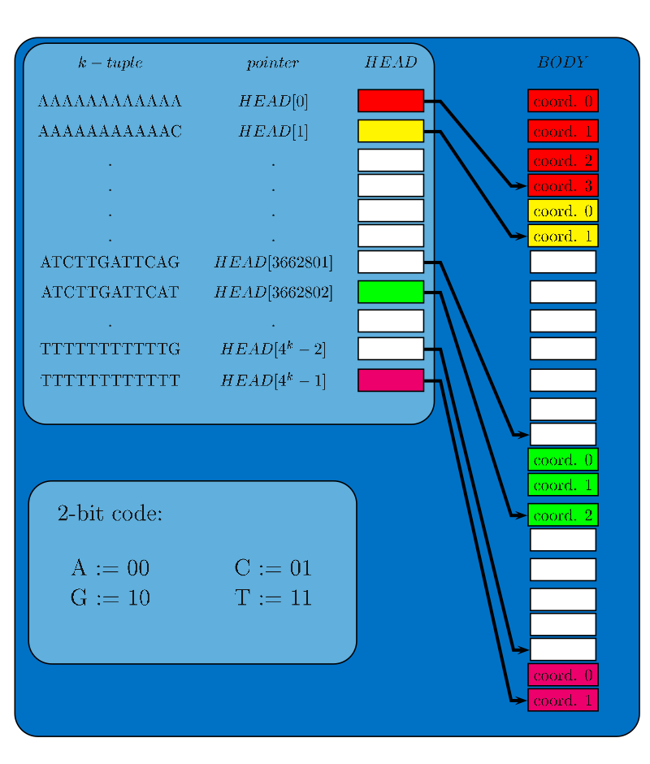
Figure 1. Schematic representation of the SSAHA hashtable.

Figure 1 shows a schematic representation of the SSAHA hashtable described in our paper. Recall that a simple 2-bit encoding is used to construct an integer value corresponding to every one of the 4^{k} possible DNA k-mers. The head array is indexed by these integers, each element pointing to the first element of the body corresponding to the relevant k-mer. This and successive elements of the body store the ordered locations of this k-mer in the subject sequence. To search for all locations of a given k-mer in the subject we simply calculate the corresponding integer via the 2-bit code and follow the pointer from that element of the head; the corresponding elements from the body then give the locations of that k-mer in the subject. This is much faster than scanning the subject to look for instances of the k-mer.

For the TraceSearch application in particular the data-structure includes two additional arrays: size and id. The size array simply stores the cumulative length of the subject in k-mers as each sequence is added. This is required to translate the ordinates stored in the body into (sequence, offset) pairs. The size array is also stored in memory requiring 4×(number of sequences) bytes. The id array stores a fixed length 8-byte record for each subject sequence, these 8 bytes are used to store the primary key for each sequence in the database, the species ID, the sequencing centre ID and the trace type ID as shown in Table 2. The size of these records will have to increase in the future, for example when the number of reads in the archive reaches 2³².

WTSI RFC | Range | Size (bits)
ID_TRACE | 1 to 1.3×10⁹ | 32
ID_SPECIES | 0 to 3000 | 16
ID_CENTRE | 0 to 200 | 8
ID_TRACE_TYPE | 0 to 200 | 8

Table 2. 8-byte encoding of trace information.

When a hashtable look-up is made it are only the ID_TRACE and the number of k-mer hits for each candidate that is returned to the alignment node for further sorting. If the user has specified a particular species, centre or trace type to be searched for, then ID_SPECIES, ID_CENTRE and ID_TRACE_TYPE are used to filter out any unwanted candidates. The fact that the lowest ID_TRACE value is 1 gives the benefit that should traces be set as invalid in the database, then the ID_TRACE can be set to zero in the id file and the hashtable server restarted, invalid traces can then be filtered out at this stage. Simply editing the id file is much faster than rebuilding the hashtable. Of course, should too many traces in one hashtable become invalid then it should be rebuilt, augmented with new data.

One very useful feature of the SSAHA hashtable is that it supports a straightforward binary addition. To add hashtables A and B, the id files may simply be concatenated, while the size file is trivially constructed by accumulating the values of size_{B} onto the last value of size_{A}. To construct the hashtable itself, we loop over all 4^{k} k-mers, concatenating the body section for each one and recording the new offset in the head.

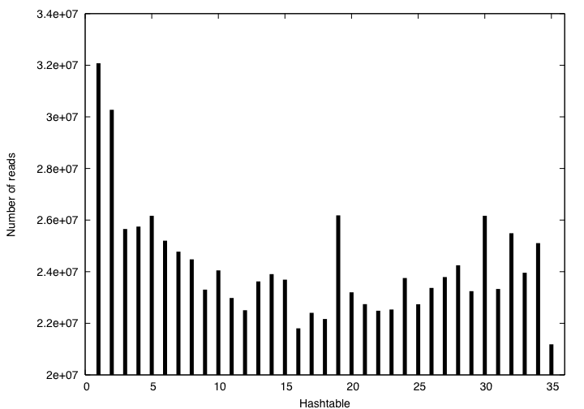

Figure 2. Number of reads selected for each partition using our method.

The motivation for partitioning data according to the number of bases in the reads is illustrated in Figure 2. The graph shows the number of reads in each partition as created by counting 21000000000 bases for each, to produce a hash of exactly 7GB. Clearly if we had counted reads to form the partitions the variation in size would be large, resulting in wasted resources.

TraceSearch Architecture
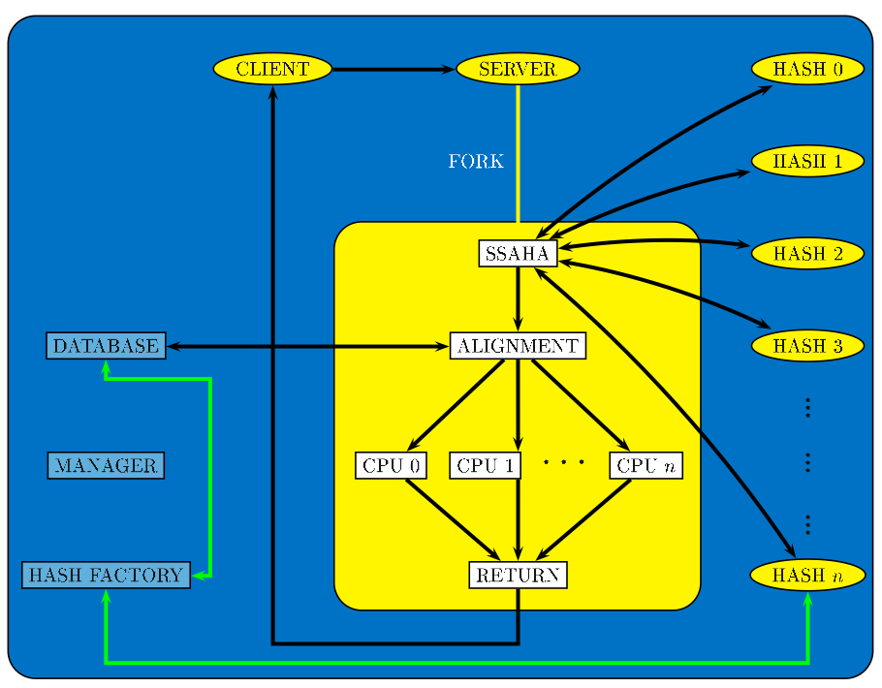
Figure 3. TraceSearch architecture.

Figure 3 shows a schematic of the TraceSearch architecture. A request is sent from a client to the front-end server. The client can be called either from the web server or a perl script for internal use. The server distributes the query sequence via TCP to a number of machines hosting a hashtable data-structure, each referring to a portion of the database. These hashtable servers return the best hits based on the alignment-free score against the relevant portion of the archive. Finally Smith-Waterman alignment of the very best matches over the whole archive is performed (possibly in parallel) on the front-end server and results are returned to the client. The front-end server communicates with the Oracle database using the OCI library (http://www.oracle.com/technology/tech/oci/index.html) to retrieve sequence for the alignments. Also using the OCI library, the hash-factory pipeline extracts all new data on a daily basis and rebuilds the latest table. Since we can add two hashtables together, we simply hash all new data and add the resulting hashtable to hashtable n. As mentioned above, it will sometimes be necessary to turn off traces in the system. For example, the sequencing centre may update a submission. We have therefore built in the ability to have more than one block of data in a single hashtable, should the partitions become fragmented.

We store the hashtable files redundantly over the nodes to avoid data loss due to hardware failure. Figure 4 refers to N+1 logical hashtables hash 0 to hash N, existing on M+1 physical machines machine 0 to machine M. Yellow arrows indicate adjacency between hashtables, black lines show a snap-shot of the hosting description. These are logical hashtables in that they don't have to be anchored to a specific machine. Indeed this would be a bad idea in terms of robustness. Ideally we would like to follow the usual high-availability solution of having a heartbeat connection between multiple machines hosting each hashtable with an instantaneous re-routing of traffic upon failure of the active machine. Unfortunately this is not viable for such a data-intensive application where N is large enough to prohibit the purchase of even two commodity machines for each hashtable.

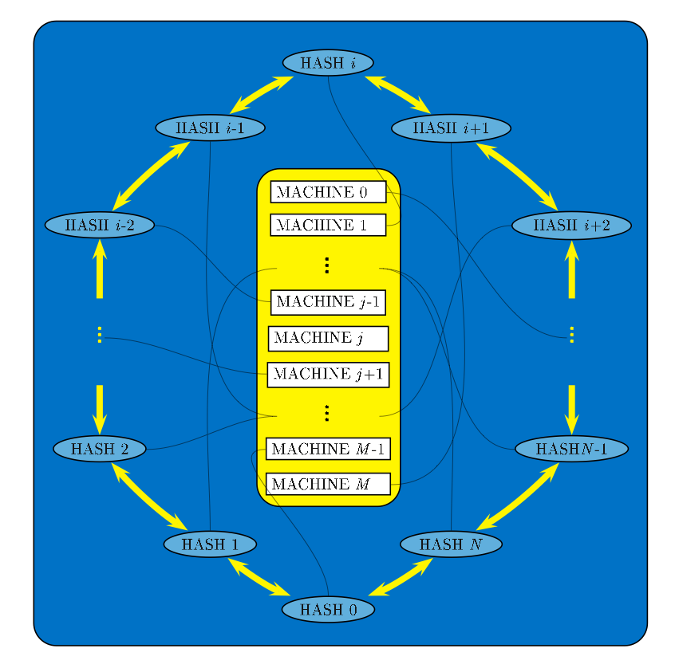
Figure 4. Ring of N+1 hashtables existing redundantly on M+1 machines, M ≥ N+2.

Instead we propose a system where we can tolerate up to two 'adjacent' machine failures with 'short' recovery time. Where short means the time taken to copy large files between machines and adjacent means that the machines are hosting hashtables that are adjacent in the sense of Figure 4. Each logical hashtable exists in a ring of hashtables and consists of an in-memory hashtable data-structure, an on-disk back-up copy and an on-disk back-up of the hashtable data-structure on the two adjacent hashtables in the ring.

If the machine hosting hashtable i fails then a back-up of its hashtable data structure is copied from the machine currently hosting either hashtable i-1 or hashtable i+1 to a spare machine, which will then be used to host hashtable i. Of course, on-disk back-ups of hashtable i-1 and hashtable i+1 will also need to be copied to this machine to remain symmetric. For example, in Figure 4, if machine 1 should fail then a back-up of the data-structure for hashtable i could be copied from machine M to say machine j and hashtable i restarted on machine j.

Clearly, if the machine hosting hashtable i and the machine hosting hashtable i+1 both fail, within the time taken to start a server, then appropriate files may be copied from the machines hosting hashtable i-1 and hashtable i+2 to two spare machines which are then able to restart hashtable i and hashtable i+1. Again on-disk back-ups of adjacent machines must be copied to this machine to remain symmetric. So, provided two spare machines are available we can recover from two such adjacent failures.

However if the machine hosting hashtable i, the machine hosting hashtable i+1 and the machine hosting hashtable i+2 fail within start-up time of each other then we cannot recover. There will no longer be an on-disk back-up of the data structure for hashtable i+1. We regard the case for more than two adjacent failures as a catastrophic failure, which must have resulted from some large-scale data centre, or blade rack failure. In this case all of the hashtables will have to be rebuilt, which is not prohibitive. Our system simply eliminates the need to perform this task on a regular basis.

In normal operation the blades should have a mean time to failure or MTBF of 50,000 hours. So statistically the expected MTBF for the whole system will be very large and the probability of data-loss is very small. We are in the process of automating the restart of a hashtable so that queries can be queued by the web server during downtime.

Disk-based Hashtable

To back-up statements made in the paper concerning the performance of a disk-based system we have done some simple calculations to illustrate the point.

$T=T_{s}+\frac{T_{p}}{P}$.

Amdahl's law above asserts that the time T, taken to execute any program is the sum of the time to execute the parallel portion T_{p}, over the number of processors P, plus the time to execute the serial portion T_{s}. It is straightforward to see that if the parallel fraction of a program is too small then it is impossible to scale performance; no matter how many processors are used. Indeed an infinite number of processors will only result in reducing T to T_{s}.

With one instance of the hashtables for our architecture, the time to perform the hashtable look-up phase is essentially serial. Although the data is distributed, no matter how many copies of the hashtables we have we still need to look-up two pages for each base of the query sequence from each table. More instances increases availability but not speed. The look-up phase is therefore serial (taking the serial time as the best we can do with parallel disks on a node, i.e. 7 seconds), while the Smith-Waterman alignment phase can easily be divided among the available processors on the alignment engine.

In the disk option the hashtable look-up is taking around 7 of the 10 seconds for each query, while hashtable look-ups from memory are essentially free taking around 0.1 seconds of the 3 seconds for each query. So for the disk option we have

$T_{\text{disk}}=7+\frac{3}{P}$,

and for the memory option we have

$T_{\text{mem}}=0\text{.}1+\frac{3}{P}$.

For the memory based option it is therefore worthwhile trying to parallelise the alignment phase among CPUs on a single node or even use more nodes to share the load, however with the disk-based option it is fruitless because search-speed will never be reduced below the serial fraction of 7 seconds no matter how big P is.

So far we have discussed the situation of a single user querying an empty system, we can now perform some simple calculations to see the effect of increased usage on the system. The total hashtable look-up time L_{total}, in our system is the sum of the look-up time on an empty system L₀ and the waiting time due to the system being busy L_{lag}

$L_{\text{total}}=L_{0}+L_{\text{lag}}$.

We assume queries to be equidistributed over time, so that the number of queries received per unit time N, dictates the lag time. Once N is greater than the unit time divided by L₀, then each new query to arrive must wait one look-up time before being processed. Once N is greater than twice the unit time divided by L₀, then each new query to arrive must wait two look-up times before being processed and so on. Hence for a unit time of one second and L₀ in seconds, the mean number of search times before a query is processed is given by

$$N_{\text{lag}}=\frac{N−1}{1L_{0}}=L_{0}(N−1)\text{.}$$

Therefore the actual time before a query is processed is given by

$$L_{\text{lag}}=L_{0}⋅N_{\text{lag}}=L_{0}⋅L_{0}(N−1)=L_{0^{2}}(N−1)$$

We can effectively reduce N by having M instances of the hashtables

$\text{Neff}=\frac{N}{M}$; $M<N$.

So finally the total look-up time is given by

$$L_{\text{total}}=L_{0}+L_{\text{lag}}=L_{0}+L_{0^{2}}(N_{\text{eff}}−1)=L_{0}(1+L_{0}(N_{\text{eff}}−1))$$

We can see that taking multiple users into account in a very simple way means that the naive look-up time L₀ is augmented by a delay term L₀(N_{eff} - 1). So only by keeping the number of instances equal to the number of concurrent users can we preserve performance. In Figure 5 we graph L_{total} against N for one instance of the memory option and multiple instances of the disk option. We see that a disk-based system quickly experiences reduced performance under load. Of course the same can be said of a RAM based system but because memory access times are orders of magnitude faster than disk seek times, the regime in which this would occur is beyond reasonable expectations. It is also clear that adding further instances of the disk-option does not improve matters as expected, diminishing returns are seen as more instances are added. As we have mentioned in the paper, these hashtable servers are likely to be used by other applications in future. Sequence-validation and contamination tests do not require an alignment score; an alignment-free measure such as number of k-mer hits is adequate to indicate a significant match. It is therefore likely that the hashtable server node could receive large amounts of traffic and for this reason we have decided to implement the memory-based option in our system.

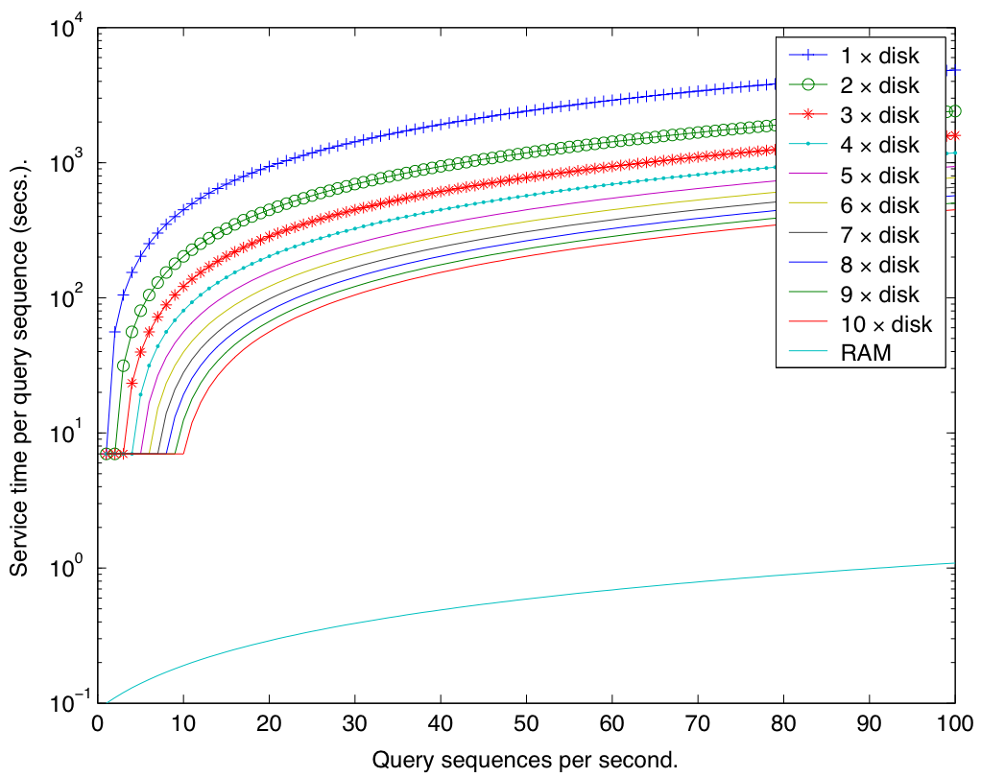
Figure 5. Simulated hashtable look-up time as the number of requests per second increases.

Quality/Vector Clipping

We clip the sequence of each trace for two reasons. Firstly it significantly reduces the size of hashable data, bringing down the cost of the hardware required for the project. Secondly it reduces the likelihood of spurious hits in the database. Base errors in the low quality tails of reads can potentially lead to higher scores for a non-homologous but erroneous sequence than for a homologous sequence with low similarity or a homologous sequence containing vector contamination. Removing the low-quality tails and any vector contamination before hashing means that the number of k-mer matches to each trace refers only to hits in high quality sequence. We do however retrieve the whole read from the database for the alignment phase.

Clipping proceeds in two stages. The first stage clips the read sequence according to the quality scores assigned by the base-calling program phred (1). The quality score, q for each base is defined in terms of the estimated probability, p of an erroneous base call

$q\text{=-}\text{10}{\text{log}}_{\text{10}}p$.

If the probability of an error in the base call is estimated at 0.1, then the quality value is 10. If the error probability is 0.01, the quality value is 20. If the error probability is 0.001, the quality value is 30, and so on. Inverting this formula gives the error probability in terms of the phred quality value, as stored in the trace archive

$p={\left(\frac{1}{\text{10}}\right)}^{\frac{q}{\text{10}}}$.

The clipping software follows a sliding window of length w, along the read of total length l. We define an integrated error rate E_{i} for each window where i is the offset into the read

$E_{i}=\sum_{j=0}^{w−1}{p_{i+j}}$; $1≤i≤l−w+1$.

The window length used for clipping all reads in the archive was w=20. Finally we define clip_{L} as the start of the first window where the integrated error rate is less than one

${\text{clip}}_{L}=\text{min}\left\{\text{i }|{\text{ E}}_{i}<\left.1\right\}\right.$,

and clip_{R} as the end of the last window for which the integrated error rate is less than one

${\text{clip}}_{R}=\text{max}\left\{i+w+1|\left.E_{i}<1\right\}\right.$.

The clipped read then consists of the sequence from position clip_{L} to clip_{R} inclusive. The read is rejected entirely if clip_{L} - clip_{R} < 100 or if the average value of p as we proceed along the clipped sequence exceeds 0.05.

Secondly the sequence is aligned against a reference library of vector sequences so that clip_{L} and clip_{R} can be adjusted to exclude any contamination. If more than half of the clipped sequence aligns to vector sequence, then the whole read is rejected.

References

(1) Ewing, B., Green, P. (1998) Base-calling of automated sequencer traces using phred. II. Error probabilities, Genome Res., 8, 186-194.

* * To whom correspondence should be addressed. Tel: +44 01223 834244; Fax: +44 01223 494919; Email: aws@sanger.ac.uk

